**UNITS AND MEASUREMENT, MOTION IN STRAIGHT LINE**

**UNIT NO. : P-01**

1. The random error in the arithmetic mean of 100 observations is x. The random error in the arithmetic mean of 400 observations would be

a) 2x b) 4x c) 1/2x d) 1/4x

1. The sum of the numbers 436.32, 227.2and 0.301 in appropriate significant figures is

a) 663.821 b) 664 c) 663.8 d) 663.82

1. The density of a material in CGS system of units is . In a system of units in which the unit of length is 10cm and unit of mass is 100g, the value of density of the material will be

a) 0.4 b) 40 c) 400 d) 0.04

1. A physical quantity P is related to four variables a,b,c and d as . The percentage error in the measurement of a, b, c and d are 1%, 3%, 4% and 2% respectively. The percentage error in the measurement of P is

a)5% b) 13% c) 10% d) none of the above

1. The area of a square is . Its side is

a)  b)  c)  d) 

1. The refractive index of water measuredis found to have values 1.34, 1.38, 1.32 and 1.36. The mean value of refractive index with percentage error is

a)   b)  c)  d) 

1. The current voltage relation of a diode is given by , where V is in volts T is in kelvin. If a student makes an error measuring while measuring the current of 5mA at 300K, what will be the error in the measurement of current?

a) 0.5mA b) 0.02mA c) 0.2mA d) 0.05mA

1. In an Vernier callipers, ten smallest divisions of the Vernier scale are equal to nine smallest divisions on the main scale is half millimetre. The Vernier constant is

a) 0.5mm b) 0.1mm c) 0.05mm d) 0.005mm

1. By the usual notations the following equation is

a) Only dimensionally correct

b) Only numerically correct

c) Both dimensionally and numerically correct

d) Neither dimensionally nor numerically correct

1. Number of particles is given crossing a unit area perpendicular to x-axis in unit time, where and are number of particles per unit volume corresponding to and. Find the dimensions of D called as diffusion constant

a)  b)  c)  d) 

1. If L, C and R denote inductance, capacitance and resistance respectively, the dimensional formula for C2LR is

a)  b)  c)  d) 

1. If the energy *E*, velocity *v*and force *F* are considered as fundamental quantities, then the dimensions of mass is

a)  b)  c)  d) 

1. A particle experiences a constant acceleration for 20 seconds after starting from rest. If it travels a distance of  in first 10 seconds and  in the next 10 seconds. Then

a)  b)  c)  d) 

1. For a moving body at any instant of time

a) If the body is not moving, the acceleration is necessarily zero

b) If the body is slowing down, the distance is negative

c) If the body is slowing down, the retardation is negative

d) If the displacement, velocity and acceleration at that time is known, we can find the displacement at any future time

1. **Statement 1:** The displacement-time graph of a body, moving with uniform acceleration is a straight line.

**Statement 2:** This follows from , where the symbols have their usual meaning.

a) Both statement -1 and statement-2 are true, but statement-2 is not the correct explanation of statement-1.

b) Both statement -1 and statement-2 are true, but statement-2 is the correct explanation of statement-1.

c) Both statement -1 and statement-2 are false.

d) The statement-1 is false but statement-2 is true.

1. The displacement of a particle is given by. The initial velocity and acceleration are respectively
2. -b, 2c b) b, -4d c) a, 2b d) b, 2c

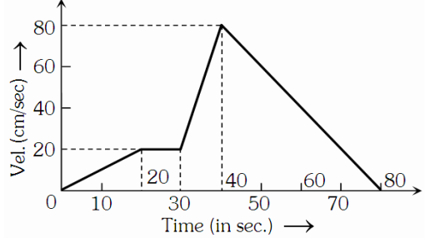

1. The v-t graph of a moving object is given in figure. The maximum acceleration is

a) 6 cms-2

b) 4 cms-2

c) 2 cms-2

d) 1 cms-2

1. A stone is dropped from height h. Simultaneously another stone is projected vertically up from the ground which reaches a height 4h. The two stones cross each other after time

a)  b)  c)  d) 

1. A man throws balls with same speeds vertically upwards one after the other at an interval of 2 seconds. What should be the speed of the throw so that more than two balls are in the sky at any time? ( take g=9.8 ms-2)

a) More than 19.6 ms-1 b) Only with the speed of 19.6 ms-1

c) Any speed less than 19.6 ms-1 d) At least 0.9 ms-1

1. A body thrown vertically upwards with an initial velocity of u reaches maximum height in 6 second. The ratio of the distances travelled by the body in first and seventh second is ( take g=10 ms-2)

a) 1:1 b) 1:2 c) 1:11 d) 11:1

1. The engine of a motorcycle can produce a maximum acceleration of 5ms-2. Its brakes can produce a maximum retardation of 10ms-2. What is the minimum time, in which it can cover a distance of 1.5km?

a) 5s b) 10s c) 15s d) 30s

1. A body *A* starts from rest with an acceleration of a1. After two seconds another body *B* starts from rest with an acceleration a2. It they travel equal distances in the 5th second, then the ratio  is

a) 5:7 b) 5:9 c) 9:5 d) 9:7

1. The relation  describes the displacement of a particle in in direction, where x is in meter and t is in second. The displacement when the velocity is zero is

a) Zero b) 5 m c) 12 m d) 24 m

1. A car starting from rest, accelerates at the rate of  through a distance S, then continues at constant speed for time t and then decelerates at the rate of  to come to rest. If the total distance traversed is 15S, then

a)  b)  c)  d) 

1. The acceleration ‘a’ in ms-2 of a particle is given by where *t* is in second. If the particle starts out with a velocity 2ms-1 then the velocity at the end of 2 second is

a) 9 ms-1 b) 18 ms-1 c) 27 ms-1 d) 36 ms-1

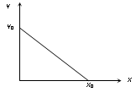

1. The given graph shows the variation of velocity with displacement.

Which one of the graph given below correctly represents the

variation of acceleration with displacement?

*x*

*a*

*x*

*a*

*x*

*a*

*x*

*a*

a) b) c) d)

1. When an object is shot from the bottom of a long smooth inclined plane kept at an angle 60o with the horizontal, it can travel a distance of *X1* along the plane. But when the inclination is decreased to 30o and the same object shot with the same velocity, it can travel distance *X2*. then *X1: X2* is

a)  b)  c)  d) 

1. A person travelling in a straight line moves with the constant velocity V1 for certain distance ‘X’and with a constant velocity V2 for next equal distance. The average velocity V is given by the relation

a)  b)  c)  d) 

1. Preethi reached the metro station and found that the escalator was not working. She walked up the stationary escalator in time t1 .On other days, if she remains stationary on the moving escalator, then the escalator takes her up in time t2. The time taken by her to walk up on the moving escalator will be

a)  b)  c) t1-t2 d) 

1. Two cars P and Q start from a point at the same time in a straight line and their positions are represented by XP(t)=at+bt2 and XQ(t)=(ft-t2 ). At what time do the cars have the same velocity?

a)  b)  c)  d) 

1. If the velocity of a particulate At+Bt2 where A and B are constants then the distance travelled by it between 1 s and 2 s is

a)  b)  c)  d) 3A+7B

1. A particle of unit mass undergoes one dimensional motion such that its velocity varies according to V(x) = βx-2n Where β and n are constants and x is the position of the particle. The acceleration of the particle as a function of x is given by

a) -2β2 x-2n+1 b) -2nβ2 e-4n+1 c) -2nβ2 x-2n-1 d) -2nβ2 x-4n-1

1. A stone falls freely under gravity. It covers distances h1 h2 and h3 in the first 5 seconds, the next 5 seconds and the next 5 seconds respectively. The relation between h1 h2 and h3 is

a) h2 = 3h1 and h3 =3h2 b) h1= h2= h3 c) h1= 2h2 = 3h3 d) h1=

1. 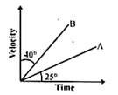The velocity-time graph for two bodies A and B are shown. Then the acceleration of A and B are in the ratio

a) tan 25° to tan 40° b) tan 25° to tan 50°

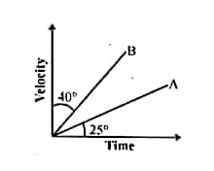

c) sin 25° to sin 50° d) cos 25° to cos 50°



1. A car moves from A to B with a speed of 30kmph and from B to A with a speed of 20kmph. What is the average speed of the car?

a) 25kmph. b) 24kmph. c) 50kmph. d)10kmph

1. A body starts from rest and moves with constant acceleration for t seconds. It travels a distance x1 in first half of time and x2 in next half of time, then

a) b)  c)  d)

1. 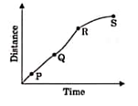A particle shows distance-time curve as shown in the figure. The maximum instantaneous velocity of the particle is around the point

a) P b) S

c) R d) Q

1. Three different objects $m_{1}, m_{2}$ and ${m }_{3}$ are allowed to fall from rest and from the same point O along three different frictionless paths. The speeds of the three objects, on reaching the ground, will be in the ratio of

a) $m_{1}: m_{2}: m_{3}$ b) $1:1:1$ c) $m_{1}: 2m_{2}: m_{3}$ d) $\frac{1}{m_{1}}:\frac{1}{m_{2}}:\frac{1}{m_{3}}$

1. 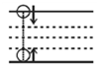A stone is projected vertically up from the bottom of a water tank. Assuming no water resistance it will go up & come down in same time but if water drag is present then the time it takes to go up, $t_{up}$ and the time it takes to come down, $t_{down}$ are related as

a) $t_{up}>t_{udown}$ b) $t_{up}=t_{udown}$

c) $t_{up}<t_{udown}$ d) cannot say

1. Which of the following velocity-time graphs shows a realistic situation for a body in motion?

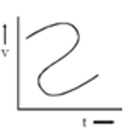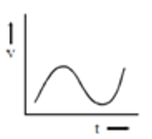

a) b)

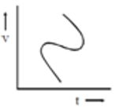

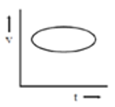

c) d)

1. In an experiment, the percentage of error occurred in the measurement of physical quantities A, B, C and D are 1%, 2%, 3% and 4% respectively. Then the maximum percentage of error in the measurement X, where  will be

a)  b) 16% c) -10% d) 10%

1. A student measured the diameter of a small steel ball using a screw gauge of least count 0.001 cm. The main scale reading is 5 mm and zero of circular scale division coincides with 25 divisions above the reference level. If screw gauge has a zero error of –0.004 cm, the correct diameter of the ball is

a) 0.053 cm b) 0.525 cm c) 0.521 cm d) 0.529 cm

1. A physical quantity of the dimensions of length that can be formed out of c, G and  is [c is velocity of light, G is universal constant of gravitation and e is charge]

a)  b)  c)  d) 

1. A motor boat covers a given distance in 6hrs moving downstream on a river. It covers the same distance in 10hrs moving upstream. The time it takes to cover the same distance in still water

a) 9hrs b) 7.5hrs c) 6.5hrs d) 8hrs

1. What is the angle between instantaneous displacement and acceleration during retardation?

a) 0 b)  c)  d) 

1. Unit of self-inductance is

a)  b) c) d) 

1. Of the following quantities, which one has dimensions different from the remaining three?

a) Energy per unit volume

b) Force per unit area

c) Product of voltage and charge per unit volume

d) Angular momentum per unit mass

1. A body travels uniformly a distance of (13.8 ±0.2) *m* in a time (4.0 ± 0.3) s. The velocity of the body within error limits is

a) (3.45 ± 0.2) *ms*-1 b) (3.45 ± 0.3) *ms*-1) c) (3.45 ± 0.d) *ms*-1 d) (3.45 ± 0.5) *ms*-1

1.  and  denote energy, mass, angular momentum and gravitational constant respectively, then the dimension of  are

a) Angle b) Length c) Mass d) Time

1. The length, breadth and thickness of a block are given by and. The volume of the block according to the idea of significant figures should be

a) b) c) d) None of these

1. A body has speed *V*, 2*V* and 3*V* in first 1/3 of distance *S,* second 1/3 of *S* and third 1/3 of *S* respectively. Its average speed will be

a) *V* b) 2*V* c) d) 

1. A car *A* is travelling on a straight level road with a uniform speed of 60It is followed by another car *B* which is moving with a speed of 70 When the distance between them is 2.5 *km*, the car *B* is given a deceleration of 20After how much time will *B* catch up with *A*

a)1*hr* b) 1/2 *hr c)*1/4 *hr* d) 1/8 *hr*

1. The speed of a body moving with uniform acceleration is *u*. This speed is doubled while covering a distance *S.* When it covers an additional distance *S,* its speed would become

a)b)  c) d)

1. Two trains one of length 100 *m* and another of length 125 *m*, are moving in mutually opposite directions along parallel lines, meet each other, each with speed 10. If their acceleration are 0.3and 0.2respectively, then the time they take to pass each other will be

a) 5*s* b) 10 *s* c)15 *s* d) 20 *s*

1. A body starts from rest with uniform acceleration. If its velocity after *n* second is then its displacement in the last two seconds is

a) b)  c) d)

1. A particle is projected with velocity  along . The deceleration on the particle is proportional to the square of the distance from the origin i.e., The distance at which the particle stops is

a) b)  c)  d)

1. A ball is thrown vertically upwards. Which of the following plots represents the speed-time graph of the ball during its flight if the air resistance is not ignored?

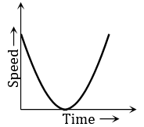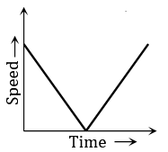a) b) c) d)

Speed

Time

Speed

Time

1. 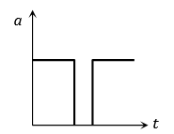Acceleration-time graph of a body is shown. The corresponding velocity-time graph of the same body is

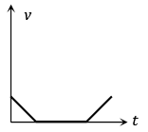

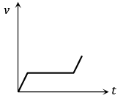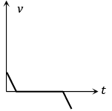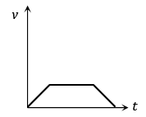a) b) c) d)

1. A wheel of radius 1 meter rolls forward half a revolution on a horizontal ground. The magnitude of the displacement of the point of the wheel initially in contact with the ground is

a) b) c) d) *π*

1. Which of the following options is correct for the object having a straight line motion represented by the following graph?

a) The object moves with constantly increasing velocity from *O* to A and then it moves with constant velocity.

*s*

*t*

*D*

*C*

*B*

*A*

*O*

b) Velocity of the object increases uniformly

c) Average velocity is zero

d) The graph shown is impossible

**VECTORS, MOTION IN A PLANE**

**UNIT NO. : P – 02**

1. A ball is projected from the ground at a speed of 10 ms-1 making an angle of 30˚ with the horizontal. Another ball is simultaneously released from a point on the vertical line along the maximum height of the projectile. Both the balls collide at the maximum height of first ball. The initial height of the second ball is (g = 10 ms-2)

a) 6.25 m b) 2.5 m c) 3.75 m d) 5 m

1. The maximum horizontal range of a projectile is 400 m. The maximum value of height attained by it will be

a) 100 m b) 200 m c) 400 m d) 800 m

1. An arrow is shot into air. Its range is 200 m and its time of flight is 5 s. If g = 10 ms-2, then the horizontal component of velocity of the arrow is

a) 13 ms-1 b) 25 ms-1 c) 31 ms-1 d) 40 ms-1

1. A ball of mass m is thrown vertically upwards. Another ball of mass 2m is thrown at an angle θ with the vertical. Both of them stay in air for same period of time. The heights attained by the two balls are in the ratio of

a) 2:1 b) 1:cosθ c) 1:1 d) cosθ:1

1. An aircraft is flying at a height of 3400 m above the ground. If the angle subtended at a ground observation point by the aircraft positions 10 s apart is 30˚, then the speed of the aircraft is

a)19.63 ms-1 b) 1963 ms-1 c) 108 ms-1 d) 196.3 ms-1

1. A body is moving in a circular path with acceleration ‘a’. If its velocity gets doubled, find the ratio of acceleration after and before the change

a) 1:4 b) 1/4 : 2 c) 2:1 d) 4:1

1. A particle is moving in a circle of radius R with constant speed *v*, if radius is double then its centripetal force to keep the same speed should be

a) Doubled b) Halved c) Quadrupled d) Unchanged

1. A projectile is fired from the surface of the earth with a velocity of 5 ms-1 and angle θ with the horizontal. Another projectile fired from another planet with a velocity of 3 ms-1 at the same angle follows a trajectory which is identical with the trajectory of the projectile fired from the earth. The value of the acceleration due to gravity on the planet is (in ms-2) is (Given *g* = 9.8 ms-2)

a) 3.5 b) 5.9 c) 16.3 d) 110.8

1. A particle has initial velocity and acceleration. The magnitude of velocity after 10 seconds will be

a) 9units b) 5units c) 5 units d) 9 units

1. A particle moves in a circle of radius 5 cm with constant speed and time period 0.2π s. The acceleration of the particle is

a) 15 ms-2 b) 25 ms-2 c) 5 ms-2 d) 36 ms-2

1. The speed of a projectile at its maximum height is half of its initial speed. The angle of projection is

a) 60o b) 15o c) 30o d) 45o

1. A particle is projected from a tower as shown in figure, then the distance from the foot of the tower where it will strike the ground will be

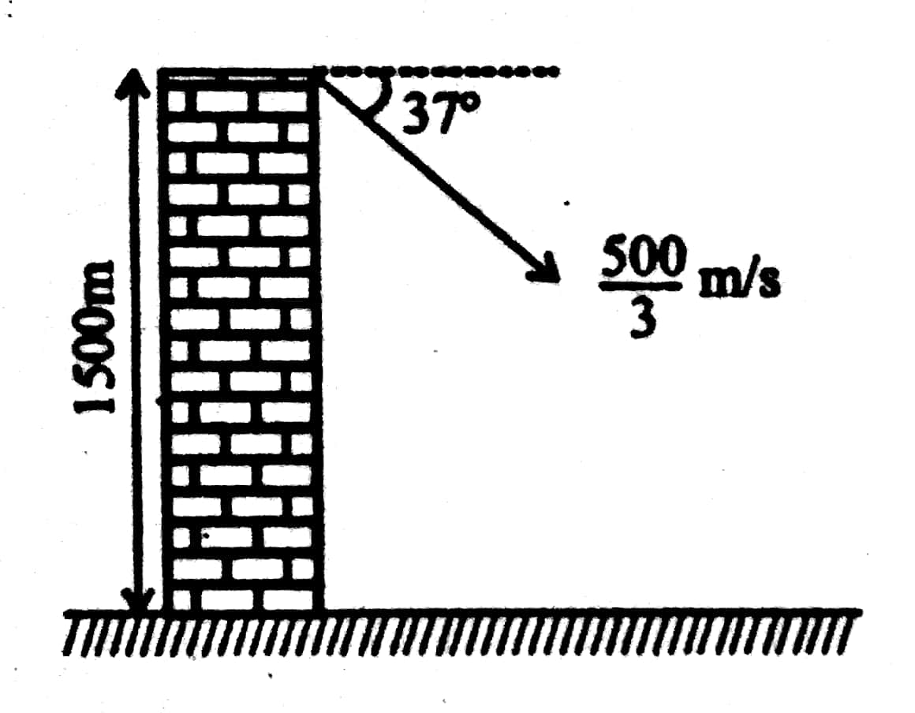

a) 4000/3 m

b) 2000/3 m

c) 1000/3 m

d) 2500/3 m

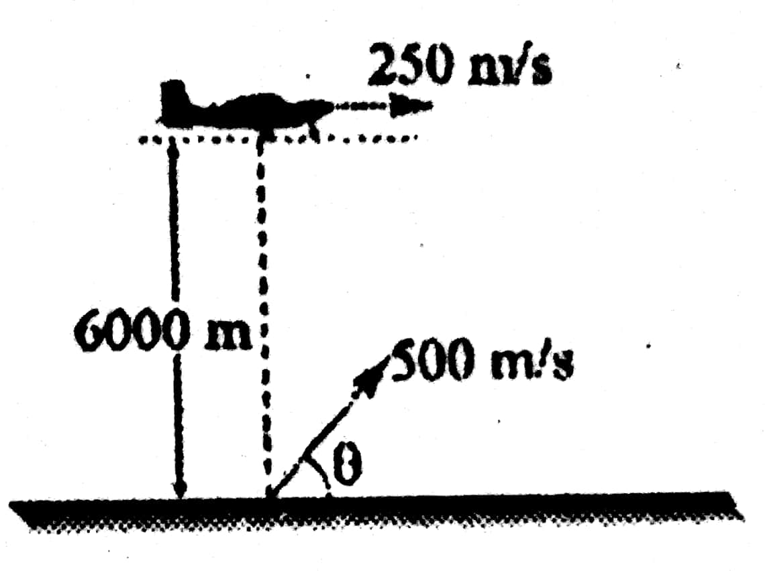

1. An aircraft moving with a speed of 250 m/s is at a height of 6000m, just overhead of an anti aircraft gun. If the muzzle velocity is 500 m/s, the firing angle θ should be

a) 30˚ b) 45˚

c) 60˚ d) 75˚

1. A particle is ejected from the tube at A with a velocity v at an angle θ with the vertical y- axis. A strong horizontal wind gives the particle a constant horizontal acceleration ‘a’ in the x-direction. If the particle strikes the ground at a point directly under its released position and the downward y- acceleration is taken as g then

a) 

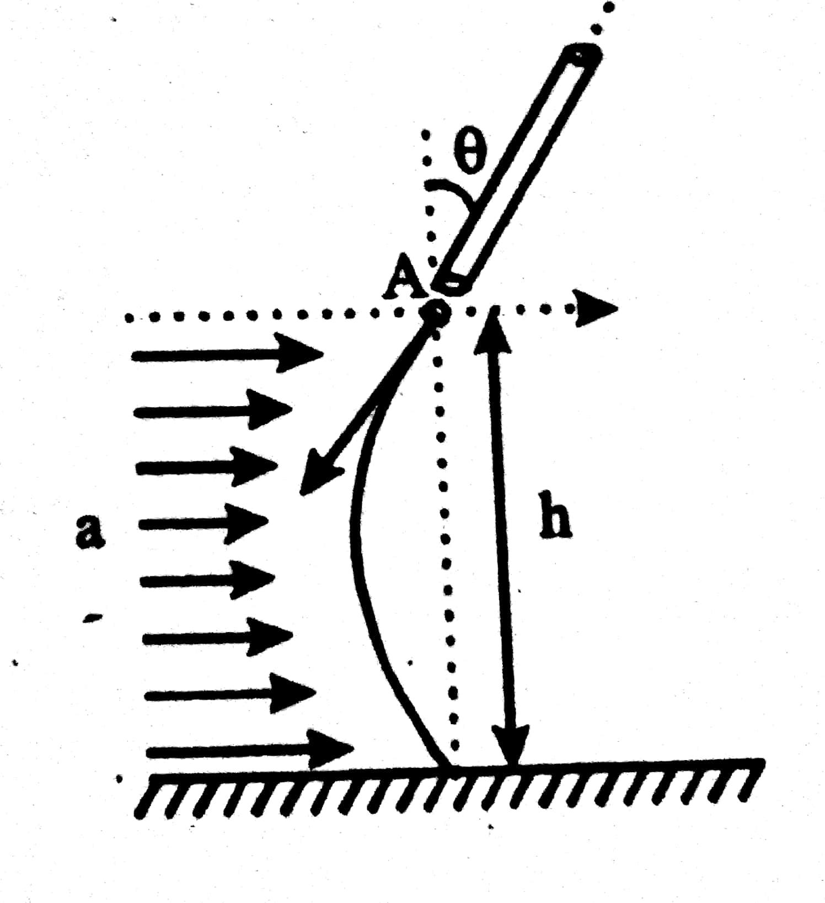

b) 

c) 

d) 

1. A particle is going parallel to x-axis with constant speed ‘v’ at a distance ‘a’ from the axis. Then its angular velocity about an axis passing through the origin O, at the instant when radial vector of the particle makes angle θ with the x-axis is

a)  b)  c)  d) 

1. A particle describes a horizontal circle in a conical funnel whose inner surface is smooth with speed of 0.5 m/s. What is the height of the plane of circle from vertex of the funnel.

a) 0.25 cm b) 2 cm c) 4 cm d) 2.5 cm

1. A particle moving along the circular path with a speed v and its speed increases by g in one second. If the radius of the circular path be r, then the net acceleration of the particle is

a)  b)  c)  d) 

1. A ball is thrown from rear end of the compartment of train to the front end which is moving at a constant horizontal velocity. An observer A sitting in the train compartment and another observer B standing on the ground draw the trajectory. They will have

a) equal horizontal and equal vertical ranges

b) equal vertical ranges but different horizontal ranges

c) different vertical ranges but equal horizontal ranges

d) different vertical and different horizontal ranges

1. For an observer on trolley direction of projection of particle is shown in the figure, while for observer on ground ball rise vertically. The maximum height reached by ball from trolley is

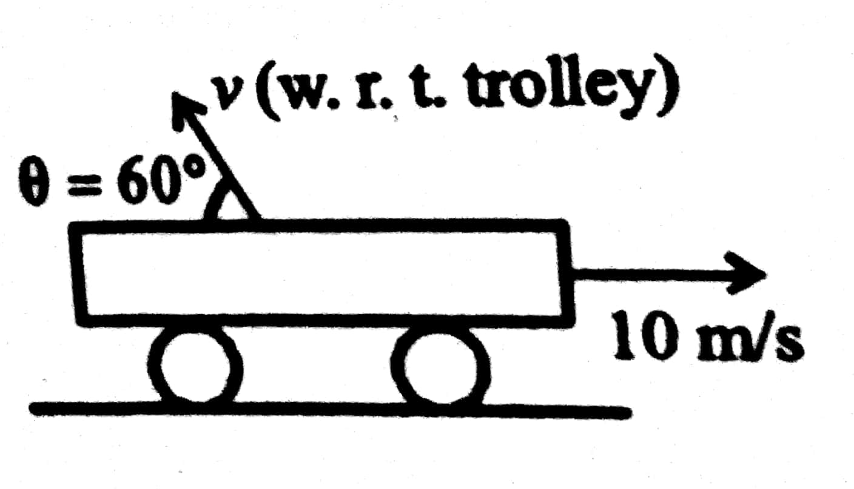

a) 10 m b) 15 m

c) 20 m d) 5 m

1. A body is projected horizontally from the top of a tower with initial velocity 18 ms-1 It hits the ground at angle 45˚. What is the vertical component of velocity when it strikes the ground

a) 9 ms-1 b)9ms-1 c)18ms-1 d) 18 ms-1

1. Two guns A and B can fire bullets at speeds 1kms-1 and 2kms-1 respectively. From a point on a horizontal ground, they are fired in all possible directions. The ratio of maximum areas covered by the bullets fired by the two guns, on the ground is:

a) 1 : 2 b) 1 : 4 c) 1 : 8 d) 1 : 16

1. Which of the following statements is true?

a) A scalar quantity is the one that is conserved in a process

b) A scalar quantity is the one that can never take negative values

c) A scalar quantity is the one that does not vary from one point to another in space

d) A scalar quantity has the same value for observers with different orientations of the axes

1. The angle between two vectors of magnitude 12 and 18 units when their resultant is 24 units is

a) 63˚51’ b) 75˚52’ c) 82˚31’ d) 89˚16’

1. The vector that is added to  and  to give a unit vector along the x-axis is

a)  b)  c)  d) 

1. If  , then the angle between  and  is

a)  b)  c)  d) 

1. The resultant of vectors. On reversing the direction of , the resultant vector becomes . Then the correct relation is

a)  b) 

c)  d) 

1. If  are unit vectors and θ is the acute angle between them, then  is a unit vector for

a) No value of θ b) one value of θ c) two values of θ d) three values of θ

1. Three vectors  satisfies the relation . The vector is parallel to

a)  b)  c)  d) 

1. A body is moving with velocity 30 m/s towards east. After 10 seconds its velocity becomes 40 m/s towards north. The average acceleration of the body is

a) 1 m/s2 b) 7 m/s2 c) m/s2 d) 5 m/s2

1. A stone tied to the end of a string 100cm long is whirled in a horizontal circle with a constant speed. If the stone makes 14 revolutions in 22s then the acceleration of the stone is

a) $16{m/s}^{2}$ b) $4{m/s}^{2}$ c) $12{m/s}^{2}$ d) $8{m/s}^{2}$

1. A train of 150m length is going towards north direction at a speed of $10{ms}^{-1}$. A parrot files at a speed of $5{ms}^{-1}$ towards South direction parallel to the railway track. The time taken by the parrot to cross the train is equal to

a) 12s b) 8s c) 15s d) 10s

1. A boat is sent across a river with a velocity of 8 km/hr. If the resultant velocity of boat is 10 km/hr, then velocity of the river is

a) 10 km/hr b) 8 km/hr c) 6 km/hr d) 4 km/hr

1. A particle has been projected with initial velocity of 20 ms-1 at an angle 30˚ with horizontal, then time at which particles velocity vector is perpendicular to the acceleration vector is (g = 10 ms-1)

a) 2s b) 1s c) 3s d) 4s

1. A stone is projected with an initial velocity at an angle to the horizontal. A small piece separates from the stone before the stone reaches its maximum height. Then this piece will

a) fall to the ground vertically

b) fly side by side with the parent stone along a parabolic path

c) fly horizontally initially and will trace a different parabolic path

d) lag behind the parent stone, increasing the distance from it

1. The equation of trajectory of projectile is given by , where x and y are in metre. The maximum range of the projectile is

a)  b)  c)  d) 

1. A projectile is thrown at an angle of 40˚ with the horizontal and its range is R1. Another projectile is thrown at an angle 40˚ with the vertical and its range is R2. What is the relation between R1 and R2?

a) R1 = R2 b) R1 = 2R2 c) 2R1 = R2 d) R1 = 4R2/5

1. Velocity of a stone projected , 2 second before it reaches the maximum height, makes angle 53˚ with the horizontal, then the velocity at highest point will be (neglect air friction and take g = 10 ms-2, tan 53 = 4/3)

a) 20 ms-1 b) 15 ms-1 c) 25 ms-1 d) 80/3 ms-1

1. A bullet is fired with a speed of 1500 m/s in order to hit a target 100 m away. If g = 10 ms-2 the gun should be aimed

a) 15 cm above the target b) 10 cm above the target

c) 2.2 cm above the target d) derectly towards the target

1. An aeroplane moving horizontally with a speed of 720 km/h drops a food pocket, while flying at a height of 397 m. The time taken by a food pocket to reach the ground and its horizontal range is

a) 3 s, 2000 m b) 5 s, 500 m c) 8 s, 1500 m d) 9 s, 1800 m

1. A body is thrown horizontally from the top of a tower of height 5m. It touches the ground at a distance of 10 m from the foot of the tower. The initial velocity of the body is (g = 10 ms-2)

a) 2.5 ms-1 b) 5 ms-1 c) 10 ms-1 d) 20 ms-1

**PREVIOUS APPEARED QUESTIONS**

1. The speed of a swimmer in still water is 20ms-1. The speed of river water is 10ms-1 and is flowing due east. If he is standing on the south bank and wishes to cross the river along the shortest path the angle at which he should make his strokes w.r.to north is given by: **[ NEET 2019]**

a) 300 west b) 00 c) 600 west b) 450 west

1. A particle moving with velocity V is acted by three forces shown by the vector triangle PQR. The velocity of the particle will: **[NEET 2019]**

a) Increase

b) Decrease

c) Remain constant

d) Change according to the smallest force 

1. The x and y coordinates of the particle at any time are x = 5t-2t2 and y = 10t respectively, where x and y are in meters and t in seconds. The acceleration of the particle at t=2s is **[NEET 2017]**

a) b) 5 ms-2 c) -4 ms-2 d) -8 ms-2

1. In the given figure, a = 15 ms-2 represents the total acceleration of a particle moving in the clockwise direction in a circle of radius R = 2.5 m at a given instant of time. The speed of the particle is **[NEET 2016]**

a) 4.5 ms-1

b) 5.0 ms-1

c) 5.7 ms-1

d) 6.2 ms-1

1. If the magnitude of sum of two vectors is equal to the magnitude of difference of the two vectors, the angle between these vectors is **[NEET 2016]**

a) 00 b) 900 c) 450 d) 1800C

1. A particle moves with so that its position vector is given by , where ω is a constant. Which of the following is true? **[NEET 2016]**

a) velocity and acceleration both are perpendicular to 

b) velocity and acceleration both are parallel to

c) velocity is perpendicular to and acceleration is directed towards the origin.

d) velocity is perpendicular to and acceleration is directed away from the origin.

1. If vectors and  are functions of time, then the value of t at which they are orthogonal to each other is: **[NEET 2015]**

a) t = 0 b)  c)  d) 

1. A particle is moving such that its position coordinate (x, y) are(2m, 3m ) at time t = 0,

(6m, 7m) at time t = 2 s and (13 m, 14 m) at time t = 5 s. Average velocity vector ( )

from t = 0 to t = 5 s is **[NEET-2014]**

a)  b)  c)  d) 

1. The trajectory of a projectile projected from origin is given by the equation. The initial velocity of the projectile is **[ CET 2019]**

a) 5 ms-1 b) ms-1 c) ms-1 d) 25 ms-1

1. The angle between velocity and acceleration of a particle describing uniform circular motion is **[ CET 2017]**

a) 450 b) 600 c) 900 d) 1800

1. If is perpendicular to, then the value of α is :

a) b) - c) 1 d) -1 **[ CET 2017]**

1. Three projectiles A, B and C are projected at an angle of 300, 450, 600 respectively. If RA, RB and RC are ranges of A < B and C respectively, then (velocity of projection is same for A, B and C) **[CET 2016]**

a)  b) c)d)

1. The component of a vector along x – axis will have a maximum value if **[CET 2016]**

a) is along positive x - axis b) is along positive y - axis

c) is along negative y - axis d) makes an angle of 450 with the x – axis.

1. A particle is projected with a velocity v so that its horizontal range twice the greatest height attained. The horizontal range is **[ CET 2015]**

a)  b)  c)  d) 

1. A particle is moving with a uniform speed in a circular orbit of radius R in a central force inversely proportional to the nth power of R. If the period of rotation of the particle is T, then

a) for any n b)  **[ CET-2015]**

c) d) 

1. A stone is thrown vertically at a speed of 30 ms-1making an angle 450 with the horizontal. What is the maximum height reached by the stone? [ g = 10 ms-2] **[ CET 2014]**

a) 30 m b) 22.5 m c) 15 m d) 10 m

1. Which of the following is not a vector quantity? **[ CET 2014]**

a) Weight b) Nuclear spin c) Momentum d) Potential energy

1. A person standing on an open ground hears the sound of a jet aeroplane, coming from north at an angle 600 with ground level. But he finds the aeroplane right vertically above his position. If v is the speed of sound, speed of the plane is: **[JEE MAINS 2019]**

a) b)  c)  d) 

1. A body is projected at t = 0 with a velocity 10 ms-1 at an angle of 600 with the horizontal. The radius of curvature of its trajectory at t = 1s is R. Neglecting air resistance and taking acceleration due to gravity g = 10ms-2, the value of R is: **[ JEE MAINS 2019]**

a) 2.5 m b) 10.3 m

c) 2.8 m d) 5.1 m

1. A particle moves from the point, at t = 0, with an initial velocity It is acted upon by a constant force which produces a constant acceleration. What is the distance of the particle from the origin at time 2s? **[JEE MAINS 2019]**

a)  b)  c) 5m d) 15m

**LAWS OF MOTION**

**UNIT NO. : P-03**

1. A body of mass 2kg moving with velocity 4ms-1 horizontally stops after 2 sec. If the body is to be kept in motion on the same surface with 4 ms-1  force needed is :
2. 8 N b. 4N c. 2N d. 1 N
3. A body of mass 2 kg is acted upon by two forces each of magnitude one newton making an angle of 60° with each other. The net acceleration of the body (in ms-2) is :

a. 0.5 b. 1.0 c. d. 

1. A 7kg object is subjected to two forces (in newton) and. The magnitude of resulting acceleration in ms-2 will be.

a. 5 b. 4 c. 3 d. 2

1. 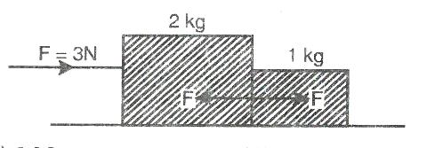Two blocks of masses 2kg and 1kg are placed on a smooth horizontal surface in contact with each other. A horizontal force of 3N is applied on the first so that the block moves with constant acceleration. The force between the blocks is:

a. 3N b. 2N c. 1N d. Zero

1. 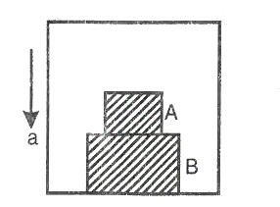An elevator is moving downwards with a uniform acceleration of 2 ms-2. Two blocks A and B are placed on its floor as shown in the Fig. The force exerted by the block A on B if the mass of A is 2kg is (g = 10 ms-2) :

a. 20N

b. 4N

c. 16N

d. 12N

1. A man of mass 90 kg is standing in an elevator whose cable broke suddenly. If the elevator falls freely, the force exerted by the floor on the man is(g = 10 ms-2):

a. 90 N b. Zero c.900 N d. None of these

1. On a smooth plane surface two blocks A and B are placed in contact. A force of 15N acts on A. If mass of B is twice that of A, the force on B is:

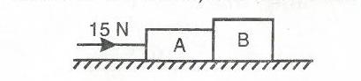

a. 30N b. 15 N c. 10N d. 5N

1. Three blocks of masses 1 kg, 6 kg and 3 kg are connected by a massless string passing over two frictionless pulleys attached at the two opposite ends of a smooth horizontal surface as shown. What is the acceleration of the system?

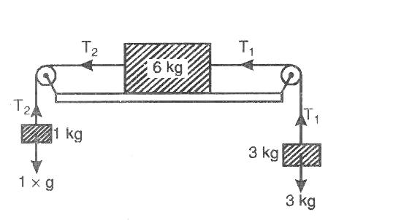 (g = 10 ms-2)

a. 1 ms-2 b. 2 ms-2 c. 3 ms-2 d. 4 ms-2

1. The force required to just move a body up the plane is double than the force required to just prevent the body from sliding down the plane. If the coefficient of friction is µ, the inclination of the plane is

a. b.  c.  d. 

1. A stationary bomb explodes into three pieces. One piece of 2kg mass moves with a velocity of

8 ms-1at right angles to the other piece of mass 1kg moving with a velocity of 12ms-1. If the mass of the third piece is 0.5kg,then the velocity of the third piece is

a.10 ms-1 b. 20 ms-1 c. 30 ms-1 d. 40 ms-1

1. A man weighs 80kg. He stands on a weighing scale in the lift, which is moving upwards with a uniform acceleration of 5ms-2.What would be the reading on the scale? (g= 10 ms-2)

a. Zero b. 400N c. 800N d. 1200N

1. A curved road of 50m in radius is banked to a correct angle for a given speed. If the speed is to be doubled keeping the banking angle to be the same the radius of curvature of the road should be changed by:

a.50 m b.150 m c.200 m d.100 m.

1. What is the maximum speed at which a car can turn round a curve of 30m radius on a level road, if the coefficient of friction between the tyres and the road is 0.4 and g = 10 ms-2?

a.5 ms-1 b. 21 ms-1 c. 11 ms-1 d. 17 ms-1

1. A cyclist riding at a speed of 9.8ms-1 takes a circular turn of radius 19.6m, what is his inclination to the vertical?

a. 30° b. 45° c. 10.5° d. 26.5°

1. A 1kg stone is tied to the end of massless string of 1m length. It is whirled in a vertical circle at a constant speed of 4 ms-1.If the tension in the string is 6N, what is the position of the stone?

(g = 10 ms-2)

a. At the bottom of the circle b. At the top of the circle

c. At the middle point of circle d. At a height of the radius.

1. An object of mass 10kg moves at a constant speed of 10 ms-1. A constant force, that acts for 4sec on the object, gives it a speed of 2 ms-1in opposite direction. The force acting on the object is

a. -3N b. -30N c. 3N d.30N

1. A player stops a football weighing 0.5kg which comes flying towards him with a velocity of 10m/s. If the impact lasts for 1/50th sec. and the ball bounces back with a velocity of 15m/s, then the average force involved is

a. 250 N b. 1250N c. 500N d. 625 N

1. A machine gun has a mass 5kg. It fires 50gram bullets at the rate of 30 bullets per minute at a speed of 400 ms-1. What force is required to keep the gun in position?

a. 1ON b. 5N c. 15N d. 30N

1. 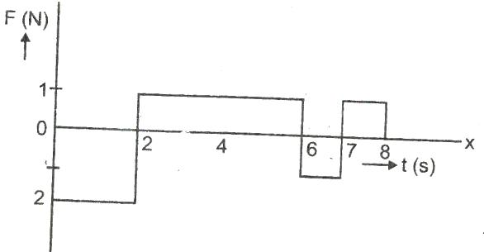A force time graph for the motion of a body is shown in Fig. Change in linear momentum between 0 and 8s is

a. Zero b. 4 N-s c. 8 Ns d. None of these

1. A particle of mass 10kg is moving in a straight line. If its displacement, x with time t is given by,then the force acting on it at the end of 4second is
2. 24N b. 240N c. 300N d. 1200N
3. A particle of mass m moving eastward with a speed v collides with another particle of the same mass moving northward with the same speed v. The two particles coalesce on collision. The new particle of mass 2m will move in the north-east direction with a velocity:

a. v/2 b. 2v c. v/ d. None of these

1. Starting from rest, a body slides down a 450 inclined plane in twice the time it takes to slide down the same distance in the absence of friction. The coefficient of friction between the body and the inclined plane is:

a. 0.33 b. 0.25 c. 0.75 d. 0.80

1. A force of 10N acts on a body of mass 20kg for 10seconds.Change in its momentum is

a. 5 kg m/s b. 100 kg m/s c. 200 kg m/s d. 1000 kg m/s

1. Two mass m and 2m are attached with each other by a rope passing over a frictionless and massless pulley. If the pulley is accelerated upwards with an acceleration ‘a’, what is the value of T?

a. b. c. d.

1. 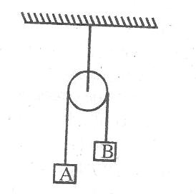Blocks A and B of masses 15kg and 10kg, respectively, are connected by a light cable passing over a frictionless pulley as shown below. Approximately what is the acceleration experienced by the system?

a. 2.0 ms-2

b. 3.3 ms-2

c. 4.9 ms-2

d. 9.8 ms-2

1. A 50kg ice skater, initially at rest, throws a 0.15kg snowball with a speed of 35m/s. What is the approximate recoil speed of the skater?

a. 0.10m/s b. 0.20m/s c. 0.70m/s d. 1.4m/s

1. Block A is moving with acceleration A along a frictionless horizontal surface. When a second block, B is placed on top of Block A the acceleration of the combined blocks drops to 1/5 the original value. What is the ratio of the mass of A to the mass of B?

a. 5:1 b. 1:4 c. 3:1 d. 2:1

1. A bullet is fired from a gun. The force on the bullet is given by .

Where, F is in newton and t is in second. The force on the bullet becomes zero as soon as it leaves the barrel. What is the average impulse imparted to the bullet?

a. 1.8 N-s b. Zero c. 9 N-s d. 0.9 N-s

1. A 0.1kg block suspended from a massless string is moved first vertically up with an acceleration of 5 ms-2 and then moved vertically down with an acceleration of 5 ms-2 . If  and  are the respective tensions in the two cases, then

a. b. , if g = 10ms-2

c.  d. , if g = 9.8 ms-2

1. A rifle man, who together with his rifle has a mass of 100kg, stand on a smooth surface and fires 10 shots horizontally. Each bullet has a mass 10g and muzzle velocity of 800 ms-1. The velocity which the rifle man attains after firing 10 shots is

a.8 ms-1 b. 0.8 ms-1 c. 0.08 ms-1 d. -0.8 ms-1

1. The coefficient of friction between two surfaces is 0.2. the angle of friction is

a. b.  c.  d. 

1. A block of mass 4 kg rests on an inclined plane. The inclination to the plane is gradually increased. It is found that when the inclination is 3 in 5, the block just begins to slide down the plane. The coefficient of friction between the block and the plane is

a. 0.4 b. 0.6 c. 0.8 d. 0.75

1. A rider on a horse back falls forward when the horse suddenly stops. This is due to

a. Inertia of horse b. Inertia of rider

c. Large weight of the horse d. Losing of the balance

1. A body of mass 2kg is placed on a horizontal surface having kinetic friction 0.4 and static friction 0.5. If the force applied on the body is 2.5N, then the frictional force acting on the body will be

[ g = 10 ms-2]

a. 8N b. 10N c. 20N d. 2.5N

1. A rocket of mass 5000kg is to be projected vertically upward. The gases are exhausted vertically downwards with velocity 1000 ms-2 with respect to the rocket. What is the minimum rate of burning the fuel so as to just lift the rocket upwards against gravitational attraction?

a. 49kgs-1 b. 147 kg s-1 c. 98kg s-1 d. 196kg s-1

1. A bucket tied at the end of a 1.6m long string is whirled in a vertical circle with constant speed. What should be the minimum speed so that the water from the bucket does not spill when the bucket is at the highest position?

a. 4m/sec b. 6.25m/sec c. 16m/sec d. None of these

1. 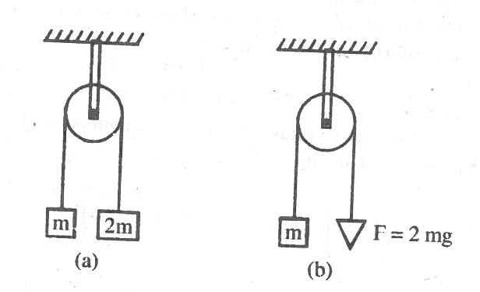Two pulley arrangements of figure given are identical. The mass of the rope is negligible. In fig (a). The mass m is lifted by attaching a mass 2m to the other end of the rope. In fig (b), m is lifted up by pulling the other end of the rope with a constant downward force F = 2mg. The acceleration of m in the two cases are respectively.

a. 3g, g b. g/3, g

c. g/3,2g d. g, g/3

1. Three blocks of masses,  and  are connected by massless strings , as shown, on a frictionless table. They are pulled with a force  = 40 N. If  = 10kg, = 6kg and

 = 4kg, the tension T2 will be

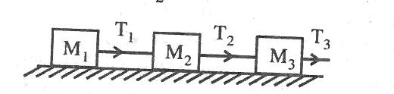

a. 20N b. 40N c. 10N d. 32N

1. A student attempts to pull himself up by tugging on his hair. He will not succeed.

a. As the force exerted is small.

b. The frictional force while gripping is small.

c. Newton’s law of inertia is not applicable to living beings

d. As the force applied is internal to the system

1. **Assertion**: The acceleration of a body down a rough inclined plane is greater than the acceleration due to gravity.

**Reason**: The body is able to slide on a inclined plane only when its acceleration is greater than the acceleration due to gravity.

a. Assertion and reason are true and the reason is the correct explanation of the assertion.

b. Both assertion and reason are true but reason is not correct explanation of the assertion.

c. Assertion is true but reason is false.

d. Assertion and reason both are false

1. An explosion blows a rock into three parts. These two are, 1kg first part moving with a velocity of 12ms-1 and 2kg second part moving with a velocity of 8ms-1. If the third part flies off with a velocity of 4ms-1, its mass would be **[NEET 2013]**
2. 5kg b. 7kg c. 17kg d.3kg
3. A rigid ball of mass m strikes a rigid wall at 600 and gets reflected without loss of speed as shown in the figure below. The value of impulse imparted by the wall in the ball will be

 **[NEET 2016]**

1.  b. mV c. 2mV d. $\frac{mV}{2}$
2. Three blocks with masses m, 2m and 3m are connected by strings, as shown in figure. After an upward force F is applied on block m, the masses move upward at constant speed v. What is the net force on the block of mass 2m (g is the acceleration due to gravity) **[NEET 2013]**



1. 6mg b. Zero c. 2 mg d. 3mg
2. Two blocks A and B of masses 2m and m, respectively, are connected by a massless and inextensible string. The whole system is suspended by a massless spring as shown in the figure. The magnitudes of acceleration of A and B, immediately after the string is cut, are respectively **[NEET 2017]**

a**.** g, g/2 b. g/2 ,g

c. g ,g d. g/2 ,g/2

1. 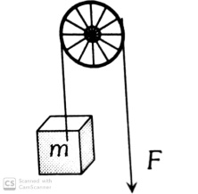A block of mass m(=0.1 kg) is hanging over a frictionless light fixed pulley by an inextensible string of negligible mass. The other end of the string is pulled by a constant force F in the vertically downward direction. The linear momentum of the block increase by 2kgms-1 in 1s after the block starts from rest. Then, (given g=10ms-2) **[WB –JEE 2013]**

a. The tension in the string is F

b. The tension in the string is 3N

c. The work done by the tension on the block is 20J during this 1s

d. The work done against the force of gravity is 10 J

1. A block of mass m is placed on a smooth inclined wedge ABC of inclination  as shown in the figure. The wedge is given an acceleration ‘a’ towards the right. The relation between ‘a’ and ‘’ for the block to remain stationary on the wedge is **[NEET 2018]**

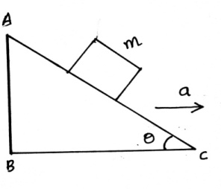a.

b.

c.

d.

1. A moving block having mass m collides with another stationary block having mass 4m. The lighter block comes to rest after collision . when the initial velocity of the lighter block is v, then the value of coefficient of restitution(e) will be  **[NEET 2018]**

a. 0.5 b. 0.8 c. 0.25 d. 0.4

1. A body initially at rest and sliding a frictionless track from a height h (as shown in the figure) just completes a vertical circle of diameter AB=D. The height h is equal to **[NEET 2018]**

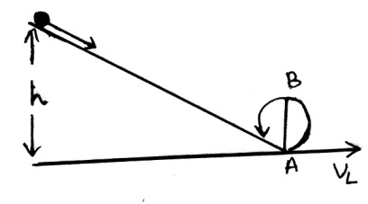

1. Which of the statements is incorrect**[NEET 2018]**

a. Frictional force opposes the relative motion

b. Limiting value of static friction is directly proportional to normal reaction.

c. Rolling friction is smaller than sliding friction.

d. Coefficient of sliding friction has dimensions of length.

1. A mass m is attached to a thin wire and whirled in a vertical circle. The wire is most likely to break down when **[NEET 2019]**

a. The mass is at the horizontal. b. The wire is horizontal

c. The mass is at the lowest point. d. Inclined at an angle of 600 from vertical.

1. When an object is shot from the bottom of a long smooth inclined plane kept at an angle 600 with horizontal, it can travel a distance x1 along the plane. But when the inclination is decreased to 300 and the same object is shot with the same velocity, it can travel x2 distance. Then x1:x2 will be , **[NEET 2019]**

a.  b.  c.  d. 

1. A block of mass 10kg is in contact against the inner wall of a hollow cylindrical drum of radius 1m. The coefficient of friction between the block and the inner wall of the cylinder is 0.1. The minimum angular velocity needed for the cylinder to keep the block stationary when the cylinder is vertical and rotating about its axis, will be : (g=10 m/s2)**[NEET 2019]**

a.  b.  c. 10 rad/s d. 

1. During in elastic collision between two objects. Which of the following quantity always remain conserved? **[KCET 2019]**

a. Total mechanical energy. b. Speed of each body.

c. Total kinetic energy d. Total linear momentum

1. A block rests on a rough inclined plane making an angle of 300 with the horizontal. The coefficient of static friction between the block and the plane is 0.8. If the frictional force on the block is 10N, the mass of the block is (g=10ms-2) **[KCET 2018]**

a. 1kg b. 2kg c. 3kg d.4kg

1. Two particles of masses m1 and m2 have equal kinetic energies. The ratio of their moments is

**[KCET 2018]**

a. $m_{1}:m_{2}$ b. $m_{2}:m_{1}$ c. ${\sqrt{m}}_{1}$: ${\sqrt{m}}_{2}$ d. $m_{1}^{2}$: $m_{2}^{2}$

1. A man weighing 60kg is in a lift moving down with an acceleration of 1.8m/s2. The force excited by the floor on him is **[KCET 2018]**
   1. 588N b. 480N c. Zero d. 696N
2. A car is negotiating a curved road of radius R. The road is banked at an angle ‘’. The coefficient of friction between the tyres of the car and the road is $μ_{s}$. The maximum safe velocity on this road is **[NEET (PHASE 1) 2016]**

 

 

1. The upper half of an inclined plane of inclination  is perfectly smooth while the lower half is rough. A body starting from the rest at top comes back to rest at the bottom if the coefficient of friction for the lower half is given by **[NEET 2017]**

 

1. Three blocks A, B and C of masses 4kg, 2kg and 1kg respectively, are in contact on a frictionless surface, as shown. If a force of 14N is applied on the 4kg block then the contact force between A and B is **[AIPMT 2015]**

a) 6N b) 8N

c)18N d) 2N

1. The figure shows the position time (x-t) graph of one dimensional motion of a body of mass 0.4kg. The magnitude of each impulse is **[AIEEE 2010]**

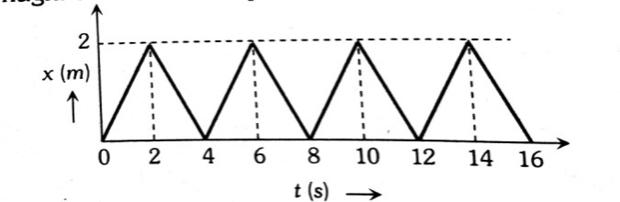

a) 0.2Ns b) 0.4Ns

c) 0.8Ns d)1.6Ns

**WORK, ENERGY AND POWER**

**UNIT NO. : P – 04**

1. A particle moving in the *xy* plane undergoes a displacement of $\vec{s }$ = (2 $\hat{i}$ + 3 $\hat{j}$) while a constant force $\vec{F }$ = (5 $\hat{i}$ + 2 $\hat{j})$) N acts on the particle. The work done by the force F is

a. 17 joule b. 18joule c. 16joule d. 15joule

1. When a $U^{238}$ nucleus, originally at rest, decays by emitting an $α$-particle, say with speed of v m/sec, the recoil speed of the residual nucleus is (in m/sec.)

a. -4v/234 b. -4v/238 c. 4v/238 d. –v/4

1. A spring of force constant 800N/m has an extension of 5cm. The work done in extending it from 5cm to 15cm is

a. 16J b. 8J c. 32J d. 24J

1. The work done in stretching a spring of force constant k from length $l_{1}and$ $l_{2}$ is

a. k ( $l_{2}^{2}$- $l_{1}^{2}$) b. $\frac{1}{2}$ k ( $l_{2}^{2}$- $l_{1}^{2}$) c. k $(l_{2}-$ $l_{1}$) d. $\frac{k}{2}$ $(l_{2}+$ $l_{1}$)

1. If the force acting on a body is inversely proportional to its velocity, the kinetic energy acquired by the body in time t is proportional to

a. $t^{0}$ b. $t^{1}$ c. $t^{2}$ d. $t^{4}$

1. The engine of a truck moving along a straight road delivers constant power. The distance travelled by the truck in time t is proportional to

a. t b. $t^{2}$ c. $\sqrt{t}$ d. $t^{3/2}$

1. When the kinetic energy of a body is increased to three times, then the momentum increases.

a. 6 times b. 1.732 times c. $\sqrt{2}$ times d. 2 times

1. Two bodies of masses 2m and m have their KE in the ratio 8:1. What is the ratio of their momenta?

a. 8:1 b. 4:1 c. 2:1 d. 1:1

1. The potential energy of a system increases if work is done

a. Upon the system by a non conservative force.

b. By the system against a conservative force

c. By the system against a non conservative force

d. Upon the system by a conservative force.

1. A metallic wire of length L metre extends by $l$ metre when stretched by suspending a weight Mg from it. The mechanical energy stored in the wire is

a. 2Mg $l$ b. Mg $l$ c. $\frac{Mg l }{2}$ d. $\frac{Mg l }{4}$

1. A particle moves under the effect of a force F = *cx* from *x* = 0 to *x* = $x_{1}$, the work done in the process is

a. ${cx}_{1}^{2}$ b. $\frac{1}{2}{cx}_{1}^{2}$ c. 2 ${cx}_{1}^{2}$ d. Zero

1. A block is acted upon by a force, which is inversely proportional to the distance covered (x). The work done will be proportional to
2. x b.  c. d. None of these
3. A small body is projected in a direction inclined at 45 $°$ to the horizontal with kinetic energy K. At the top of its flight, its kinetic energy will be

a. Zero b. K/2 c. K/4 d. 

1. A cord is used to lower vertically a block of mass M, through a distance d at a constant downward acceleration of g/8. Then the work done by the cord on the block is

a. Mg d/8 b. 3Mg d/8 c. Mg d d. -7 mg d/8

1. Consider the following two statement:

I. Linear moment of a system of particles is zero.

II. Kinetic energy of a system of particles is zero.

Then

a. I implies II but II does not imply I b. I does not imply II but II implies I

c. I implies II and II implies I d. I does not imply II and II does not imply I

1. A ball is dropped from a height h. If the coefficient of restitution be e, then to what height will it rise after jumping twice from the ground?

a. e h/2 b. 2 e h c. e h d. h

1. A ball of mass m moving with a constant velocity strikes against a ball of same mass at rest.

If e = coefficient of restitution, then what will be the ratio of velocity of two balls after collision?

1.  b.  c.  d. 
2. A crane is used to lift 1000kg of coal from a mine 100m deep. The time taken by the crane is 1 hour. The efficiency of the crane is 80%. If g = 10ms-2 , then the power of the crane is.
3.  b.  c.  d. 
4. 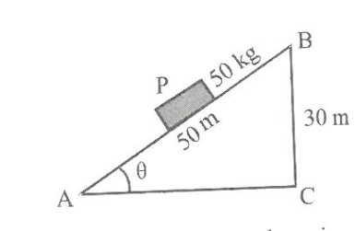In figure, a carriage P is pulled up from A to B. The relevant coefficient of friction is 0.40. The work done will be

a. 10kJ

b. 23kJ

c. 25kJ

d. 28Kj

1. A body of mass m moving with velocity v makes a head on elastic collision with another body of mass 2m which is initially at rest. The loss of kinetic energy of the colliding body (mass m) is

a. of its initial kinetic energy b. of its initial kinetic energy

c.  of its initial kinetic energy d.  of its initial kinetic energy

1. In the non-relativistic regime, if the momentum is increase by 100%, the percentage increase in kinetic energy is

a. 100 b. 200 c. 300 d. 400

1. A body is dropped from height of 20m and rebounds to a height 10m. The loss of energy is

a. 10% b. 45% c. 50% d. 75%

1. 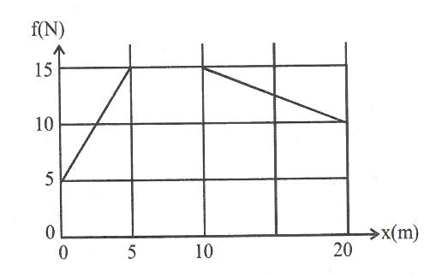Figure here shows the frictional force versus displacement for a particle in motion. The loss of kinetic energy in travelling over s = 0 to 20 m will be

a. 250J b. 200J

c. 150J d. 10J

1. Hail storms are observed to strike the surface of the frozen lakes at 30 $°$ with the vertical and rebound at 60 $°$ with the vertical. Assume contact to be smooth, the coefficient of restitution is

a.  b.  c.  d. e = 3

1. The potential energy of a conservative system is given by , where y represents the position of the particle and a as well as b are constants. What is the force acting on the system?

a. –ay b. –by c. 2ay-b d. b -2ay

1. An automobile engine of mass M accelerates and a constant power p is applied by the engine. The instantaneous speed of the engine will be
2.  b.  c.  d. 
3. A particle, initially at rest on a frictionless horizontal surface, is acted upon by a horizontal force which is constant in magnitude and direction. A graph is plotted of the work done on the particle W, against the speed of the particle v. If there are no other horizontal forces acting on the particle, the graph would look like.

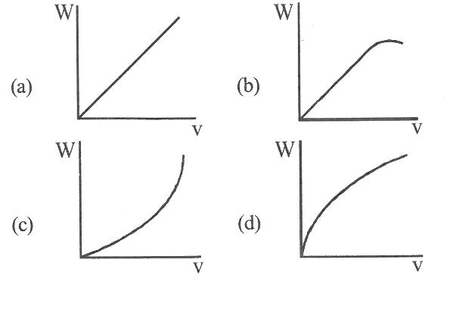

1. A particle of mass m moving eastward with a speed v collides with another particle of the same mass moving northwards with the same speed If two particles coalesce on collision, the new particle of mass 2 m will move in the north-east direction with a velocity

a. v / 2 b.  c.  d. none of these

1. A small block of mass m is kept on a rough inclined surface of inclination θ fixed in an elevator. The elevator goes up with a uniform velocity v and the block does not slide the wedge. The work done by the force of friction on the block in time t as seen by the observer on the inclined lane will be

a. zero b. mgvt c.mgvt  d. mgvt sin 2

1. Two masses and moving with velocities and in opposite direction collide elastically and after the collision and with velocities  and respectively. Then the ratio  /  is
2.  b. c. 1 d. 
3. Two blocks of masses 10 kg and 4 kg are connected by a spring of negligible mass and placed on a frictionless horizontal surface. An impulse gives a velocity of 14 m/s to the heavier block in the direction of the lighter block. The velocity of the centre of mass is

a. 30 m/s b. 20 m/s c. 10m/s d. 5m/s

1. 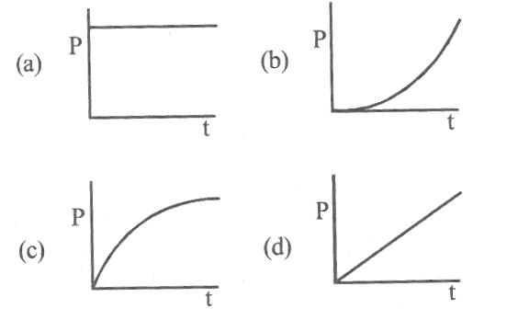A motor drives a body along a straight line with a constant force. The power P developed by the motor must vary with time t according to
2. The forces F acting on a body moving in a circle of radius r is always perpendicular to the instantaneous velocity v. The work done by the force on the body in half rotation is

a. Fv b.  c. Fr d. 0

1. The negative of the distance rate of change of potential energy is equal to

a. Force acting on the particle in the direction of displacement

b. Acceleration of the particle, perpendicular to displacement

c. Power

d. Impulse

1. The ball rolls down without slipping (which is at rest at a) along ab having friction. It rolls to a maximum height  where bc has no friction. , and  are kinetic energies at a, b and c.

Which of the following is correct?

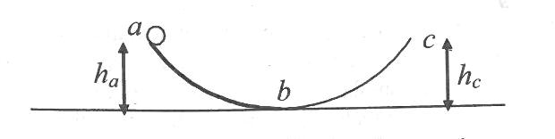

a. b.  c.  d. 

1. If v be the instantaneous velocity of the body dropped from the top of a tower, when it is located at height h, then which of the following remains constant?

a. $gh + v^{2}$ b. $gh + \frac{v^{2}}{2}$ c. $gh - \frac{v^{2}}{2}$ $d. gh - v^{2}$

1. In a simple pendulum of length $l$ the bob is pulled aside from its equilibrium position through an angle $θ$ and then released. The bob passes through the equilibrium position with speed

a. $\sqrt{2g l(1+cos⁡θ )}$ b. $\sqrt{(2g l sin⁡θ )}$ c. $\sqrt{2g l}$ d. $\sqrt{2g l(1-cos⁡θ )}$

1. A stationary particle explodes into two particles of masses $m_{1}$ and $m_{2}$ which move in opposite direction with velocities $v_{1}$ and $v_{2}$. The ratio of their kinetic energies $E_{1}$/ $E_{2}$ is

a. $m_{1}v_{2}$/ $m_{2}v_{1}$ b. $m_{2}$/ $m_{1}$ c. $m_{1}$/ $m_{2}$ d. 1

1. An explosion breaks a rock into three parts in a horizontal plane. Two of them go off at right angles to each other. The first part of mass 1 kg moves with a speed of ${12 ms}^{-1}$ and the second part of mass 2 kg moves with speed ${8 ms}^{-1}$. If the third part flies off with speed ${4 ms}^{-1}$ then its mass is

a. 5 kg b. 7 kg c. 17 kg d. 3 kg

1. If the kinetic energy of a body is increased by 300%, the momentum of the body is increased by

a. 300% b. 200% c. 100% d. 50%

**PREVIOUS APPEARED QUESTIONS**

1. During inelastic collision between two objects, which of the following quantity always remains conserved? **[CET 2019]**

a. Total mechanical energy b. Speed of each body

c. Total kinetic energy d. Total linear momentum

1. A force F = 20 + 10 y acts on a particle in y-direction where F is in newton and y in meter. Work done by this force to move the particle from y=0 to y=1m is **[ NEET 2019]**

a. 30J b. 5J c. 25J d. 20J

1. A moving block having mass m, collides with another stationary block having mass 4m. The lighter block comes to rest after collision. When the initial velocity of the lighter block is v, then the value of coefficient of restitution (e) will be **[NEET 2018]**

a. 0.8 b. 0.25 c. 0.5 d. 0.4

1. Consider a drop of rain water having mass 1 g falling from a height of 1 km. It hits the ground with a speed of 50 m/s. Take g constant with a value 10 m/s2. The work done by the (i) gravitational force and the (ii) resistive force of air is  **[NEET 2017]**

a. (i) -10J , (ii) -8.25J b. (i) 1.25J , (ii) -8.25J

c. (i) 100J , (ii) 8.75J d. (i) 10J , (ii) -8.75J

1. Two identical balls A and B having velocities of 0.5 m/s and -0.3 m/s respectively collide elastically in one dimension. The velocities of B and A after the collision respectively will be **[NEET 2016]**

a. -0.5 m/s and 0.3 m/s b. 0.5 m/s and -0.3 m/s

c. -0.3 m/s and 0.5 m/s d. 0.3 m/s and 0.5 m/s

1. A particle moves from a point to when a force of N is applied. How much work has been done by the force? **[NEET 2016]**

a. 8J b. 11J c. 5J d. 2J

1. A body of mass 1 kg begins to move under the action of a time dependent force , where i and j are unit vectors along x and y axis. What power will be developed by the force at the time t? **[NEET 2016]**

a. ( ${2t}^{2}$ + ${3t}^{3})W$ b. ( ${2t}^{2}$ + ${4t}^{4})W$ c. ( ${2t}^{3}$ + ${3t}^{4})W$ d. ( ${2t}^{3}$ + ${3t}^{5})W$

1. The heart of a man pumps 5 litres of blood through the arteries per minute at a pressure of 150 mm of mercury. If the density of mercury be 13.6 x 103 kg/m3 and g = 10 m/s2 then the power of heart in watt is: **[NEET 2015]**

a. 1.50 b. 1.70 c. 2.35 d. 3.0

1. A block of mass m, lying on a smooth horizontal surface, is attached to a spring (of negligible mass) of spring constant k. The other end of the spring is fixed. The block is initially at rest in its equilibrium position. If now the block is pulled with a constant force F, the maximum speed of the block is **[JEEMAINS 2019]**

a. b.  c.  d. 

1. Three blocks A, B and C are lying on a smooth horizontal surface. A and B have equal masses, m while C has mass M. Block A is given an brutal speed v towards B due to which it collides with B perfectly inelastically. The combined mass collides with C, also perfectly in elastically of the initial kinetic energy is lost in whole process. What is value of M/m? [**JEEMAINS 2019]**

a. 4 b.5 c. 3 d. 2

1. A force acts on a 2 kg object so that its position is given as a function of time as. What is the work done by this force in first 5 seconds? **[JEEMAINS 2019]**

a. 850J b. 900J c. 950J d.875J

1. A particle which is experiencing a force, given by, undergoes a displacement of.  If the particle had a kinetic energy of 3 J at the beginning of the displacement, what is its kinetic energy at the end of the displacement ? **[JEEMAINS 2019]**

a. 15J b. 10J c. 12J d. 9J

1. A block of mass m is kept on a platform which starts from rest with constant acceleration g/2 upward. Work done by normal reaction on block in time t is : **[JEE MAINS 2019]**

a. 0 b.  c.  d. 

1. A body of mass 1 kg falls freely from a height of 100 m on a platform of mass 3 kg which is mounted on a spring having spring constant k = 1.25 x 106 N/m. The body sticks to the platform and the spring's maximum compression is found to be x. Given that g = 10 ms-2, the value of x will be close to : **[JEEMAINS 2019]**

a. 4 cm b. 8 cm c. 80 cm d. 40 cm

1. An alpha-particle of mass m suffers l-dimensional elastic collision with a nucleus at rest of unknown mass. It is scattered directly backwards losing, 64% of its initial kinetic energy. The mass of the nucleus is **[JEEMAINS 2019]**

a. 4m b. 3.5m c. 2m d. 1.5m

1. A person trying to lose weight by burning fat lifts a mass of 10 kg upto a height of l m 1000 times. Assume that the potential energy lost each time he lowers the mass is dissipated. How much fat will he use up considering the work done only when the weight is lifted up? Fat supplies 3. 8 x l07 J of energy per kg which is converted to mechanical energy with a 20% efficiency rate. **[JEEMAINS 2016]**

a.  b.  c.  d. 

1. A time dependent force F = 6t acts on a particle of mass 1 kg. If the particle starts from rest, the work done by the force during the first 1 second will be **[JEEMAINS 2017]**

a. 4.5J b. 22J c. 9J d. 18J

1. In a collinear collision, a particle with an initial speed v0 strikes a stationary particle of the same mass. If the final total kinetic energy is 50% greater than the original kinetic energy, the magnitude of the relative velocity between the two particles, after collision, is :

**[JEEMAINS 2018]**

a.  b.  c.  d. 

1. A body of mass m starts moving from rest along x axis so that its velocity varies as where a is a constant and s is the distance covered by the body. The total work done by all the forces acting on the body in the first t seconds after the start of the motion is :

**[ JEE MAINS 2018]**

a. b.c.  d. 

1. Two particles of the same mass m are moving in circular orbits because of force given by . The first particle is at distance r = 1 and the second at r = 4. The best estimate for the ratio of kinetic energies of the first and the second particle is closest to:

**[JEE MAINS 2018]**

1.  b.  c. d. 

**SYSTEM OF PARTICLES AND ROTATIONAL MOTION**

**UNIT NO. : P – 05**

1. A child is standing at one end of a long trolley moving with a speed v on a smooth horizontal track. If the child starts running towards the other end of the trolley with a speed u, the centre of mass of the system (trolley + child) will move with a speed

a) zero b) (v + u) c) (v - u) d) v

1. Three point masses m1, m2 and m3 are located at the vertices of an equilateral triangle of side a. What is the moment of inertia of the system about an axis along the altitude of the triangle passing through m­­­1?
   1.  b)  c)  d) 
2. A carpet of mass M, made of an inextensible material, is rolled along its length in the form of a cylinder of radius R and kept on a rough floor. If the carpet is unrolled, without sliding, to a radius R/2, the decrease in potential energy is
   1. MgR b) MgR c) MgR d) MgR
3. A circular ring of mass M and radius R is rotating about its axis at an angular frequency. Two blocks, each of mass m, are gently placed on the opposite ends of a diameter of the ring. The angular frequency of the ring becomes. The ratio /  is

a)  b)  c)  d) 

1. Two particles of the same mass move in the x-y plane with velocities 2 ms-1 and 3ms-1 . The first particle is given an acceleration (2+2)ms-2  and the second particle is given an acceleration (2+ 4)ms-2. The centre of mass of the system of two particles will move along a
   1. Straight line b) circle c) ellipse d) parabola
2. Three rods, each of mass M and length L, are welded together to form an equilateral triangle. The moment of inertia of the triangular frame about an axis passing through its centroid and perpendicular to its plane is
   1.  b)  c)  d) 
3. A car of mass 1000 kg is moving with a velocity of 10 ms-1 towards another car of mass 1500 kg moving with a velocity of 15 ms-1 in the same direction. Find the velocity of the centre of mass of the two cars.
   1. 13 m/s b) 20 m/s c) 25 m/s d) 30 m/s
4. A force F = (2+3) newton acts on a particle whose position vector with respect to origin O is metre. Find the magnitude and direction of the torque.

a) 22Nm along positive Z axis b) 22Nm along negative Z axis

c) 35 Nm along positive Z axis d) 35 Nm along negative Z axis

1. A particle of mass m is moving in a horizontal circle of radius r with kinetic energy K and time period T. The magnitude of the angular momentum of the particle about the centre of the circle will be
   1.  b)  c)  d) 
2. The radius of gyration K of a hollow sphere of mass M and radius R about a certain axis is equal to R. Find the distance of that axis from the centre of the sphere.

a)    

1. Two circular discs have masses in the ratio of 1:2 and radii in the ratio of 2:1. The ratio of their moments of inertia about their diameter is
   1. 1:1 b) 2:1 c) 4:1 d) 8:1
2. A solid sphere rolls down from the top of an inclined plane. Its velocity on reaching the bottom of the plane is v. When the same sphere slides down from the top of the plane, its velocity on reaching the bottom is. The ratio /v is
   1.  b) 1 c)  d) 
3. A solid sphere, disc and solid cylinder all of the same mass and made of the same material are allowed to roll down(from rest) on an inclined plane, then

a) Solid sphere reaches the bottom first b) Solid sphere reaches the bottom last

c) Disc will reach the bottom first d) All reach the bottom at the same time.

1. A hemispherical bowl of radius R is kept on a horizontal table. A small sphere of radius r (r < < R) is placed at the highest point at the inside of the bowl and let go. The sphere rolls without slipping. Its velocity at the lowest point is
   1.  b)  c)  d) 
2. 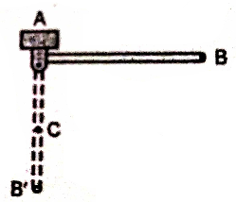One end of the uniform rod of length *l* and mass m is hinged at A. It is released from rest from horizontal position AB as shown in Fig. The force exerted by the rod on the hinge when it becomes vertical is
   1.  b) 

c) 5 mg d) 

1. A uniform rod of mass m and length *l* is suspended by means of two light inextensible strings as shown in Fig. Tension in one string immediately after the other string is cut is
   1. 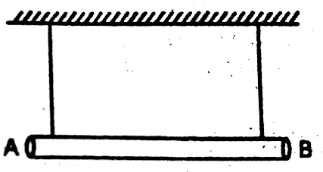 b) mg

c) 2 mg d) 

1. 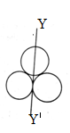Three rings each of mass m and radius R are arranged as shown in the figure. The moment of inertia of the system about Yis

a)3MR b)  MR2

c) 5 MR2 d) MR2

1. A rod of length L is non – uniform. Its mass per unit length varies linearly with distance from left end. Then its centre of mass from left end is at a distance

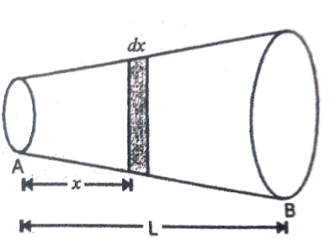( take linear density at left end = 0).

* 1.  b) 

c)  d) 

1. A comet moves in an elliptical orbit with an eccentricity of e = 0.20 around a star. The distance between the perihelion and the aphelion is 1.0 x 108 km. If the speed of the comet at perihelion is 81 km/s, then the speed of the comet at the aphelion , is

a) 182 km/s b) 36 km/s c) 121.5/km/s d) 54 km/s

1. 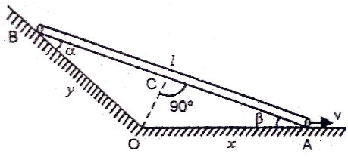A rod of length *l* slides down along the inclined wall as shown in Fig. At the instant when the speed of end A is v, then speed of B is

a)  b) 

c)  d) 

1. 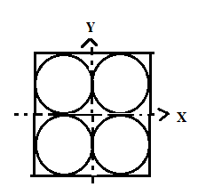Four holes of radius R are cut from a thin square plate of side 4R and mass M. The moment of inertia of the remaining portion about z – axis is
   1.  b) 

c)  d) 

1. 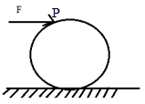A uniform solid cylinder of mass m and radius R is placed on a rough horizontal surface. A horizontal constant force F is applied at the top point P of the cylinder so that it starts pure rolling. The acceleration of the cylinder is
   1. F/3 m b) 2 F/3 m

c)  d) 5 F/3 m

1. A rigid rod is rotating as well as translating on a smooth horizontal surface. The velocities of its ends at any moment are as shown below. If 600, the value of v2 is
   1. 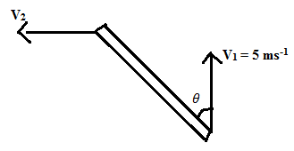8.7 ms-1 b) 5.0 ms -1

c) 4.0 ms -1 d) 2.9 ms -1

1. A particle moves along a circle of radius m with constant tangential acceleration. If the velocity of the particle is 80 ms-1 at the end of the second revolution after motion has begun, the tangential acceleration is.
   1. 640 ms-2 b) 160 ms-2 c) 40 ms-2 d) 40 ms-2
2. A uniform cylinder has a radius R and length L. If the moment of inertia of this cylinder about an axis passing through its centre and normal to its circular face is equal to the moment of inertia of the same cylinder about an axis passing through its centre and normal to its length; then,
   1. L = R b) L = $√3R$ c) L = $\frac{R}{√3}$ d) L = 0
3. Two spheres each of mass M and radius R/2 are connected with a massless rod of length 2R as shown. What will be the moment of inertia of the system about an axis passing through the centre of one of the spheres and perpendicular to the rod
   1. 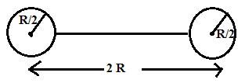 b) 

c)  d) 

1. A solid sphere is rolling on a frictionless surface, as shown below, with a translational velocity

*v* ms-1. If sphere climbs up to height h then value of v should be

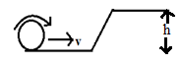a)  b) $≥$

c) 2 gh d) gh

1. A disc of moment of inertia  is rotating at 600 rpm. If the frequency of rotation changes from 600 rpm to 300 rpm, then the work done is
   1. 1467 J b) 1452 J c) 1567 J d) 1632 J
2. The angular speed of a body changes from to  without applying a torque but due to change in its moment of inertia. The ratio of radii of gyration in the two cases is
   1.  b)  c)  d) 
3. A molecule consist of two atoms, each of mass m, separated by a distance a. If K is the average rotational kinetic energy of the molecule at room temperature, its frequency of rotation is
   1.  b)  c)  d) 
4. The moment of inertia of a rod ( length *l* , mass m ) about an axis perpendicular to the length of the rod and passing through a point equidistant from its midpoint and one end is
   1.  b)  c)  d) 
5. A rupee coin starting from rest rolls down a distance of 1 m on an inclined plane at an angle of 30° with the horizontal. Assuming that g = 9.81 m/s2, time taken is  
   a) 0.32 s b) 0.48 s c) 0.78 s d) 1.0 s
6. A circular plate of uniform thickness has a diameter of 56 cm. A circular portion of diameter

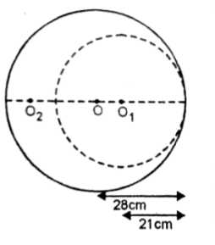42 cm is removed from one edge as shown in Fig. The centre of mass of the remaining portion from the centre of plate will be at

* 1. 5 cm

b) 7 cm

c) 9 cm

d) 11 cm

1. A long horizontal rod has a bead which can slide along its length, and initially placed at a distance L from one end A of the rod. The rod is set in angular motion about A with constant angular acceleration α. If the coefficient of friction between the rod and the bead is µ, and gravity is neglected, then the time after which the bead starts slipping is
   1.  b)

c)  d) none of these

1. 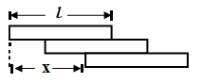Three identical bricks of length *l* are placed on the top of each other as shown in Fig. so that the part of each overhangs the one below. Find in terms of *l*, the maximum value of the total over- hung x.
   1.  b) 

c)  d) 

1. In the Fig(i) half of the meter scale is made of wood while the other half of steel. The wooden part is pivoted at 0. A force F is applied at the end of steel part. In figure(ii) the steel part is pivoted at 0 and the same force is applied at the wooden end
   1. more acceleration will be produced in(i)
   2. more acceleration will be produced in(ii)
   3. same acceleration will be produced in both conditions
   4. information is incomplete

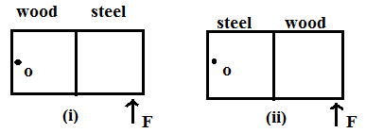

1. A circular disc of radius R and thickness $\frac{R}{6}$ has moment of inertia I about an axis passing through its centre and perpendicular to its plane. It is melted and recasted into a solid sphere. The moment of inertia of the sphere about its diameter as axis of rotation is
   1. I b) $\frac{2I}{8}$ c) $\frac{I}{5}$ d) $\frac{I}{10}$
2. A thin uniform circular ring is rolling down an inclined plane of inclination 300 without slipping. Its linear acceleration along the inclined plane will be
   1. g/2 b) g/3 c) g/4 d) 2g/3
3. A solid cylinder on moving with constant speed v0 reaches the bottom of an incline of 30°. A hollow cylinder of same mass and radius moving with the same constant speed v0 reaches the bottom of a different incline of $θ$. There is no slipping and both of them go through the same distance in the same time; $θ$ is then equal to  
   a) 37° b) 300 c) 42° d) 45°
4. 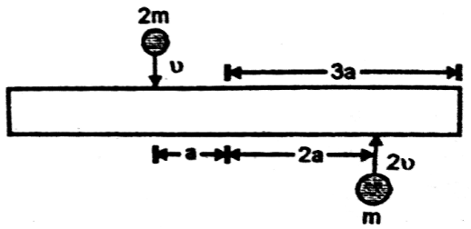A uniform bar of length 6 a and mass 8 m lies on a smooth horizontal table. Two point masses m and 2 m moving in the same horizontal plane with speeds 2 v and v respectively strike the bar as shown in Fig. and stick to the bar after collision. Denoting angular velocity about the centre of mass, total energy and centre of mass velocity by , E and vc respectively, we have after collision

a) vc= 0 b)  c)  d) 

1. A solid cylinder of mass 2kg and radius 4cm is rotating about its axis at the rate of 3rpm. The torque required to stop after 2π revolutions is

a) 12 x 10–4 Nm b) 2 x 106 Nm c) 2 x 10–6 Nm d) 2 x 10–3 Nm

1. A disc of radius 2m and mass 100kg rolls on a horizontal floor. Its centre of mass has a speed of 20cms–1. How much work is needed to stop it?

a)2J b) 1J c) 3J d) 30kJ

1. From a uniform circular disc of radius R and mass 9M, a small disc of radius  is removed as shown in the figure. The moment of inertia of the remaining disc about an axis perpendicular to the plane of the disc and passing through the centre of disc is

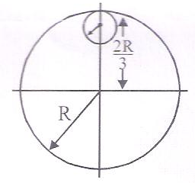a)  b) 

c)  d) 

1. 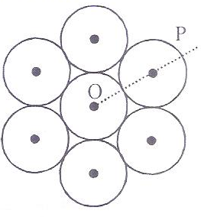Seven identical circular planar discs, each of mass M and radius R are welded symmetrically as shown. The moment of inertia of the arrangement about the axis normal to the plane and passing through the point P is

a)  b) 

c)  d) 

1. Three objects, A: (a solid sphere),

B: (a thin circular disc) and

C: (a circular ring), each have the same mass M and radius R. They all spin with the same angular speed ω about their own symmetry axes. The amounts of work (W) required to bring them to rest, would satisfy the relation

a) WA > WC > WB b)WC > WB > WA c) WB > WA > WC d)WA > WB > WC

1. A solid sphere is in rolling motion. In rolling motion, a body possesses translational kinetic energy (Kt) as well as rotational kinetic energy (Kr) simultaneously. The ratio Kt : (Kt +Kr) for the sphere is

a) 2 : 5 b) 7 : 10 c) 10 : 7 d) 5 : 7

1. A solid sphere is rotating freely about its symmetry axis in free space. The radius of the sphere is increased keeping its mass same. Which of the following physical quantities would remain constant for the sphere?

a) angular momentum b) angular velocity

c) rotational kinetic energy d) moment of inertia

1. The moment of the force at (2,0, –3) about the point (2, –2, –2) is given by

a)  b)  c)  d) 

1. A rope is wound around a hollow cylinder of mass 3kg and radius 40cm. What is the angular acceleration of the cylinder if the rope is pulled with a force of 30N?

a) 25m/s2 b) 0.25rad/s2 c) 25rad/s2 d) 5m/s2

1. Two discs of same moment of inertia rotating about their regular axis passing through centre and perpendicular to the plane of disc with angular velocities ω1 and ω2. They are brought into contact face to face coinciding the axis of rotation. The expression for loss of energy during this process is

a)  b)  c)  d) 

1. Two rotating bodies A and B of masses m and 2m with moments of inertia IA and IB (IB > IA) have equal kinetic energy of rotation. If LA and LB be their angular momenta respectively, then

a) LB < LA b) LA > LB c)  d) LA =2LB

1. A solid sphere of mass m and radius R is rotating about its diameter. A solid cylinder of the same mass and same radius is also rotating about its geometrical axis with an angular speed twice that of the sphere. The ratio of their kinetic energies of rotation  will be

a) 1 : 4 b) 3 : 1 c) 2 : 3 d) 1 : 5

1. A light rod of length has two masses m1 and m2 attached to its two ends. The moment of inertia of the system about an axis perpendicular to the rod and passing through the centre of mass is

a)  b)  c)  d) 

1. From a disc of radius R and mass M, a circular hole of diameter R, whose rim passes through the centre is cut. What is the moment of inertia of the remaining part of the disc about a perpendicular axis passing through the centre?

a)  b) c)  d) 

1. A disc and a sphere of same radius but different masses roll off on two inclined planes of the same altitude and length. Which one of the two objects gets to the bottom of the plane first?

a) sphere b) both reach at the same time

c) depends on their masses d) disc

1. A uniform circular disc of radius 50cm at rest is free to turn about an axis which is perpendicular to its plane and passes through its centre. It is subjected to a torque which produces a constant angular acceleration of 2 rad s–2. Its net acceleration in ms–2 at the end of 2s is approximately a) 7 b) 6 c) 3 d) 8
2. Point masses m1 and m2 are placed at the opposite ends of a rigid rod of length L and negligible mass. The rod is to be set rotating about an axis perpendicular to it as shown in the figure.

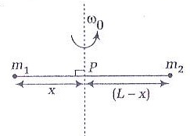The position of point P on this rod through which the axis should pass, so that the work required to set the rod rotating with angular velocity ω0 is minimum is given by

a)  b) 

c)  d) 

1. A force is acting at a point given by . The value of α for which the angular momentum about the origin is conserved is

a) –1 b) 2 c) 0 d) 1

1. An automobile moves on a road with a speed of 54kmph. The radius of its wheels is 0.45m and the moment of inertia of the wheel about its axis of rotation is 3kgm2. If the vehicle is brought to rest in 15s, then the magnitude of average torque transmitted by its brakes to the wheel is

a) 6.66 kgm2s–2 b) 8.58 kgm2s–2 c) 10.86 kgm2s–2 d) 2.86 kgm2s–2

1. A rod of weight w is supported by two parallel knife edges A and B and is in equilibrium in a horizontal position. The knives are at a distance d from each other. The centre of mass of the rod is at a distance x from A. The normal reaction on A is

a)  b)  c)  d) 

**GRAVITATION AND ELASTICITY**

**UNIT NO : P - 06**

1. Kepler’s second law is a consequence of

a) Conservation of energy b) Conservation of linear momentum

c) Conservation of angular momentum d) Conservation of mass

1. In our solar system, the inter-planetary region has chunks of matter(much smaller in size compared to planets)called asteroids. They

a) Will not move around the sun, since they have very small masses compared to the sun

b) Will move in an irregular way because of their small masses and will drift away into outer

space

c) Will move around the sun in closed orbits but not obey Kepler’s laws

d) Will move in orbits like planets and obey Kepler’s laws

1. The period of moon’s rotation around the earth is 29days. If moon ‘s mass were 2 fold its present value and all other things remain unchanged, the period of Moon’s rotation would be nearly

a) $29\sqrt{2}$ days b) $\frac{29}{\sqrt{2}}$ days c) 29 × 2 days d) 29 days

1. If earth stands still what will be its effect on man’s weight

a) Increases b) Decreases c) Remains same d) None of these

1. The maximum and minimum distances of a comet from the sun are 8 × 1012 m and 1.6 × 1012 m. If its velocity when nearest to the sun is 60 m/s, what will be its velocity in m/s when it is farthest

a) 12 b) 60 c)112 d)6

1. A steel rod of length 1 m and radius 10cm is stretched by a force 100kN along its length. The stress produced in the rod is ()

a) b) c) d)

1. According to Hooke’s law of elasticity, if stress is increased, the ratio of stress to strain

a) Decreases b) Increases c) Becomes zero d) Remains same

1. There are two wires of same material and same length while the diameter of second wire is 2 times the diameter of the first wire, then the ratio of extension produced in the wires by applying same load will be

a) 1:1 b) 2:1 c) 1:2 d) 4:1

1. The strain –stress curves of three wires of different materials are shown in the figure P,Q and R are the elastic limits of the wires. The figure shows that

O

Stress

Q

Strain

P

R

a) Elasticity of wire P is maximum

b) Elasticity of wire Q is maximum

c) Tensile strength of R is maximum

d) None of the above is true

1. A steel ring of radius r and cross section area A is fitted on to a wooden disc of radius R(R>r). If young’s modulus be E, then the force with which the steel ring is expanded is

a)  b) c) d)

1. Three identical point masses each of mass 1 kg lie in the x-y plane at points(0, 0), (0,0.2m) and (0.2m, 0). The net gravitational force on the mass at the origin is

a)  b)  c) d) 

1. Which of the following graphs represents correctly the variation of the gravitational field(*I*) with the distance (r) from the centre of a spherical shell of mass M and radius ‘a’.

r

*l*

r = a

r

*l*

r = a

r

*l*

r = a

r

*l*

r = a

1. b) c) d)
2. Weight of a body of mass m decreases by 1% when it is raised to height h above the earth’s surface. If the body is taken to a depth h in a mine, change in its weight is

a) 2% decrease b)0.5% decreases c) 1% increase d) 0.5% increase

1. A planet has mass 1/10 of that of earth , while radius is 1/3 that of earth. If a person can throw a stone on earth surface to a height of 90m, then he will be able to throw the stone on that planet to a height

a) 90m b) 40m c) 100m d) 45m

1. The orbital velocity of an artificial satellite in a circular orbit just above the earth’s surface is v. for a satellite orbiting at an altitude of half of the earth’s radius, the orbital velocity is

a) b)  c) d)

1. A cable that can support a load of 800 N is cut into two equal parts. The maximum load that can be supported by either part is

a) 100 N b) 400 N c) 800 N d) 1600 N

1. What increase in pressure is required to decrease the volume of 200 litre of water by 0.004 percent? Given bulk modulus of water is 2100 MPa.

a) 21kPa b) 84 kPa c) 42 kPa d) none of these

1. A block of gelatin is 60 mm by 60 mm by 20 mm when unstressed. A force of 0.245 N is applied tangentially to the upper surface, causing a 5 mm displacement relative to the lower surface. Following observations are made regarding the block.

(i) The shearing stress develop on surface is 68.1 Pa

(ii) The shearing strain develop on surface is 0.25 Pa

(iii) The shear modulus of material is 272. 4 N/m2

Regarding above statements we can say:

a) Only statements (i) and (iii) are correct

b) Only statements (ii) and (iii) are correct

c) Only statements (i) and (ii) are correct

d) All the statements are correct

1. A force of 106 Nm-2is required for breaking a material. If density is 3 x 103 kg m-3 then what should be the maximum length which can be hanged so that it is the point of breaking by its own weight?

a) 34 m b) 340 m c) 3.4 m d) 0.34 m

1. If the work done in stretching another wire by 1mm is 2J, the work necessary for stretching another wire of same material but with radius of cross-section and half the length by 1mm is

a)J b) 4 J c) 8 J d) 16 J

1. A small planet is revolving around a very massive star in a circular orbit of radius R with a period of revolution T. If the gravitational force between the planets and the star were proportional to R-5/2, then T would be proportional

a) R3/2 b) R3/5 c) R7/2 d)R7/4

1. A research satellite of mass 200kg circles the earth in an orbit radius where  is the radius of earth. Assuming the gravitational pull on a mass of 1 kg on the earth’s surface to be 10N, the pull on the satellite will be
2. 890 N b) 889 N c) 885 N d) 892 N
3. Match the following columns for a planet of mass m revolving around the sun in an elliptical orbit of semi-major axis ‘a’ and semi-minor axis ‘b’. T is the time period of planet.

|  |  |
| --- | --- |
| Column-1 | Column-2 |
| i. | p. Kepler’s first law |
| ii. Areal velocity is not constant | q. Kepler’s second law |
| iii. Orbit of planet is elliptical | r. Kepler’s third law |
| iv. | s. none of these |

Mark the correct choice from the given codes.

**Codes**

a) i – s , ii – r, iii – q, iv – p b) i – p , ii – q, iii – r, iv – s

c)i – q , ii – r, iii – s, iv – p d) i – r , ii – s, iii – p, iv – q

1. Mass of moon is 7.34 x 1022 kg. If the acceleration due to gravity on the moon is 1.4 ms-2 , the radius of the moon is (G= 6.667 x 10-11 Nm2/kg2)

a) 0.56 x 10 4 m b) 1.87 x 106 m c) 1.92 x 106 m d) 1.01 x 108 m

1. The radii of two planets are respectively  and and their densities are respectively and . The ratio of the acceleration due to gravity at their surfaces is

a) b)

c) d)

1. The acceleration due to gravity at the poles and the equator is and  respectively. If the earth is a sphere of radius  and rotating about its axis with angular speed  then  is given by

a)  b)  c) d) 

1. Four particles each of mass m are placed at the vertices of a square of side *l*. The potential energy of the system is

a)  b) 

c)  d) 

1. In the following four periods
2. Time of revolution of a satellite just above the earth’s surface()
3. Period of oscillation of mass inside the tunnel bored along the diameter of the earth 
4. Period of simple pendulum having a length equal to the earth’s radius in a uniform field of

9.8 N/kg()

1. Period of an infinite length simple pendulum in the earth’s real gravitational field ()

a)  b)  c)  d) 

1. A particle of mass M is situated at the centre of spherical shell of mass M and radius *a.* The magnitude of the gravitational potential at a point situated at distance from the centre will be
2.  b)  c)  d) 
3. Given radius of earth R and length of the day T the height of a geostationary satellite is
4.  b) c)  d)
5. A 900 kg elevator hangs by a steel cable for which the allowable stress is 1.15 x 108 N/m2. What is the minimum diameter required if the elevator accelerates upward at 1.5 m/s2?
6.  b) c) d)
7. If the volume of a wire remains constant when subjected to tensile stress, the value of Poisson’s ratio of the material of the wire is
8. 0.1 b) 0.2 c) 0.4 d) 0.5
9. When a pressure of 100 atm is applied on a spherical ball, then its volume reduces to 0.01%. The bulk modulus of the material of the rubber in dyne/cm2 is
10. 10 x 1012 b) 100 x 1012 c) 1 x 1012 d) 20 x 1012
11. A uniform cube is subjected to volume compression. If each side is decreased by 1%, then bulk strain is
12. 0.01 b) 0.06 c) 0.02 d) 0.03
13. A brass rod of cross-sectional area1 cm2 and length 0.2 m is compressed lengthwise by a weight of 5 kg. If Young’s modulus of elasticity of brass is 1 x 1011 N/m2 , then increase in the energy of the rod will be
14. 10-5 J b) 2.5 x 10-5 J c) 5 x 10-5 J d) 2.5 x 10-4 J
15. When the load on a wire is slowly increases from 3 to 5 kg-wt, the elongation increases from 0.61 to 1.02 mm. The work done during the extension of wire is:
16. 0.16 J b) 0.016 J c) 1.6 J d) 16 J
17. If a pressure p is applied normal to a wire of Young’s modulus Y, the energy stored per unit volume is :
18.  b)  c)  d) 
19. **Assertion:** Lead is more elastic than rubber.

**Reason:** If the same load is attached to lead and rubber wires of the same cross-sectional area, the strain of lead is very much less than that of rubber.

1. If both assertion and reason are true and reason is the correct explanation of assertion
2. If both assertion and reason are true but reason is not the correct explanation of assertion.
3. If assertion is true but reason is false.
4. If both assertion and reason are false.
5. If a rubber ball is taken at the depth of 200 m in a pool, its volume decreases by 0.1%. If the density of water is 1 x 103 kg/m3, then the volume elasticity in N/m2 will be
6. 108 b) 2 x 108 c) 109 d) 2 x 109
7. The potential energy U between two molecules as a function of the distance X between them has been shown in the figure. The two molecules are

X

U

O

B

A

C

1. Attracted when X lies between A and B and are repelled when X lies between B and C
2. Attracted when X lies between B and C and are repelled when X lies between A and B
3. Attracted when they reach B
4. Repelled when they reach B
5. Two astronauts are floating in gravitational free space after having lost contact with their spaceship. The two will

a) Keep floating at the same distance between them b) Move towards each other

c) Move away from each other d) Will become stationary

1. The masses of two planets are in the ratio 1 $:2$. Their radii are in the ratio 1 $:2$.The acceleration due to gravity on the planets are in the ratio
2. 1 $:2$ b) 2 $:1$ c) 3 $:5$ d) 5 $:3$
3. If the acceleration due to gravity, g, is 10m­s-2 at the surface of the earth( radius 6400km), then at a height of 1600km the value of g will be (in ms-2)
4. 6.5 b) 5 c) 7.5 d) 2.5
5. The ratio between the values of acceleration due to gravity at a height 1km above and at a depth of 1km below the earth’s surface is (radius of earth is R)
6. $\frac{R-2}{R-1}$ b) $\frac{R}{R-1}$ c) $\frac{R-2}{R}$ d) $\frac{2R}{R-1}$
7. A body of mass ‘m’ is taken from the earth’s surface to the height equal to twice the radius (R) of the earth. The change in potential energy of body will be

a) $\frac{1}{3}$ mgR b) mg2R c) $\frac{2}{3}$ mgR d) $3$ mgR

1. An astronaut experience weightlessness in a space satellite. It is because

a) The gravitational force is small at that location in space.

b) the gravitational force is large at that location in space

c) the astronaut experience no gravity

d) the gravitation force is infinitely large at that location in space

1. Infinite number of masses , each 1 kg ,is placed along the x-axis at

x= $±1m,±2m,±4m,±8m,±16m………..$.The magnitude of the resultant gravitational

potential in terms of gravitational constant G at the origin (x=0) is

1. $\frac{G}{2}$ b) G c) 2G d) 4G
2. A satellite S is moving in an elliptical orbit around the earth. The mass of the satellite is very small compared to the mass of the earth. Then

a) the total mechanical energy of S varies periodically with time.

b) the linear momentum of S remains constant in magnitude

c) the acceleration of S is always directed towards the centre of the earth.

d) the angular momentum of S about the centre of the earth changes in direction, but its magnitude remains constant.

1. A satellite is orbiting close to the earth and has a kinetic energy K. The minimum extra kinetic energy required by it to just overcome the gravitational pull of the earth is
2. 2K b)2 $\sqrt{2 }$ K c)K d) $\sqrt{3}$ K
3. If the mass of the sun were ten times smaller and the universal gravitational constant were ten times larger in magnitude, which of the following is not correct.

a) time period of simple pendulum on the earth would decrease.

b) walking on the earth would become more difficult.

c) raindrops will fall faster.

d) ’g’ on the ground will not change.

1. When a block of mass M is suspended by a long wire of length L, the length of the wire becomes (L + l). The elastic potential energy stored in the extended wire is:
   1. Mgl b) MgL c) $1/2$ Mgl d) $3/2$ MgL
2. The approximate depth of an ocean is 2700 m. The compressibility of water is Pa and density of water is 103 kg/m3. What fractional compression of water will be obtained at the bottom of the ocean?

a) b) c) d)

1. The following four wires are made of the same material. Which of them will have the largest extension when the same tension is applied?

a) length = 50cm, diameter = 0.5mm b) length = 100cm, diameter = 1mm

c) length = 200cm, diameter = 2mm d) length = 300cm, diameter = 3mm

1. The potential energy of particle in a force field is, where A and B are positive constants and r is the distance of particle from the centre of the field. For stable equilibrium, the distance of the particle is :

a)  b) c) d)

1. A force of is required for breaking a material. The density ρ of the material is . If the wire is to break under its own weight, the length of the wire made of that material should be
   1. 20 m b) 200 m c)100 m d) 2000 m
2. A wire is stretched such that its volume remains constant. The Poisson’s ratio of the material of the wire is

a) - 0.50 b) -0.25 c)0.50 d)0.25

1. Two wires A and B are stretched by the same load. If the area of cross – section of wire ‘A’ is double that of ‘B’, then the stress on ‘B’ is

a) equal to that on A b) twice that on A

c) Half that on A d) four times that on A

1. A spring is stretched by applying a load to its free end. The strain produced in the spring is

a) volumetric b) shear

c) longitudinal and shear d) longitudinal

1. The following four wires of length L and radius r are made of the same material. Which of these will have the largest extension, when the same tension is applied?

a) L = 100cm, r = 0.2 mm b) L = 200cm, r = 0.4 mm

c) L = 300cm, r = 0.6 mm d) L = 400cm, r = 0.8 mm

1. Which of the following substances has the highest elasticity?

a) Rubber b) Copper c) Sponge d) steel

**FLUID MECHANICS, THERMAL PROPERTIES OF MATTER**

**UNIT NO. : P-07**

1. Two soap bubbles each of radius r coalesce in vacuum under isothermal conditions to form a bigger bubble of radius R. Then R is equal to

a)  b)  c)  d) 2r

1. Several spherical drops of a liquid each of radius r coalesce to form a single drop of radius R. If T is the surface tension, then the energy liberated will be

a)  b)  c) d) 

1. 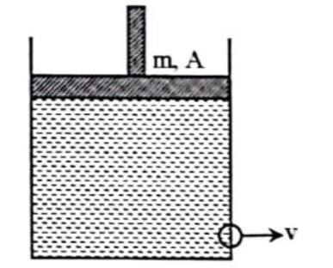A cylindrical vessel contains a liquid of density  up to height h the liquid is closed by a piston of mass m and area of cross section A. There is a small hole at the bottom of vessel. The speed v with which the liquid comes out of the hole is

a)  b) 

c)  d) 

1. Two wood blocks of masses m1 and m2 and each of specific gravity 0.5 are submerged at a depth of h1 and h2 in a vessel (h2>h1) filled with water, which is accelerated upwards with an acceleration of g/2. The difference in time taken by the blocks to reach the surface, when released with zero velocity is

a) zero b)  c)  d) 

1. 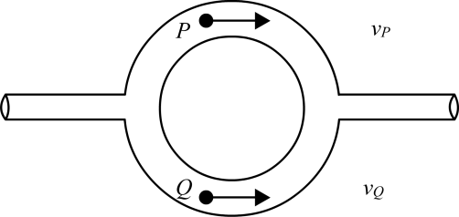Figure shows a liquid flowing through a tube at the rate of 0.1m3/s. The tube is branched into two semicircular tubes of cross sectional area A/3 and 2A/3.

The velocity of liquid at Q is (the cross sectional area of

main tube is A=10-2m2 and Vp=20m/s.)

a) 5 m/s b) 30 m/s

c) 35 m/s d) none of these

1. An air bubble of radius r in water is at a depth h below the water surface at some instant. If P is the atmospheric pressure and d and T are the density and surface tension of the water respectively, the pressure inside the bubble will be

a)  b)  c)  d)

1. The pressure of a gas filled in the bulb of a constant volume gas thermometer at temperatures 0°C and 100°C are 27.50 cm and 37.50 cm of Hg respectively. At an unknown temperature the pressure is 32.45 cm of Hg. Unknown temperature is

a) 30°C b) 39°C c) 49.5°C d) 29.6°C

1. The coefficient of linear expansion of cube is α and the coefficient of volume expansion of liquid is . On increasing the temperature of (liquid + cube) system, the cube will sink if

a) =3α b) >3α c) <3α d) =2α

1. 200 g of ice at –20°C is mixed with 500 g of water at 20°C in an insulating vessel. Final mass of water in vessel is(specific heat of ice = 0.5 cal g-1°C-1)

a) 700 g b) 600 g c) 400 g d) 200 g

1. 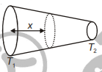Two ends of a rod of non uniform area of cross-section are maintained at temperature  and  as shown in the figure. If I is heat current through the cross-section of conductor at distance x from its left face, then the variation of I with x is best resented by

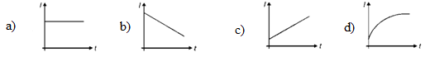

1. Two walls of thickness, thermal conductivities, are in contact. In steady state if the temperatures at the outer surfaces are****, the temperature at the common wall will be.
2.  b) c) d)
3. 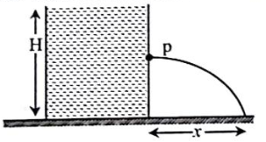A tank is filled with water upto a height H. Water is allowed to come out of the hole P in one of the walls at some depth below the surface of the water. The maximum horizontal range x is

a) H/2 b) 

c) H d) none of these

1. The total weight of a piece of wood is 6kg.In the floating state in water its 1/3 part remains inside the water. On this floating solid, what maximum weight is to be put such that the whole piece of wood is to be drowned in the water.

a) 12kg b) 10kg c) 14kg d) 15kg

1. 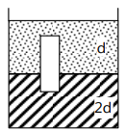A homogeneous solid cylinder of length L(L<H/2),cross sectional area A/5 is immersed such that it floats with its axis vertical at the liquid-liquid interface with length L/4 in the dense liquid as shown in the figure. The lower density liquid is open to atmosphere having pressure P0. The density D of the solid is given by

a)  b)  c) 4d d) 

1. The radius of a soap bubble is r and the surface tension of soap solution is T. Keeping the temperature constant, the extra energy needed to double the radius of the soap bubble by blowing is

a) b)  c)  d) 

1. 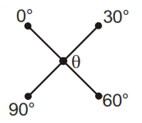Four rods of same material and having the same cross section and length have been joined, as shown.The temperature of the junction of four rods will be

a) 20°C b) 30°C

c) 45°C d) 60°C

1. A car moving on road when over taken by a bus

a) Pulled towards bus b) pulled away from bus

c) data insufficient d) not affected

1. Two metal spheres have radii r and 2r and they emit thermal radiation with maximum intensities at wavelengths λ and 2λ respectively. The respective ratio of the radiant energy emitted by them per second will be

a) 4 : 1 b) 1 : 4 c) 16 : 1 d) 8 : 1

1. Two small spherical metal balls, having equal masses, are made from materials of densities and  (=8) and have radii of 1mm and 2mm, respectively. They are made to fall vertically from rest in a viscous medium whose coefficient of viscosity equals  and whose density is

0.1. The ratio of their terminal velocities would be

1.  b)  c)  d) 
2. The coefficient of linear expansion of a crystalline substance in one direction is

2 × 10–4/°C and in every direction perpendicular to it is 3 × 10–4/°C. The coefficient of cubical expansion of crystal is equal to

a) 5 × 10-4/°C b) 4× 10-4/°C c) 8 × 10-4/°C d) 7 × 10-4/°C

1. In a hydraulic press, the small cylinder has a diameter of d1 cm and large piston has a diameter of d2 cm. If a force F1 is applied to small piston , the force F2  on large piston is given by

a)  b)  c)  d)

1. A bullet of mass 10 g moving with a speed of 20 m/s hits an ice block of mass 990 g kept on a frictionless floor and gets stuck in it. How much ice will melt if 50% of the lost KE goes to ice? (initial temperature of the ice block and bullet = 0°C)

a) 0.001 g b) 0.002 g c) 0.003 g d) 0.004 g

1. 50 g ice at 0°C is dropped into a calorimeter containing 100 g water at 30°C. If thermal capacity of calorimeter is zero then amount of ice left in the mixture at equilibrium is

a) 12.5 g b) 25 g c) 20 g d)10 g

1. Heat is being supplied at a constant rate to the sphere of ice which is melting at the rate of 0.1 gm/s. It melts completely in 100 s. The rate of rise of temperature thereafter will be
2. 0.4°C/s b) 2.1°C/s c) 3.2°C/s d) 0.8°C/s
3. Liquid is flowing through two tubes of length L and 3L and radius r and 3r respectively are connected in series. The pressure difference across first and second tube are in the ratio
4. 3:1 b) 1:3 c) 27:1 d) 9:1
5. A spherical black body with radius 12 cm radiates 450 W power at 500 K. If the radius is halved and temperature is doubled, the power radiated in watt would be

a) 225 b) 450 c) 900 d) 1800

1. If transmission power of a surface is, reflective power is , then what is its absorptive power
2.  b) c) d) 
3. A wire of length L and density d is kept on the surface of liquid. What can be maximum radius such that the wire is in equilibrium due to surface tension?

a)  b)  c)  d) 

1. 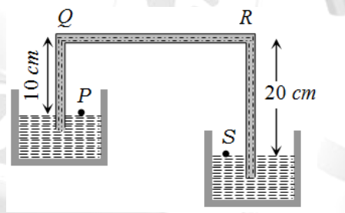A siphon in use is demonstrated in the following figure. The density of the liquid flowing in siphon is 1.5 gm/cc. The pressure difference between the point P and S will be

1. 105 N/m b) 

c) zero d) infinity

1. Two straight metallic strips each of thickness t and length  are riveted together. Their coefficients of linear expansions are . If they are heated through temperature ΔT, the bimetallic strip will bend to form an arc of radius.

a) $\frac{t}{\left\{\left(∝_{1}+∝_{2}\right)∆T\right\}}$) b) $\frac{t}{\left\{\left(∝_{2}-∝_{1}\right)∆T\right\}}$) c) $t\left(∝_{1}+∝_{2}\right)∆T$ d) $t\left(∝_{2}-∝_{1}\right)∆T$

1. A solid sphere of density η ( > 1) times lighter than water is suspended in a water tank by a string

tied to its base as shown in fig. If the mass of the sphere is m then the tension in the string is

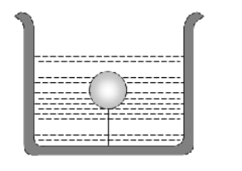 

 

1. In which one of the following cases will the liquid flow in a pipe be most streamlined

a) Liquid of high viscosity and high density flowing through a pipe of small radius

b) Liquid of high viscosity and low density flowing through a pipe of small radius

c) Liquid of low viscosity and low density flowing through a pipe of large radius

d) Liquid of low viscosity and high density flowing through a pipe of large radius

1. The apparent coefficient of expansion of liquid, when heated in a copper vessel is C and when heated in a silver vessel is S. If A linear coefficient of expansion of copper, then the linear coefficient of expansion of silver is

a) $\frac{C+S-3A}{3}$ b) $\frac{C-S+3A}{3}$ c) $\frac{S+3A-C}{3}$ d) $\frac{C+S+3A}{3}$

1. A square plate of 0.1 m side moves parallel to a second plate with a velocity of 0.1 m/s, both plates being immersed in water. If the viscous force is 0.002 N and the coefficient of viscosity is 0.01poise, distance between the plates in m is

a) 0.1 b) 0.05 c) 0.005 d) 0.0005

1. A metal ball of mass 1kg and specific heat capacity s falls from a height of 10cm and bounces to a height of 4m. if all dissipated energy Q is absorbed by the the ball as heat, its temperature rises by 0.075K. (g = 10ms-2)

a)Q =60J b) Q=100J c) s= 8Jkg -1k-1 d)s= 1300 Jkg -1k-1

1. 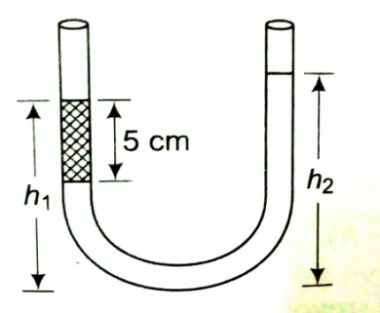An open ended U-tube of uniform cross sectional area contains water (density of 1.0g/cm3) standing initially 20cm from the bottom in each arm. An immiscible liquid of density 4.0gcm-3 is added to one arm until layer 5cm high forms, as shown in the figure. What is the ratio h2/h1 of the heights of the liquid in the two arms?

a) 3/1 b) 5/2

c) 2/1 d) 3/2

1. **Assertion:** Hot water extinguishes fire more quickly than cold water.

**Reason:** Hot water requires comparatively less heat to get heated to 100oC and then absorbs much more heat to get converted into vapors.

1. Assertion is true, reason is true, reason is a correct explanation for assertion.

b) Assertion is true, reason is false.

c) Assertion is true, reason is true, reason is not a correct explanation for assertion.

d) Assertion is false, reason is false.

1. Water rises to a height h in a capillary tube of area of cross section a. To what height will water rise in capillary tube of area of cross section 4a?

a) h/4 b) h/2 c) 2h d) 4h

1. In a surrounding medium of temperature 10oC , a body takes 7min for a fall of temperature from 60oC to 40oC. in what time the temperature of the body will fall from 40o C to 28oC?

a) 7min b) 11min c) 14min d) 21min

1. A beaker full of hot water is kept in a room. If it cools from 80˚C to 75˚C in t1min, from 75˚C to 70˚C in t2 min and from 70˚C to 65˚C in t3 min then

a) t1=t2=t3 b) t1<t2=t3 c) t1<t2<t3 d) t1>t2>t3

1. Eight drops of a liquid of density ρ and each of radius α are falling through air with air with a constant velocity 3.75 cms-1.When the eight drops coalesce to form a single drop the terminal velocity of the new drop will be

a) 15×10-2 ms-1 b) 2.4×10-2 ms-1 c) 15×102 ms-1 d) 25×10-2 ms-1

1. The temperature at which the vapor pressure of a liquid becomes equal to the external(atmospheric) pressure is its

a) melting point b) sublimation point c) critical point d) boiling point

**PREVIOUS YEAR QUESTIONS**

1. A soap bubble, having radius of 1 mm, is blown from a detergent solution having a surface tension of 2.5 ×10–2 N/m. The pressure inside the bubble equals at a point Z0 below the free surface of water in a container. Taking g = 10 m/s2, density of water = 103kg/m3 the value of Z0 is **[NEET 2019]**

a) 0.5cm b) 10 cm c) 10 cm d) 1 cm

1. Asmall hole of area of cross section 2mm2 is present near bottom of a fully filled open tank of height 2m.Taking g=10m/s2, the rate of flow of water through the open hole would be nearly

**[NEET 2019]**

a) b)  c)  d)

1. A small metal sphere of radius r and density  falls from rest in a viscous liquid of density and coefficient of viscosity. Due to friction heat is produced. The rate of production of heat when sphere attains terminal velocity is proportional to **[NEET 2018]**

a) r2 b) r3 c) r4 d) r5

1. The power radiated by a black body is P and it radiates maximum energy at wavelength. If the temperature of the black body is now changed so that it radiates maximum energy at wavelength .the power radiated by it now becomes nP. The value of n is **[NEET 2018]**

a)  b)  c)  d) 

1. 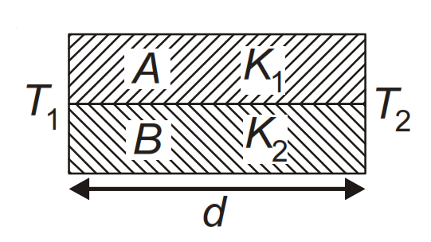Two rods A and B of different materials are welded together as shown in figure. Their thermal conductivities are K1 and K2. The thermal conductivity of the composite rod will be

**[NEET 2017]**

a)  b) 

c)  d) 2()

1. A black body is at a temperature of 5760 K. The energy of radiation emitted by the body at wavelength 250 nm is U1, at wavelength 500 nm is U2 and that at 1000 nm is U. Wien's constant,

b = 2.88 × 106 nmK. Which of the following is correct? **[NEET 2016]**

a) U1=0b) U2=0 c) U1>U2 d) U2>U1

1. A piece of ice falls from a height h so that it melts completely. Only one-quarter of the heat produced is absorbed by the ice and all energy of ice gets converted into heat during its fall. The value of h is [Latent heat of ice is 3.4 × 105 J/kg and g = 10 N/kg]

**[NEET 2016]**

a) 34 km b) 544 km c) 136 km d) 68 km

1. 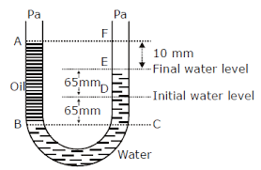A U tube with both ends open to atmosphere, is partially filled with water. Oil which is immiscible with water poured into one side until it stands at a distance of 10mm above the water level on the other side. Mean while the water rises by 65mm from its original level. The density of the oil in kg/m3  is **[NEET 2017]**

a) 425 b) 800

c) 928 d) 650

1. Two identical bodies are made of a material for which the heat capacity increases with temperature. One of these is at 100ºC, while the other one is at 0ºC. If the two bodies are brought into contact, then, assuming no heat loss, the final common temperature is - **[NEET 2016]**

a) 50ºC b) more than 50ºC

c) 0ºC d) less than 50ºC but greater than 0ºC

1. A body cools from a temperature 3T to 2T in 10 minutes. The room temperature is T. Assume that Newton’s law of cooling is applicable. The temperature of the body at the end of next 10 minutes will be - **[NEET 2016]**

  c)  d) T

1. Three liquids of densities ρ1,ρ2 and  ρ3(ρ1>ρ2>ρ3) having the same value of surface tension T rise to the same heights in three identical capillary tube. The angle of contact obey

**[NEET 2016]**

a)  

 

1. Two non mixing liquids of densities are put in a container. The height of each liquid is h. A solid cylinder of length L and density d is put in this container. The cylinder floats with its axis vertical and length pL(p<1) in denser liquid. The density d is equal to **[NEET 2016]**

a)  b)  c)  d) 

1. A wind with speed 40m/s blows parallel to the roof of a house. The area of roof is 250m2. Assuming that the pressure inside the house is atmospheric pressure, the force exerted by wind on the roof and direction of force will be () **[NEET 2015]**

a) 2.4 × 105N ,upwards b) 2.4 × 105N, down wards

c) 4.8 × 105N,down wards d) 4.8 × 105N,upwards

1. A certain number of spherical drops of a liquid of radius r coalesce to forma single drop of radius R and volume V. if T is the surface tension of liquid then **[JEE MAINS 2014]**

a)energy=is released b) energy=is absorbed

c) energy=is released d) energy neither released nor absorbed

1. Two metal rods 1 and 2 of same lengths have same temperature difference between their ends. Their thermal conductivities are K1and K2 and cross sectional areas A1 and A2 respectively. If the rate of heat conduction in one is four times that of 2, then **[NEET 2013]**

a) K1A1=4K2A2 b) K1A1=2K2A2 c ) 4K1A1=K2A2 d) K1A1=K2A2

1. A fluid is in streamline flow across a horizontal pipe of variable area of cross section. For this which of the following statements is correct? **[NEET 2013]**
2. The velocity is minimum at the narrowest part of the pipe and the pressure is minimum at

the widest part of the pipe.

b) The velocity is maximum at the narrowest part of the pipe and pressure is maximum at the

widest part of the pipe

c) Velocity and pressure both are maximum at the narrowest part of the pipe

d) Velocity and pressure both are maximum at the widest part of the pipe.

# The temperature of 100 g of water is to be raised from 24°C to 90°C by adding steam to it. The mass of the steam required for this purpose is [JIPMER 2015]

a) 10g b) 12g c) 16g d) 14g

1. A liquid of coefficient of viscosity poise is flowing in a pipe of radius 3cm such that the rate of volume flow is 1000 litre/min. Determine Reynolds number **[JEE MAINS 2019]**

a) 3563 b) 3500 c) 3400 d) 3600

1. An ideal fluid flows (laminar flow) through a pipe of non-uniform diameter. The maximum

and minimum diameters of the pipes are 6.4 cm and 4.8 cm, respectively. The ratio of the

minimum and the maximum velocities of fluid in this pipe is: **[JEE MAINS 2020]**

a)  b)  c)  d) 

1. A non-isotropic solid metal cube has coefficients of linear expansion as 5 × 10–5 /°C along the x-axis and 5 × 10–6/°C along the y and the z-axis. If the coefficient of volume expansion of the solid is C × 10–16/°C then the value of C is : **[JEE MAINS 2020]**

a) 60 b) 50 c) 10 d) 15

1. Two liquids of densities  an  () are filled up behind a square wall of side 10 m as

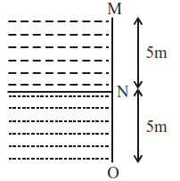shown in figure. Each liquid has a height of 5 m. The ratio of the forces due to these liquids exerted on upper part MN to that at the lower part NO is (Assume that the liquids are not mixing)

**[JEE MAINS 2020]**

a)  

 

1. A small spherical droplet of density d is floating exactly half immersed in a liquid of density

and surface tension T. The radius of the droplet is (take note that the surface tension applies an

upward force on the droplet)  **[JEE MAINS 2020]**

   

1. Water flows in a horizontal tube (see figure).The pressure of water changes by 700 Nm–2

between A and B where the area of cross section are 40 cm2 and 20 cm2, respectively. Find the

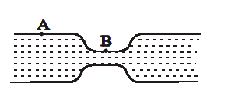rate of flow of water through the tube.(density of water = 1000 kgm–3)  **[JEE MAINS 2020]**

a) 1810 cm3/s b) 3020 cm3/s

c) 2720 cm3/s d) 2420 cm3/s

**THERMODYNAMICS AND KINETIC THEORY OF GASES**

**UNIT NO: P-08**

1. A perfect gas goes from state A to another state B by absorbing 8×105 J of heat and doing 6.5 x 105 J of external work. It is now transferred between the same two states in another process in which it absorbs 105 J of heat. Then in the second process

a) work done on the gas is 0.5 × 105 J b) work done by gas is 0.5 × 105 J

c) work done on gas is 105 J d) work done by gas is 105 J

1. In a thermodynamic system working substance is ideal gas, it’s internal energy is in the form of

a) Kinetic energy only b) Kinetic and potential energy only

c) potential energy d) none of these

1. A monoatomic gas of n- moles is heated from temperature T1 to T2 under two different conditions (i) at constant volume and (ii) constant pressure. The change in internal energy of the gas is

a) more for (i) b) more for (ii)

c) same in both cases d) independent of number of moles

1. In an isothermal process the volume of an ideal gas is halved. One can say that

a) Internal energy of the system decreases b) Work done by the gas is positive

c) Work done by the gas is negative d) Internal energy of the system increases

1. A monoatomic gas($γ$ = 5/3) is suddenly compressed to $\frac{1}{ 8}$ its original volume adiabatically, then the pressure of the gas will change to

a) b) 8 c)  d) 32 times its initial pressure

1. In a reversible isochoric change

a) ∆W =0 b ) ∆Q= 0 c) ∆T = 0 d) ∆U = 0

1. In a Carnot engine, the temperature of reservoir is 927° C and that of sink is 27° C. If the work done by the engine when it transfers heat from reservoir to sink is 12.6× 106 J, the quantity of heat absorbed by the engine from the reservoir is

a)16.8 x 106 J b) 4 x 106 J c) 7.6 x 106 J d) 4.2 x 106 J

1. 200 cal of heat is given to a heat engine so that it reject 150 cal of heat, if source temperature is 400 K , then the sink temperature is

a)300 K b) 200 K c) 100 K d) 50 K

1. A refrigerator works between 4° C and 30° C. It is required to remove 600 calories of heat every second in order to keep the temperature of the refrigerated space constant. The power is

(Take 1 cal = 4.2 Joules)

a)2.365 W b) 23.65 W c) 236.5 W d) 2365 W

1. 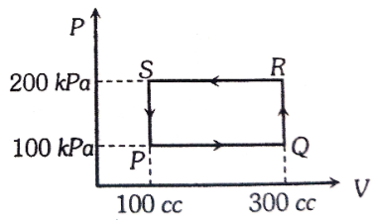A thermodynamic system is taken through the cycle PQRSP process. The net work done by the system is

a) 20 J b) – 20 J

c) 400 J d) -374 J

1. An ideal heat engine working between temperature T1 and T2 has an efficiency , the new efficiency if both the source and sink temperature are doubled, will be

a) b) c)  d)

1. 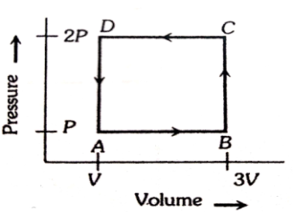A thermodynamic system is taken through the cycle ABCD as shown in figure. Heat rejected by the gas during the cycle is   
   a) 2 PV b) 4 PV

c) 1/2 PV d) PV

1. A thermally insulated vessel contains an ideal gas of molecular mass M and ratio of specific heats y. It is moving with speed $v$ and is suddenly brought to rest. Assuming no heat is lost to the surroundings, its temperature increases by
   1.  b) c) d)
2. When an ideal monoatomic gas is heated at constant pressure, fraction of heat energy supplied which increases the internal energy of gas, is  
   a)2/5 b)3/5 c)3/7 d) 3/4
3. The relationship between pressure and the density of a gas expressed by Boyle's law,

P = KD holds true a) For any gas under any conditions b) For some gases under any conditions  
c) Only if the temperature is kept constant d) Only if the density is constant

1. 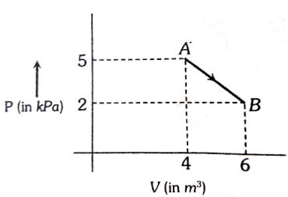One mole of an ideal diatomic gas undergoes a transition from A to B along a path AB as shown in the figure, the change in internal energy of the gas during the transition is

a) -20 kJ b) 20 J

c) -12 kJ d) 20 kJ

1. The ratio of the specific heats =in terms degrees of freedom (n) is given by
   1.  b) c)  d) 
2. If pressure of a gas contained in a closed vessel is increased by 0.4% when heated by 1°C, the initial temperature must be   
   a) 250 K b) 250°C c) 2500 K d) 25°C
3. The root mean square velocity of the molecules in a sample of helium is 5/7th that of the molecules in a sample of hydrogen. If the temperature of hydrogen sample is 0°C,then the temperature of the helium sample is about   
   a) 0°C b) 0 K c) 273°C d) 100°C
4. If the ratio of vapour density for hydrogen and oxygen is , then under constant pressure the ratio of their rms velocities will be

a) b)  c)  d) 

1. Two cylinders of equal size are filled with equal amount of ideal diatomic gas at room temperature. Both the cylinders are fitted with pistons. In cylinder A the piston is free to move while in B position is fixed. When same amount of heat is supplied to both the cylinders, the temperature of the gas in cylinder A raises by 30 K. What will be the rise in temperature of the gas in cylinder B

a) 42K b) 30K c) 20K d) 56K

1. 70 calories of heat are required to raise the temperature of 2 moles of an ideal gas at constant pressure from 30° C to 35° C. The amount of heat required to raise the temperature of same gas through the same range (30° C to 35° C) at constant volume (R= 2cal mol-1 K-1) is

a) 30 cal b) 50 cal c) 70 cal d) 90 cal

1. The average kinetic energy of a helium atom at 30° C is

a) Less than 1 eV b) A few KeV c) 50 – 60 eV d) 13.6 eV

1. At 0 K which of the following properties of a gas will be zero

a) Kinetic energy b) potential energy c) Vibrational energy d) density

1. 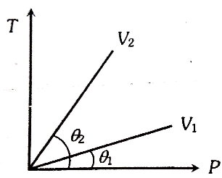From the following P-T graph what inference can be drawn

a) V2 >V1 b) V2 < V1

c) V2 = V1 d) none of the above

1. The mean free path of molecules of a gas,( radius r ) is inversely proportional to

a) r b)  c) r3 d) r2

1. If the internal energy of n1 moles of He at temperature 10 T is equal to the internal energy of n2 mole of hydrogen at temperature 6 T. The ratio of is

a) 3/5 b) 2 c) 1 d) 5/3

1. The kinetic energy of one mole gas at 300K temperature is E. At 400 K temperature, kinetic energy is E'. The value of E'/E is

a) 1.33 b)  c)  d) 2

1. If the mean free path of atoms is doubled then the pressure of gas will become

a) P/4 b) P/2 c) P/8 d) P

1. The molar specific heats of an ideal gas at constant pressure and volume are denoted by CP and CV , respectively. If  and R is the universal gas constant, then C­V is equal to
   1.  b)  c)  d) 
2. In a cyclic process, work done by the system is

a) Zero b) Equal to heat given to the system

c) More than the heat given to the system d) Independent of heat given to the system

1. A gas mixture consists of 2 moles of oxygen and 4 moles argon at temperature T. Neglecting all vibrational modes, the total internal energy of the system is

a) 4 RT b) 15 RT c) 9 RT d) 11RT

1. Identify the wrong statement

a) for isothermal process, ∆T= 0 b) for isochoric process, ∆V= 0

c) for adiabatic process, ∆Q= 0 d) for cyclic process, ∆W= 0

1. Which of the following cannot determine the state of a thermodynamic system

a) Pressure and volume b) Volume and temperature

c) Temperature and pressure d) any one of pressure, volume or temperature

1. In a given process for an ideal gas, dW= 0 and dQ < 0. Then for the gas

a) The temperature will decrease b) The volume will increase

c) The pressure will remain constant d) The temperature will increase

1. An ideal gas at 27° C is compressed adiabatically to  of its original volume. If then the rise in temperature is

a) 450 K b) 375 K c) 225 K d) 405 K

1. A monoatomic ideal gas, initially at temperature T1 is enclosed in a cylinder fitted with a frictionless piston. The gas is allowed to expand adiabatically to a temperature T2  by releasing the piston suddenly. If L1 and L2 are the lengths of the gas column before and after expansion respectively, then T1/T2 is given by
   1.    
2. One mole of an ideal gas at an initial temperature of T K does 6 R joules of work adiabatically. If the ratio of specific heats of this gas at constant pressure and at constant volume is 5/3, the final temperature of gas will be

a) (T + 2.4 ) K b) (T - 2.4 ) K c) (T + 4 ) K d) (T- 4 ) K

1. A gas ends expands under constant pressure P from volume V1 and V2. The work done by the gas is

a) P(V2 ­– V1) b) P(V1 ­– V2) c) P() d) 

1. A container having 1 mole of a gas at a temperature 270C has a movable piston which maintains at constant pressure in container of 1 atm. The gas is compressed until temperature becomes 1270C. The work done is ( Cp for gas is 7.03 calmol-1 K)

a) 703 J b) 831 J c) 121 J d) 2035 J

1. A gas is compressed isothermally to half its initial volume. The same gas is compressed separately through an adiabatic process until its volume is again reduced to half. Then

a) Compressing the gas isothermally will require more work to be done

b) Compressing the gas through adiabatic process will require more work to be done.

c) Compressing the gas isothermally or adiabatically will require the same amount of work.

d) Which of the case (whether compression through adiabatic process )requires more work will depend upon the atomicity of the gas

1. Pressure temperature relationship for an ideal gas undergoing adiabatic change is ($γ=\frac{C_{p}}{C_{v}}$)

a) b) 

c)  d) 

1. During an adiabatic process, the pressure of a gas is found to be proportional to the cube of its absolute temperature. The ratio of for the gas is

a)3/2 b)4/3 c)2 d)5/3

1. A refrigerator works between 50C and 350C. It is required to remove 500 calories of heat every second in order to keep the temperature of the refrigerated space constant. The power is (take 1 cal=4.2 joules)

a)2.365W b)23.65W c)226W d)2365W

1. A carnot engine having an efficiency 1/10 as heat engine, is used as a refrigerator. If the workdone on the system is 10J, the amount of energy absorbed from the reservoir at lower temperature is a)99J b)90J c)1J d)100J
2. The temperature inside a refrigerator is t20C and the room temperature is t10C. The amount of heat delivered to the room for each joule of electrical energy consumed ideally will be

a)  b)  c)  d) 

1. Two Carnot engines A and B are operated in succession. The first one, A receives heat from a source at T1= 800K and rejects to sink at T2K. The second engine B receives heat rejected by the first engine and rejects to another sink at T3= 300K.If the work outputs of two engines are equal , then the value of T2 is

a)100K b)300K c)550K d)700K

1. In the given (V-T) diagram , what is the relation between pressure P1 and P2

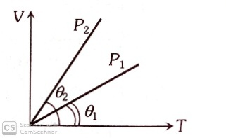a) Cannot be predicted.

b) P2=P1

c) P2>P1

d) P2<P1

1. 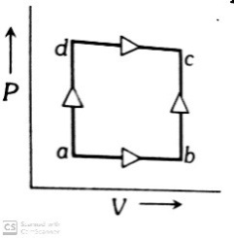A system is taken from state a to state c by two paths adc and abc as shown in the figure. The internal energy at a is Ua = 10J. Along the path adc the amount of heat absorbed $δQ=50J$ and the work obtained W1=20J whereas along the path abc the heat absorbed Q2=36J. The amount of work along path abc is

a)10J

b)12J

c)36J

d)6J

1. 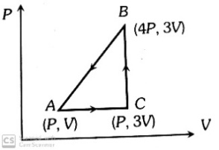A sample of ideal mono-atomic gas is taken round the cycle ABCA as shown in the figure. The work done during the cycle is

a)Zero

b)3 PV

c)6PV

d)9PV

1. The efficiency of heat engine working between the freezing point and boiling point of water is

a) 6.25% b) 25% c) 26.8% d) 12.5%

1. Increase in temperature of a gas filled in a container would lead to

a) decrease in its pressure b) decrease in intermolecular distance

c) increase in its mass d) increase in its kinetic energy

1. At what temperature will the rms speed of oxygen molecules become just sufficient for escaping from the earth’s atmosphere. Given: mass of oxygen molecule, m = 2.76 x 10-26kg, Boltzmann constant, kB = 1.38 x 10-23J/K

a) 1.25 x 104K b) 2.50 x 104K c) 5.01 x 104K d) 8.36 x 104K

1. If a pressure of a gas contained in a closed vessel is increased by 0.4%. when heated by 10C,then the initial temperature must be

a) 250K b)250 0C c) 2500K d) 250C

1. A given sample of an ideal gas occupies a volume V at a pressure P and absolute temperature T. The mass of each molecule of the gas is m. Which of the following gives the density of the gas?

a) P/kTV b) mkT c) P/kT d) Pm/kT

1. The molecules of a given mass of a gas have rms velocity of 200m/s at 270C and 1x105N/m2 pressure. When temperature and pressure of the gas are respectively 1270C and 0.05 x 105N/m2, then the rms velocity of its molecules in m/s is

a) b)  d) 

1. The specific heat of a gas in an isothermal process is

a)Infinite b) zero c) Negative d) Remains same

1. The amount of heat energy required to raise the temperature of 1g of helium at NTP from T1K to T2K is

a) b) c)  d)

1. An ideal gas occupies a volume of 2 m3 at a pressure of 3 x 106 Pa. The energy of the gas
2. 9 x 106 J b) 3 x 102 J c) 6 x 104 J d) 108 J
3. Gas at a pressure P0 is contained in a vessel. If the masses of all the molecules are halved and their speeds are doubled, then the resulting pressure P will be equal to

a) 4P0 b) 2P0 c) P0 d) 3P0

**OSCILLATIONS, WAVES AND SOUND**

**UNIT NO. : P – 09**

1. The two nearest harmonics of a tube closed at one end and open at other end are 220 Hz and 260 Hz. What is the fundamental frequency of the system?

a) 10 Hz b) 20 Hz c) 30 Hz d) 40 Hz

1. A siren emitting a sound of frequency 800Hz moves away from an observer towards a cliff at a speed of 15 ms-1. Then the frequency of sound that the observer hears as the echo reflected from the cliff is ( Take velocity of sound on air = 330ms-1)

a) 800 Hz b) 838 Hz c) 885 Hz d) 765 Hz

1. The number of possible natural oscillations of air column in a pipe closed at one end of length 85 cm whose frequencies lie below 1250 Hz are (velocity of sound 340 ms-1)
   1. 4 b) 5 c) 7 d) 6
2. A source of unknown frequency gives 4 beats per second when sounded with a source of known frequency 250 Hz. The second harmonic of the source of unknown frequency gives 5 beats per second when sounded with a source of frequency 513 Hz. The unknown frequency is
   1. 254 Hz b) 246 Hz c) 240 Hz d) 260 Hz
3. Two identical piano wires kept under the same tension T have a fundamental frequency of 600Hz. The fractional increase in the tension of one of the wires which will lead to occurrence of 6 beats per second when both wires oscillate together would be
   1. 0.02 b) 0.03 c) 0.04 d) 0.01
4. A transverse wave is represented by y = A sin. For what value of the wavelength is wave velocity equal to the maximum particle velocity?

a)  b)  c) 2  d) A

1. The equation of displacement of two waves are given as Y1= 10 sin (3t +/3),

Y2= 5(sin 3t+) . Then what is the ratio of their amplitudes.

* 1. 1:2 b) 2:1 c) 1:1 d) none of these

1. Two waves having the intensities in the ratio of 9:1 produce interference. The ratio of maximum to the minimum intensity, is equal to
   1. 2:1 b) 4:1 c) 9:1 d) 10:8
2. A body of mass `m’ is attached to the lower end of a spring whose upper end is fixed. The spring has negligible mass. When the mass 'm' is slightly pulled down and released, it oscillates with a time period of 3s. When the mass 'm' is increased by 1kg, the time period of oscillation becomes 5s. The value of 'm' in kg is,

a)  b)  c)  d) 

1. Ratio of kinetic energy to the potential energy of a particle executing SHM at a distance equal to half of its amplitude, the distance being measured from its equilibrium position is
   1. 3:1 b) 4:1 c) 2:1 d) 8:1
2. The period of oscillation of a simple pendulum is T = . The measured value of 'L' is 20 cm known to 1mm accuracy and the time for 100 oscillations of the pendulum is found to be 90 s using a wrist watch of 1s resolution. The accuracy in the determination of g is
   1. 2 % b) 3% c) 1% d) 5%
3. The amplitude of a damped oscillator becomes half in one minute. The amplitude after 3 minutes will be times the original, where X is

a)2×3 b) 23 c) 32  d) 3 x 22

1. The second overtone of an open organ pipe has the same frequency as the first overtone of a closed pipe L meter long. The length of the open pipe will be

a)L b)2L c)  d) 4 L

1. A uniform rope of length L and mass m1 hangs vertically from a rigid support. A block of mass m2 is attached to the free end of the ropes. A transverse pulse of wavelength  , is produced at the lower end of the rope. The wavelength of the pulse when it reaches the top of the rope is  . The ratio  is

a)  b)  c)  d) 

1. A speeding motorcyclist sees traffic jam ahead of him. He slows down to 36 kmh-1. He finds that traffic has eased and a car moving ahead of him at 18kmh-1 is honking at a frequency of 1392Hz. If the speed of sound is 343ms-1, the frequency of the honk as heard by him will be

a)1332 Hz b) 1372 Hz c) 1412 Hz d) 1454 Hz

1. A wave travelling in the positive x- direction having displacement along y- direction as 1m, wavelength 2π m and frequency of Hz is represented by

a) y= sin(x-2t) b) y = sin ( 2π x – 2π t)

c) y = sin ( 10π x – 20π t) d) y = sin ( 2π x + 2π t)

1. Two periodic waves of intensities I1 and I2  pass through a region at the same time in the same direction. The sum of the maximum and minimum intensities is

a) I1 + I2  b)  c)  d) 2 

1. Two points are located at a distance of 10 m and 15 m from the source of oscillation. The period of oscillation is 0.05s and the velocity of the wave is 300 ms-1. What is the phase difference between the oscillations of two points?

a)  b)  c) π d) 

1. Intensity level of sound whose intensity is 10-8 Wm-2 is

a)8 dB b) 4 dB c) 40 dB d) 80 dB

1. A source producing sound of frequency 170Hz is approaching a stationary observer with a velocity 17ms-1. The apparent change in the wavelength of sound heard by the observer is(speed of sound in air=340 ms-1)

a)0.1 m b) 0.2 m c) 0.4 m d) 0.5 m

1. Ten tuning forks are arranged in increasing order of frequency in such a way that any two nearest tuning forks produces 4 beats per second. The highest frequency is twice of the lowest. Possible highest and the lowest frequencies are

a)80 and 40 b) 100 and 50 c) 44 and 22 d) 72 and 36

1. A transverse wave is described by the equation. The maximum particle velocity is four times the wave velocity if

a)  b)  c)  d) 

1. Average velocity of a particle executing SHM in one complete vibration is

a)  b) 0 c)  d) 

1. 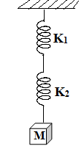A mass M is suspended by two springs of force constants K1 and K2 respectively as shown in the diagram. The total elongation of the two springs is

a)  b) 

c)  d) 

1. In damped oscillations, the amplitude of oscillations is reduced to one-third of its initial value a0 at the end of 100 oscillations. When the oscillator completes 200 oscillations, its amplitude must be

a)  b)  c)  d) 

1. A simple pendulum has time period T1. The point of suspension is now moved upward according to equation y = Kt2 where K = 1ms-2. If new time period is T2 then ratio  will be

a)  b)  c)  d) 

1. A body executing simple harmonic motion has a maximum acceleration equal to 24 ms-2 and maximum velocity equal to 16ms-1. The amplitude of the simple harmonic motion is

a)  m b)  m c)  m d)  m

1. An air column, closed at one end and open at the other, resonates with a tuning fork when the smallest length of the column is 50 cm. The next larger length of the column resonating with the same tuning fork is

a)100 cm b) 150 cm c) 200 cm d) 66.7 cm

1. Two waves are represented by the equation y1 = a sin  and

y2 = a cos, where x is in meter and t in second. The phase difference between them is

a)1.25 rad b) 1.57 rad c) 0.57 rad d) 1.0 rad

1. Each of the two strings of length 51.6 cm and 49.1 cm are tensioned separated by 20 N force. Mass per unit length of both the strings is same and equal to 1 gm-1. When both the strings vibrate simultaneously the number of beats is
   1. 5 b) 7 c) 8 d) 3
2. The sound intensity level at a point 4 m away from a point source is 10dB, then the sound level at a distance 2m from the same source would be
   1. 16 dB b) 26 dB c) 23 dB d) 32 dB
3. The phase difference between two points separated by 1 m in a wave of frequency 120Hz is 900. The wave velocity is

a)180 ms-1 b) 240 ms-1 c) 480 ms-1 d) 720 ms-1

1. If you set up the seventh harmonic on a string fixed at both ends, how many nodes and antinodes are set up in it
   1. 8 , 7 b) 7 , 7 c) 8, 9 d) 9 , 8
2. A particle executes linear SHM with an amplitude of 3 cm. When the particle is at 2 cm from the mean position, the magnitude of its velocity is equal to that of its acceleration. Then its time period in seconds is

a) b)  c)  d) 

1. Infinite springs with force constant K, 2K, 4K and 8K.... respectively are connected in series. The effective force constant of the spring will be
   1. 2K b) K c)  d) 2048
2. A particle of mass ‘m’ is attached to a spring of spring constant k and has a natural angular frequency . An external force F(t) proportional to cost() is applied to the oscillator. The time displacement of the oscillator will be proportional to
   1.  b)  c)  d) 
3. The period of oscillation of a simple pendulum of length L suspended from the roof of a vehicle which moves without friction down an inclined plane of inclination α, is given by
   1.  b)  c)  d) 
4. A SHM is represented by x = 5 $\sqrt{2}$ (sin ). The amplitude of the SHM is
   1. 10 cm b) 20 cm c) 5 d) 50 cm
5. The instantaneous displacement of a simple pendulum oscillator is given by x = A cos (). Its speed will be maximum at time
   1.  b)  c)  d) 
6. An organ pipe P1 closed at one end vibrating in its first overtone and another pipe P2 open at both ends vibrating in its third overtone are in resonance with a given tuning fork. The ratio of lengths of P1 and P2 is
   1. 1:2 b) 1:3 c) 3:8 d) 3:4
7. The relation between time and displacement for two particles is given by y1= 0.06 sin 2π . The ratio of the intensity of the waves produced by the vibrations of the two particles will be
   1. 2:1 b) 1: 2 c) 4:1 d) 1:4
8. A hospital uses an ultrasonic scanner to locate tumours in a tissue. The operating frequency of the scanner is 4.2 Mhz. The speed of sound in a tissue is 1.7 kms-1. The wavelength of sound in the tissue is close to
   1. 4 x 10-4 m b) 8 x 10-3 m c) 4 x 10-3 m d) 8 x 10- 4m
9. A man sets his watch by the sound of a siren placed at a distance 1 km away. If the velocity of sound is 330ms-1
   1. His watch is set 3 sec faster b) His watch is set 3 sec slower

c) His watch is set correctly d) none of the above

1. A tuning fork of frequency 512Hz makes 4 beats per second with the vibrating string of a piano. The beat frequency decreases to 2 beats per second, when the tension in the piano string is slightly increased. The frequency of the piano string before increasing the tension was
   1. 510 Hz b) 514 Hz c) 516 Hz d) 508 Hz
2. The equation of a simple harmonic wave is given by y=3 sin $\frac{π}{2}$ (50t-x) where x and y are in meters and t is in seconds. The ratio of maximum particle velocity to the wave velocity is
   1.  b) c) 3 d) 
3. If we study the vibration of a pipe open at both ends. Then the following statements is not true
   1. Open end will be anti node
   2. Odd harmonics of the fundamental frequency will be generated
   3. All harmonics of the fundamental frequency will be generated
   4. Pressure change will be maximum at both ends
4. A string is stretched between fixed points separated by 75 cm. It is observed to have resonant frequencies of 420 Hz and 315 Hz. There are no other resonant frequencies between these two. The lowest resonant frequency for this string is
   1. 155 Hz b) 205 Hz c) 10.5 Hz d) 105 Hz
5. Two cars moving in opposite directions approach each other with speed of 22 ms-1 and 16.5 ms-1 respectively. The driver of the first car blows a horn having a frequency 400Hz. The frequency heard by the driver of the second car is (velocity of sound 340 ms-1)
   1. 350 Hz b) 361 Hz c) 411 Hz d) 448 Hz
6. The force constants of two springs are K1 and K2. Both are stretched till their elastic energies are equal. If the stretching forces are F1 and F2 , then F1 :F2 is
   1. K1: K2 b) K2: K1 c)  d ) 
7. Two SHM’s of angular frequency 100 rad s-1 and 1000 rad s-1 have the same amplitude.

The ratio of their maximum accelerations is

* 1. 1:103 b) 1:104 c) 1:10 d) 1:102

1. A particle executes SHM with amplitude 0.2 m and time period 24s. The time required for it to move from the mean position to a point 0.1 m from the mean position is  
   a) 2s b) 3s c) 8s d) 12 s
2. A pendulum is executing SHM and its maximum kinetic energy is K1. If the length of the pendulum is doubled and it performs SHM with the same amplitude as in the first case, its maximum kinetic energy is K2. Then

a) K2=K1 b)  c) K2= 2 K1 d) 

1. A tuning fork and sonometer give 5 beats per second, when the length of the wire is 1m and 1.05m respectively. The frequency of tuning fork is  
   a) 210 Hz b) 205 Hz c) 410 Hz d) 420 Hz
2. The velocity of sound in hydrogen is 1224 ms-1. Its velocity in a mixture of hydrogen and oxygen containing 4 parts by volume of hydrogen and 1 part oxygen is
   1. 1224 ms-1 b) 612 ms-1 c) 2448 ms-1 d) 306 ms-1
3. The extension in a string, obeying Hook's law is x. The speed of sound in the stretched string is V. If the extension in the string is increased to 1.5x, the speed of sound will be

a) 1.22 V b) 0.61V c)1.50V d) 0.75V

1. The ratio of intensities between two coherent sound sources is 4:1. The difference of loudness in decibels between maximum and minimum intensities , when they interfere in space is
   1. 10 log 2 b) 20 log 3 c) 10 log 3 d) 20 log 2
2. The equation of a standing wave is y = 0.8 cossin 200πt where x is in cm and t is in s. The separation between consecutive nodes will be
   1. 10 cm b) 20 cm c) 30 cm d) 40 cm
3. If the equation of a progressive wave is given by y (m) = 4 Then which of the following is correct?
   1. V = 5 cm s-1 b)  c) A = 0.04 cm d) f = 50 Hz
4. A simple pendulum performs simple harmonic motion about x=0 with an amplitude ‘a' and time period T. The speed of the pendulum at x =  will be
   1.  b)  c)  d) 
5. Three sound waves of equal amplitudes have frequencies (n-1), n, (n+1). They superimpose to give beats. The number of beats produced per second will be
   1. 1 b) 4 c) 3 d) 2

**ELECTRIC CHARGES AND FIELDS**

**UNIT NO: P-10**

1. The ratio of the force between two charges in vacuum at a certain distance apart to that between the same charges, the same distance apart in a medium of permittivity ε is

a) ε:1 b) 1: ε c) ε0: ε d) ε: ε0

1. Figure shows three charges. If all the charges are in equilibrium, then the ratio Q/q is

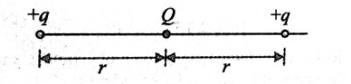

a) - 4 b) +4 c)  d) 

1. Three charges 4q, Q and q are in a straight line in the positions 0, *l*/2 and *l* respectively. Resultant force at q will be zero if Q is equal to

a) -q b) -2q c) –q/2 d) 4q

1. Positive charges of 2μC and 8μC are placed 15cm apart. At what distance from the smaller charge, the electric field due to them will be zero?

a)3cm b) 5cm c) 7cm d) 10cm

1. Two charges 9e and 3e are placed at a distance r. The distance of the point where the electric field intensity will be zero is

a) from 3e charge b) from 9e charge

c)  from 3e charge d) from 9e charge

1. The charge Q is placed at each of the two opposite corners of a square. A charge q is placed at each of the other two opposite corners of the square. If the charges Q are in equilibrium, the value of q is

a)  b)  c)  d) 

1. Two small identical spheres having charges +10 μC and -90 μC attract each other with a force of

F newton. If they are kept in contact and then separated by the same distance, the new force between them is

a) F/6 b) 16F c) 16F/9 d) 9F

1. Two identical balls having like charges and placed at a certain distance apart repel each other with a certain force. They are brought in contact and then moved apart to a distance equal to half their initial separation. The force of repulsion between them becomes 4.5 times in comparison with the initial value. The ratio of the initial charges of the balls is

a) 2 b) 3 c) 4 d)1.5

1. Two identical point charges are placed at a separation of *l*. P is a point on the line joining the charges. At a distance x from any one charge, the field at P is E. E is plotted against x for value of x from close to zero to slightly less than *l.* Which of the following best represents the resulting curve?

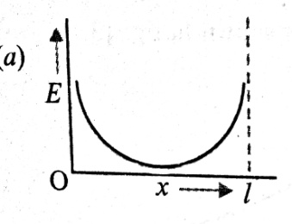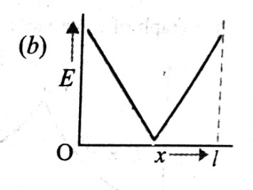 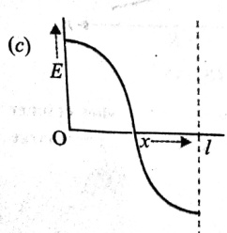 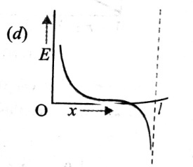

1. Three positive charges of equal value q are placed at the vertices of an equilateral triangle. The resulting lines of force should be sketched as in

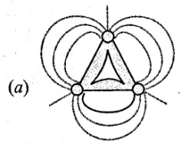 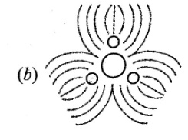 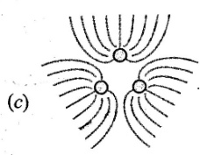 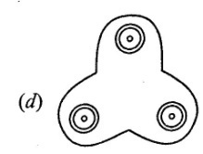

1. A non conducting ring of radius R has uniformly distributed positive charge Q. A small part of the length d, is removed (d<<R). The electric field at the centre of the ring will now be

a) directed towards the gap, inversely proportional to R3

b) directed towards the gap, inversely proportional to R2

c) directed away from the gap, inversely proportional to R3

d) directed away from the gap, inversely proportional to R2

1. A charge q is placed at the centroid of an equilateral triangle. Three charges equal to Q are placed at the vertices of the triangle. The system of four charges will be in equilibrium if q is equal to

a)  b)  c)  d) 

1. Consider a rectangular cube with positive point charge +Q in all corners except for one which has a negative point charge –Q. Let the distance from any corner to the centre of the cube be r. What is the magnitude of electric field at point P at the centre of the cube?

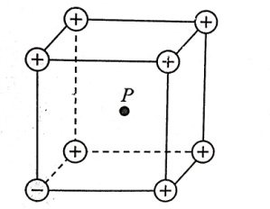

a) E= 7 k Q/r2 b) E= k Q/r2 c) E= 2 k Q/r2 d) E= 6 k Q/r2

1. A positively charged insulator is brought near two metallic spheres that are in contact. The metallic spheres are then separated. The sphere which was at far end from the insulator will have

a) no net charge b) a negative charge

c) a positive charge d) either a –ve or +ve charge

1. Two concentric conducting thin shells of radius R and 2R carry charges +Q and +3Q respectively. The magnitude of the electric field at points A and B at a distance x outside and inside from the surface of outer sphere is same. Then the value of x is

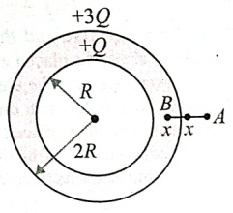a) R/3 b) 2R/3

c) R/4 d) R/2

1. Two spherical conductors B and C having equal radii and carrying equal charges in them repel each other with a force F when kept at some distance. A third spherical conductor having same radius as that of B but uncharged is brought in contact with B, then brought in contact with C and finally removed away from both. The new force of repulsion between B and C is

a) F/4 b) 3F/4 c) F/8 d) 3F/8

1. Four charges equal to –Q are placed at the four corners of a square and a charge q is at its centre. If the system is in equilibrium, the value of q is

a) b)  c)  d) 

1. Consider a neutral conducting sphere. A positive point charge is placed outside the sphere. The net charge on the sphere is then

a) negative and distributed uniformly over the surface of the sphere

b) negative and appears only at the point on the sphere closest to the point charge

c) negative and distributed non-uniformly over the entire surface of the sphere

d) Zero

1. Two identical small bodies each of mass m and charge q are suspended from two strings each of length *l* from a fixed point. This whole system is taken into an orbiting artificial satellite. Then the tension in the string is

a)  b)  c)  d) 

1. Five identical charges +q are placed at five corner of a regular hexagon of side a. Find the magnitude of the electric field at the centre

a)  b)  c)  d) 

1. Two point charges +4q and +q are separated by distance r. A third point charge Q is placed between the two charges. For the whole system to be in equilibrium, what should be the value of Q and what should be its distance from charge +q?

a)  b)  c)  d) 

1. In the figures shown, there are four situations in which charged particles are at equal distances from the origin. E1, E2, E3  and E4 are the magnitudes of fields at the origin O in each case. Select the correct alternative.

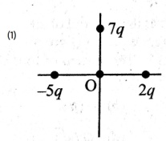 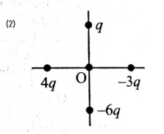 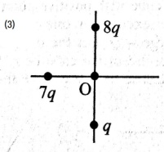 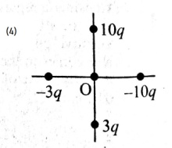

a) E1>E2>E3 >E4 b) E1<E2<E3 <E4 c) E1=E2=E3 =E4 d) E1>E2<E3 <E4

1. Electric field strength due to a ring of radius R at a distance x from its centre on the axis of ring carrying a charge Q is given by . At what distance from the centre will the electric field be maximum?

a)x=R b) x=R/2 c)  d) 

1. Two point charges of +1μC and -9 μC are placed 8cm apart in air. Determine the position of the point (from -9 μC) at which the resultant electric field is zero.

a)50cm b)24cm c)10cm d)15cm

1. A pendulum bob of mass 80mg and carrying a charge of 2x10-8C is at rest in a uniform horizontal electric field of 20,000 V/m. Find the tension in the thread

a)89x10-4N b) 8.9x10-5N c) 8.9x10-3N d) 8.9x10-4N

1. If a soap bubble is given some charge, then its radius

a) Increases b) Decreases c) Remain unchanged

d) May increase or decrease depending upon the given charge is positive or negative

1. A charge q is to be divided on two small conducting spheres. What should be the value of charges on the spheres so that when placed at a certain distance apart, the repulsion force between them is maximum

a) q/4 and 3q/4 b) q/2 and q/2 c) q/3 and q/3 d) q/4 and q/4

1. Force of attraction between two point charges Q and –Q separated by d metre is Fe. When these charges are placed on two identical spheres of radius R=0.3d whose centres are d metre apart, the force of attraction between them is

a) greater then Fe b) equal to Fe c) less than Fe d) we can not say

1. An electric dipole is in unstable equilibrium in uniform electric field. Angle between its electric dipole moment and electric field is

a ) 900 b) 1200 c) 00 d) 1800

1. Two charges of 20x10-6 C and -20x10-6 C are placed at points A and B respectively 20cm apart. What is the electric field at point C, 20cm away from A and B

a)4.5x106 N/C b) 85x102 N/C c) 4.5x103 N/C d) 8.5x106 N/C

1. A uniform horizontal electric field is established in the space between two large vertical parallel plates. A small conducting sphere of mass m is suspended in the field from a string of length L. If the sphere is given a charge +q, then the period of oscillation of the pendulum is

a) b)  c)  d) 

1. Three infinitely long charge sheets are placed as shown in the figure. The electric field at point P is

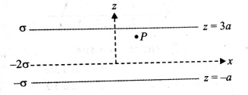a)  b) 

c)  d) 

1. The electric flux entering and leaving an enclosed surface is and respectively. The electric charge inside the enclosed surface will be

a) (+ ) b) (- ) c) (+ )/ d)(- )/

1. 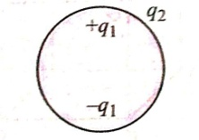Consider the charge configuration and a spherical Gaussian surface as shown in the figure. When calculating the flux of the electric field over the spherical surface, the electric field will be due to

a) q2 b) only the positive charges

c) all the charges d) +q1 and –q1

1. An electric dipole is placed at an angle of 300 with electric field intensity 2x105 N/C. It experiences a torque equal to 4Nm. The charge on the dipole, If the dipole length is 2cm, is

a)8mC b) 2mC c) 5mC d) 7mC

1. A point charge of +6μC is placed at distance 20cm directly above the centre of a square of side 40cm. The magnitude of the flux through the square is

a)  b) c)  d) 

1. You are travelling in a car during a thunderstorm. In order to protect yourself from lighting, you would prefer to

a) Touch the nearest electric pole b) take shelter under a tree

c) get out and crouch on the ground d) remain in the car

1. What is the angle between the electric dipole moment and the electric field strength due to it on the equatorial line

a) 00 b) 900 c) 1800 d) None of these

1. When 1019 electrons are removed from a neutral metal plate, the electric charge on it is

a) 1.6C b) -1.6C c) 1019 C d) 10-19C

1. The field due to a charge at a distance x from it is E. When the distance is doubled the intensity of the electric field is

a)E/8 b)E c)2E d) E/4

1. Two point charges A and B, having charges +Q and –Q respectively, are placed at certain distance apart and force acting between them is F. If 25% charge of A is transferred to B, then force between the charges becomes (NEET 2019)

a) F b)  c) d)

1. A hollow metal sphere of radius R is uniformly charged. The electric field due to the sphere at a distance r from the centre (NEET 2018)

a) increases as r increases for r < R and r> R

b) zero as r increases for r < R, decreases as r increases for r >R

c) zero as r increases for r < R, increases as r increases for r > R

d) decreases as r increases for r < R and for r > R

1. Two identical charged spheres suspended from a common point by two massless strings of length l, are initially at a distance d ( d<<l) apart because of their mutual repulsion. The charges begin to leak from both the spheres at a constant rate. As a result the spheres approach each other with a velocity v, then v varies as a function of the distance x between the spheres as (NEET 2016)

a) b)  c) d)

1. Two fixed charges A and B of 5μC each are separated by a distance of 6m. C is the midpoint of the line joining A and B. A charge Q of -5μC is shot perpendicular to the line joining A and B through C with a kinetic energy of 0.06J. The charge Q comes to rest at a point D. The distance CD is (KCET 2012)

a) 3m b)  c) 3 d) 4 m

1. Two identical conducting balls A and B have positive charges q1 and q2 respectively. But q1q2. The balls are brought together so that they touch each other and kept in their original positions. The force between them is (KCET 2020)

a) less than that before the balls touched b) greater than that before the balls touched

c) same as that before the balls touched d) zero

1. Two pith balls carrying equal charges are suspended from a common point by string of equal length, the equilibrium separation between them is r. Now the strings are rigidly clamped at half the height. The equilibrium separation between the balls now become (NEET 2013)

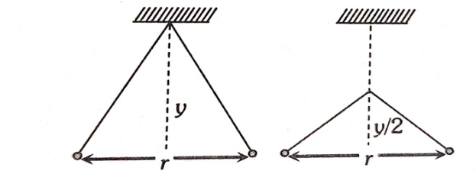

a) b) 

c) d)

1. Two small spheres of masses M1 and M2 are suspended by weightless insulating threads of lengths L1 and L2. The spheres carry charges Q1 and Q2 respectively. The spheres are suspended such that they are in level with one another and the threads are inclined to the vertical at angles of θ1 and θ2 as shown. Which one of the following condition is essential, if θ1= θ2? (KCET 2010)

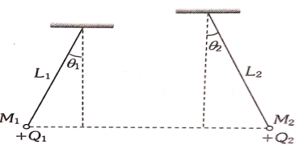 a) but 

b) 

c) 

d) 

1. Two charges each equal to q, are kept at x = -a and x =a on the x axis. A particle of mass m and charge q0= q/2 is placed at the origin. If charge q0 is given a small displacement ( y<<a) along y axis, the net force acting on the particle is proportional to (JEE main 2013)

a) y b) –y c) 1/y d) -1/y

1. Electric charges of 1μC, -1μC and 2μC are placed in air at the corners A, B and C respectively of an equilateral triangle ABC having length of each side 10 cm. the resultant force on the charge at C is (KCET 2015)

a)0.9 N b) 1.8 N c) 2.7 N d)3.6N

1. Two charges are at a distance d apart. If a copper plate (conducting medium) of thickness d/2 is placed between them, the effective force will be (KCET 2005)

a)2F b) F/2 c) 0 d) 

1. The total electric flux through a cube when a charge 8q is placed at one corner of the cube is (KCET 2010)

a)  b)  c)  d) 

1. The region between two concentric spheres of radii a and b, respectively , has volume charge density . Where A is a constant and r is the distance from the centre. At the centre of the spheres is a point charge Q. the value of A such that the electric field in the region between the spheres will be constant, is (JEE main 2016)

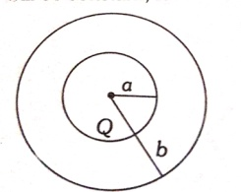 a)  b) 

c)  d) 

1. A charge q is placed at the centre of the line joining two equal charges Q. The system of three charges will be in equilibrium, if Q is equal to (KCET 2001 & 2004)

a) –Q/2 b) –Q/4 c) +Q/4 d)+Q/2

1. An electric dipole has a pair of equal and opposite point charges q and –q separated by a distance 2x. The axis of the dipole is defined as (KCET 2008)

a) Direction from positive charge to negative charge

b) Direction from negative charge to positive charge

c) Perpendicular to the line joining the two charges drawn at the centre and plotting upward

direction

d) Perpendicular to the line joining the two charges drawn at the centre and plotting downward

direction

1. An electric charge Q is placed at the centre of a cube of side a. The electric flux on one of its faces will be (KCET 2012)

a)  b)  c)  d) 

1. The SI unit of electric flux is (KCET 2001)

a)weber b) volt x metre

c) newton per coulomb d) joule per coulomb

1. If Ea be the electric field strength of a short dipole at a point on its axial line and Ee that on equatorial line at the same distance, then (KCET 2004)

a) Ee = 2Ea b) Ea = 2Ee c) Ee = Ea d) none of the above

1. An electric dipole consisting of two opposite charges of 2x10-6 C each separated by a distance of 3 cm is placed in an electric field of 2 x 105 N/C. The maximum torque on the dipole will be ( in Nm) (NEET Karnataka 2013)

a) 12 x 10-1 b) 12x 10-3 c) 24 x 10-1 d) 24 x 10-3

1. Identify the wrong statement in the following. Coulomb’s law correctly describes the electric force that (KCET 2005)

a) binds the electron of an atom to its nucleus

b) binds the proton and neutron in the nucleus of an atom

c) binds atoms together to form molecules

d)binds atoms and molecules together to form solids

1. A comb run through one’s dry hair attracts small bits of paper. This is due to (KCET 2006)

a) Comb is a good conductor

b) Paper is a good conductor

c) The atoms in the paper get polarised by the charged comb

d) The comb possesses magnetic properties

**ELECTROSTATIC POTENTIAL AND CAPACITANCE**

**UNIT NO. : P-11**

1. Three isolated equal charges q are placed at the three corners of an equilateral triangle. The statement which is true for net electric potential V and net electric field intensity E at the centre of the triangle is

a) E=0, V=0 b) V=0, E0 c) V0, E =0 d) V 0, E0

1. A hollow charged metal sphere has radius r. If the potential difference between its surface and a point at a distance 3r from the centre is V, then the electric field intensity at distance 3r from the centre is

a)  b)  c)  d) 

1. 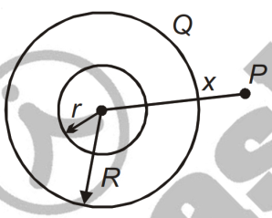Two concentric hollow conducting spheres of radius r and R are shown. The charge on outer shell is Q. What charge should be given to inner sphere so that the potential at any point P outside the outer sphere is zero?

a)  b) 

c) d) 

1. Figure shows the variation of electric field intensity E versus distance x. What is the potential difference between the points at x = 2 m and at x = 6 m from O?

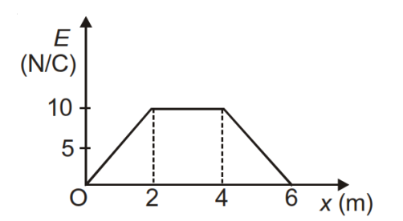

a) 30V

b) 60V

c) 40V

d) 80V

1. 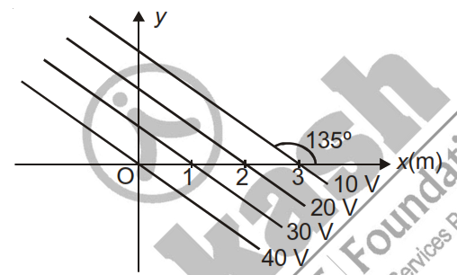Figure shows a set of equipotential surfaces. The magnitude and direction of electric field that exists in the region is

a)10 V/m at 45º with x-axis

b)10 V/m at –45º with x-axis

c) 5V/m at 45º with x-axis

d) 5 V/m at –45º with x-axis

1. Determine the electric field strength vector if the potential of this field depends on x, y coordinates as V = 10axy

a)  b) - c)  d) 

1. A particle A has charge +q and particle B has charge +4q with each of them having the same mass m. When allowed to fall from rest through the same electric potential difference, the ratio of their speeds VA /VB will become

a) 1 : 2 b) 2 : 1 c) 1 : 4 d) 4 : 1

1. Calculate the work done in taking a charge –2 × 10-9 C from A to B via C (in diagram)

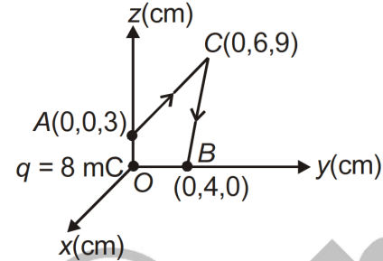

a) 0.2 joule

b) 1.2 joule

c) 2.2 joule

d) Zero

1. An electric dipole of length 2 cm is placed with its axis making an angle of 30° to a uniform electric field 105 N/C. If it experiences a torque of 10 Nm, then potential energy of the dipole

a) – 10 J b) – 20 J c) – 30 J d) – 40 J

1. Three charges –q, Q and –q are placed respectively at equal distances on a straight line. If the potential energy of the system of three charges is zero, then what is the ratio of Q : q ?

a) 1 : 1 b) 1 : 2 c) 1 : 3 d) 1 : 4

1. 1000 small water drops each of capacitance C join together to form one large spherical drop. The capacitance of bigger sphere is

a) C b) 10 C c) 100 C d) 1000 C

1. The following arrangement consists of five identical metal plates parallel to each other. Area of each plate is A and separation between the successive plates is d. The capacitance between P and Q is

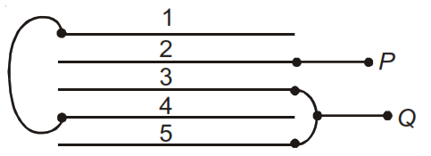a)  b) 

c)  d) 

1. Two similar conducting balls having charges +q and –q are placed at a separation d from each other in air. The radius of each ball is r and the separation between their centres is d

(d >>r). Calculate the capacitance of the two ball system

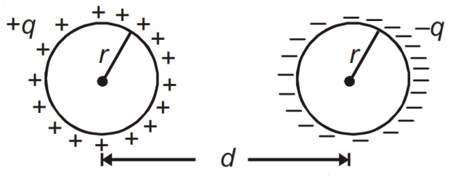

a) 4 b) 2

c) 4 d) 2

1. 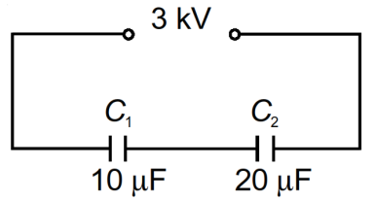Capacitors C1(10F) and C2(20F) are connected in series across a 3 kV supply, as shown. What is the charge on the capacitor C1?

a) 45000C b) 20000C

c) 15000C d) 10000C

1. In the circuit below, if a dielectric is inserted into C2 then the charge on C1 will

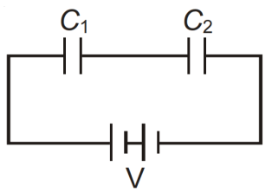 a) Increase

b) Decrease

c) Remain same

d) Be halved

1. A capacitor with plate separation d is charged to V volts. The battery is disconnected and a dielectric slab of thickness d/2 and dielectric constant ‘2’ is inserted between the plates. The potential difference across its terminals becomes

a) V b) 2V c) 4V/3 d) 3V/4

1. An uncharged parallel plate capacitor having a dielectric of constant K is connected to a similar air cored parallel capacitor charged to a potential V. The two capacitors share charges and the common potential is . The dielectric constant K is

a)  b)  c)  d) 

1. Three point charges q, q and –2q are placed at the corners of an equilateral triangle of side ‘L’. Calculate work done by external force in moving all the charges far apart without acceleration

a)  b)  c)  d) 

1. 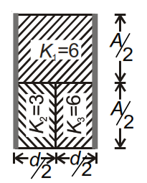Three different dielectrics are filled in a parallel plate capacitor as shown. What should be the dielectric constant of a material, which when fully filled between the plates produces same capacitance?

a) 4

b) 6

c) 5

d) 9

1. There exists a uniform electric field E= 4× 105 Vm–1 directed along negative x-axis such that electric potential at origin is zero. A charge of –200C is placed at origin, and a charge of

+200C is placed at (3 m, 0). The electrostatic potential energy of the system is

a) 120 J b) – 120 J c) – 240 J d) Zero

1. Find the charge on capacitor C3.Given that C1=C2=C and C3=C4=4C

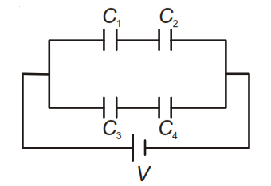

a)  b) 

c)  d) 

1. While working on a physics project at school physics lab, you require a 4F capacitor in a circuit across a potential difference of 1 kV. Unfortunately, 4F capacitors are out of stock in your lab but 2F capacitors which can withstand a potential difference of 400 V are available in plenty. If you decide to use the 2F capacitors in place of 4F capacitor, minimum number of capacitors required are

a) 16 b) 18 c) 20 d) 12

1. Electric charges having same magnitude of electric charge 'q ' coulombs are placed at

x = 1 m, 2 m, 4 m,8m ....... so on. If any two consecutive charges have opposite sign but the first charge is necessarily positive, what will be the potential at x = 0?

a) Infinity b) Zero c)  d) 

1. A series combination of n capacitors, each of value C1, is charged by a source of potential difference 4 V. When another parallel combination of n2 capacitors, each of value C2, is charged by a source of potential difference V, it has the same (total) energy stored in it, as the first combination has. The value of C2, in terms of C1, is then **[AIPMT (Prelims)-2010]**

a)  b)  c)  d)

1. Charges +q and –q are placed at points A and B respectively which are a distance 2L apart, C is the midpoint between A and B. The work done in moving a charge +Q along the semicircle CRD is **[AIPMT (Prelims)-2007**]

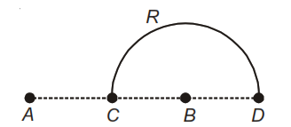a)  b) 

c)  d) 

1. 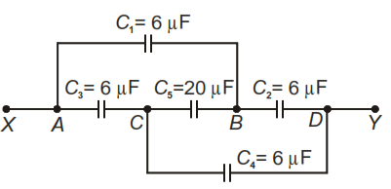What is the effective capacitance between points X and Y?
2. 12
3. 18
4. 24
5. 6
6. Identical charges (–q) are placed at each corners of cube of side b then electrostatic potential energy of charge (+q) which is placed at centre of cube will be

a)    

1. 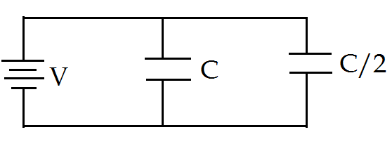Two condensers, one of capacity C and other of capacity C/2 are connected to a V-volt battery, as shown in the figure. The work done in charging fully both the condensers is

a) (1/4) CV2 b) (3/4) CV2

c) (1/2) CV2 d) 2CV2

1. Two metallic spheres of radii 1cm and 2cm are given charges 10-2 C and 5x10-2C respectively. If they are connected by a conducting wire, the final charge on the smaller sphere is

a) 3x10-2C b) 4x10-2C c) 1x10-2C d) 2x10-2C

1. Two charged spheres of radii R1 and R2 having equal surface charge density. The ratio of their potential is

a)    

1. A sphere of radius 1cm has potential of 8000V, then energy density near its surface will be

a) 64x105J/m3 b) 2.83 J/m3 c) 8x103 J/m3 d) 32 J/m3

1. A ball of mass 1gm and charge 10-8 C moves from a point A, where the potential is 600V to the point B where the potential is zero. velocity of the ball of the point B is 20cm/s. The velocity of the ball at the point A will be

a)16.8m/s b) 22.8cm/s c) 228m/s d) 168m/s

1. A small conducting sphere of radius r is lying concentrically inside a bigger hollow conducting sphere of radius R. The bigger and smaller sphere are charged with Q and q(Q>q) and are insulated from each other. The potential difference between the spheres will be

a)  b) 

c)  d) 

1. Two spherical conductors of radii r1 and r2 are at potential V1 and V2 respectively, and then what will be the common potential when the conductors are brought in contact?

a)  b)  c)  d) none of these

1. A 5F capacitor is charged by a 220V supply. It is then disconnected from the supply and is connected to another uncharged 2.5F capacitor. How much energy of the first capacitor is lost?

a) 0.02J b) 0.121J c) 0.04J d) 0.081J

1. The plates of parallel plate capacitor are charged up to 100V.If 2mm thick plate is inserted between the plates, and then to maintain the same potential difference, the distance between the capacitor plate is increased by 1.6mm. The dielectric constant of the plate is

a) 5 b) 4 c) 1.25 d) 2.5

1. 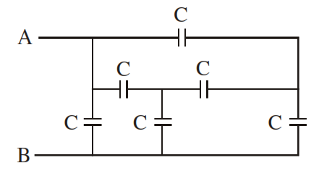Find the equivalent capacitance of the system across terminals A and B.

a) 2C b) 4C

c) 3C d) 5C

1. A parallel plate capacitor has the space between its plates filled by two slabs of thickness d/2 each and dielectric constant K1 and K2 . If d is the plate separation of capacitor , then capacity of the capacitor is

a)  b) 

c)  d) 

1. 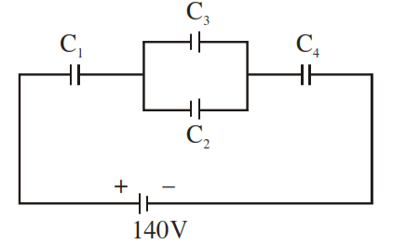In the circuit arrangement shown in the figure, the value of C1=C2=C3=30pF and C4=120pF. If the combination is charged with 140V DC supply, the potential difference across fourcapacitors will be respectively

a) 80V, 40V, 40V and 20V b) 20V, 40V, 40V and 80V

c) 35V, 35V, 35V and 35V d) 80V, 20V, 20V and 20V

1. 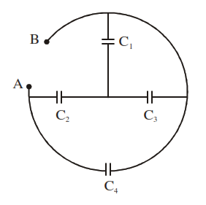In the arrangement of capacitors shown in the figure, each capacitor is 9F, then equivalent capacitance between A and B is

a) 18F b) 9F

c) 15F d) 4.5F

1. n identical capacitors are grouped in series ,n such capacitors are grouped in parallel. These two groups are connected in series .The effective capacitance of the combination is

a) nC b)  c)  d) 

**PREVIOUS YEAR QUESTIONS**

1. A 60 pF capacitor is fully charged by a 20 V supply. It is then disconnected from the supply

and is connected to another uncharged 60 pF capacitor is parallel. The electrostatic energy

that is lost in this process by the time the charge is redistributed between them is (in nJ**)**

**[JEE MAINS 2020]**

a) 6 b) 10 c) 12 d)20

1. A parallel plate capacitor has plates of area A separated by distance 'd' between them. It is

filled with a dielectric which has a dielectric constant that varies as k(x) = K(1 + x) where

'x' is the distance measured from one of the plates. If (d) <<1, the total capacitance of the

system is best given by the expression  **[JEE MAINS 2020]**

 

 

1. Effective capacitance of parallel combination of two capacitors C1 and C2 is 10 µF. When

these capacitors are individually connected to a voltage source of 1V, the energy stored in the

capacitor C2 is 4 times that of C1. If these capacitors are connected in series, their

effective capacitance will be : **[JEE MAINS 2020]**

a) 3.2 µF b) 8.4 µF c) 1.6 µF d) 4.2 µF

1. Two identical capacitors A and B, charged to the same potential 5V are connected in two

different circuits as shown below at time t = 0.If the charge on capacitors A and B at time

t = CR is QA and QB respectively, then (Here e is the base of natural logarithm)

**[JEE MAINS 2020]**

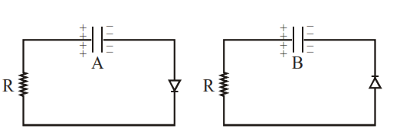  

 

1. A capacitor is made of two square plates each of side 'a' making a very small angle between

them, as shown in figure. The capacitance will be close to **[JEE MAINS 2020]**

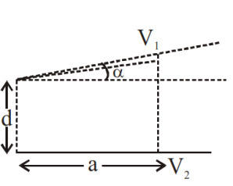  

 

1. In the circuit below, if a dielectric is inserted into C2 then the charge on C1 will

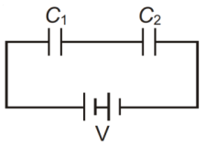 a) Increase

b) Decrease

c) Remain same

d) Be halved

1. A capacitor is charged by a battery. The battery is removed and another identical uncharged capacitor is connected in parallel. The total electrostatic energy of resulting system

**[NEET-2017]**

a) Increases by a factor of b) Decreases by a factor of 2

c) Remains the same d) Increases by a factor of 2

1. The diagrams below show regions of equipotentials**. [NEET-2017]**

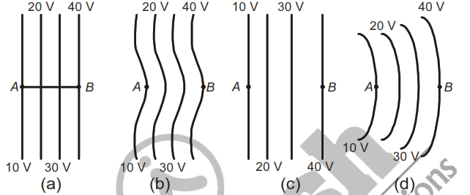 A positive charge is moved from A to B in each diagram.

1. Maximum work is required to move q in

figure(c)

b) In all the four cases the work done is the same.

c) Minimum work is required to move q in

figure (a).

d) Maximum work is required to move q in

figure(b).

1. A, B and C are three points in a uniform electric field. The electric potential is [**NEET-2013]**

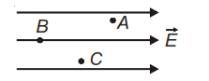a) Maximum at B

b) Maximum at C

c) Same at all the three points A, B and C

d) Maximum at A

1. 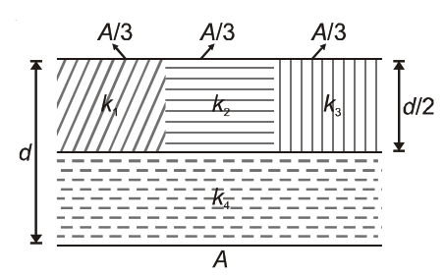A parallel-plate capacitor of area A, plate separation d and capacitance C is filled with four dielectric materials having dielectric constants k1, k2, k3 and k4 as shown in the figure below. If a single dielectric material is to be used to have the same capacitance C in this capacitor, then its dielectric constant k is given by **[NEET (Phase-2)-2016]**

a)  b) 

c)  d) 

1. A parallel plate air capacitor has capacity C, distance of separation between the plates is d and potential difference V is applied between the plates. The force of attraction between the plates of parallel plate air capacitor is  **[NEET-2016]**

a)  b)  c)  d) 

1. 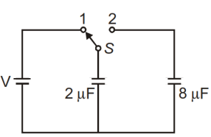A capacitor of 2F is charged as shown in the diagram. When the switch S is turned to position 2, the percentage of its stored energy dissipated is  **[NEET-2016]**

a) 80% b) 0%

c) 20% d) 75%

1. A parallel plate capacitor has a uniform electric field E in the space between the plates is d and area of plate is A. the energy stored in the capacitor is **[ JEE MAINS 2012,2011,2008]**

a) b)  c)  d) 

1. Three concentric spherical shells have radii a,b,c (a<b<c) and have surface charge densities  respectively. If VA ,VB and VC denote the potential of three shells, then for c=a+b, we have  **[JEE MAINS]**

a) VC=VB=VA b) VC=VBVA c) VCVBVA d) VA=VCVB

56.A capacitor of capacitance C charged by an amount Q is connected in parallel with an uncharged capacitor of capacitance 2C. The final charge on the capacitors are [**KCET 2019]**

a) Q/2,Q/2 b) Q/4,3Q/4 c) Q/3,2Q/3 d) Q/5,4Q/5

1. 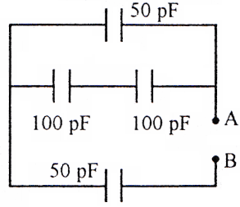The equivalent capacitance between A and B is, [**KCET 2019]**

a) 50 pF

b) (100/3) pF

c) 150 pF

d) 300pF

1. For the arrangement of capacitors as shown in the circuit, the effective capacitance between the points A and B in microfarad is (capacitance of each capacitor is 4 F ) [**KCET 2018]**

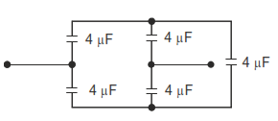a) 4

b) 2

c) 1

d) 8

1. The work done to move a charge on an equipotential surface is[**KCET 2018]**

a) Infinity b) Less than 1 c) Greater than 1 d) Zero

1. The resultant capacitance between the points A and B is

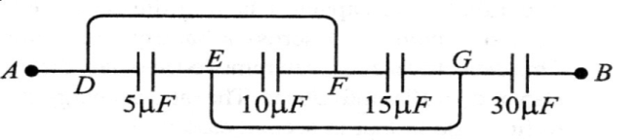a)  b) 

c) 60 d) 

1. Four charges of same magnitude q are placed at four corners of a square of side a. The value of electric potential at the centre of the square will be

a)  b)  c)  d) 

**CURRENT ELECTRICITY**

**UNIT NO : P-12**

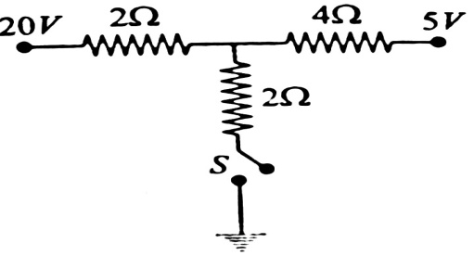

1. As the switch S is closed in the circuit shown, the current

passed through it is

a) 6A b) 4.5A

c) 3A d) Zero

1. A battery of emf E produces currents I1 and I2 when connected to external resistances R1 and R2 respectively. The internal resistance of the battery is

a) b)  c) d) 

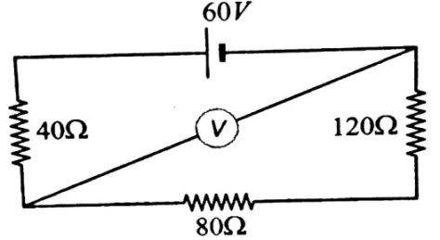

1. In the given circuit, the resistance of the voltmeter is 800. Its

reading is

a) 40 V b) 60V

c) 50 V d) 48 V

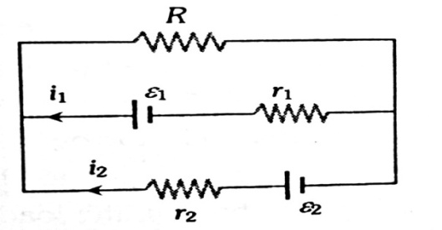

1. For the electrical circuit given, which of the following equation

is correct

 

 

1. 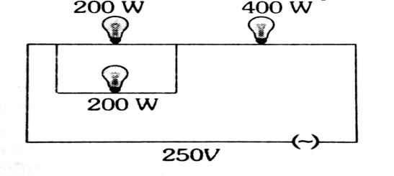Three electric bulbs of 200W,200W and 400W are shown in

the figure. The resultant power of the combination is

a) 800W b) 400W

c) 200W d) 600W

1. In the circuit shown, the magnitude and direction of flow of current through the point e is

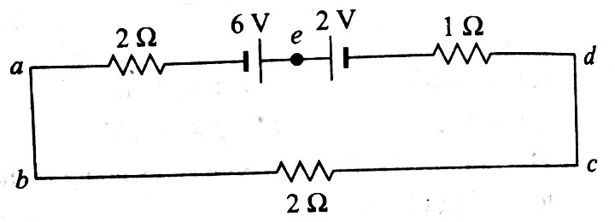a) 1A from a to d through e

b) 7/3A from d to a through e

c) 0.4A from d to a through e

d) 0.8A from a to d through e

1. 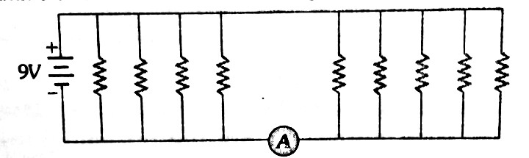If each resistance in the figure is of 9then reading of

the ammeter is

a) 5A b) 8A

c) 2A d) 9A

1. Two metal wires of identical dimension are connected in series. If and are the conductivities of the metal wires respectively, the effective conductivity of the combination is

a)  b) c) d)

1. To get maximum current through a resistance of 3, one can use *n*parallel rows of *m* identical cells connected in series. If the total number of cells is 24 and the internal resistance of each cell is 0.5, then

a) *m*= 6, *n* = 4 b) *m* = 8, *n* = 3 c) *m* =2, *n* = 12 d) *m* = 12, *n* = 2

1. Carbon resistors, used in electronic circuits are marked for their value of resistance and

tolerance by colour code. A given resistor has colour scheme brown, red, green and gold.

Its value in ohm is

a) 5.2 x 10610% b) 2.4 x 1055% c) 1.2 x 10410% d) 1.2 x 1065%

1. 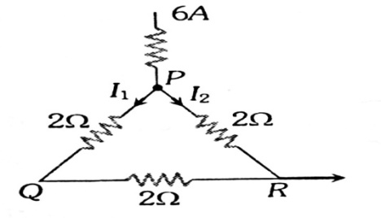If 6A is the entering current, then the current I1 and I2 are

a) 2A,4A

b) 4A,2A

c) 1A,2A

d) 2A,1A

1. When a resistance of 2 ohm is connected across the terminals of a cell, the current is 0.5A. When the resistance is increased to 5 ohm, the current is 0.25 A. The internal resistance of the cell is

a) 0.5ohm b) 1ohm c) 1.5 ohm d) 2 ohm

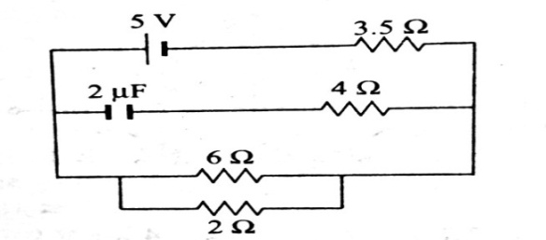

1. In the circuit shown, current through 2 resistor is

a) 0.25A b) 0.4A

c)0.75A d) 1A

1. 64 cells each of emf 8V and internal resistance 1 are used in mixed grouping. They send maximum current through an external resistance 4. The maximum current is

a) 4A b) 8A c)12A d) 16A

1. 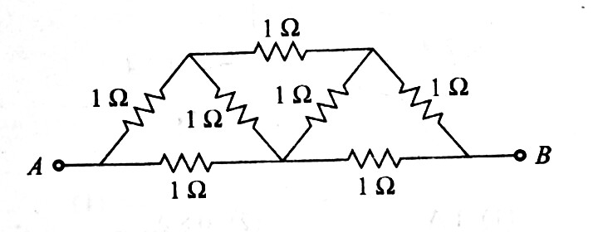The effective resistance of the network between A and B is

a) b)7

c) d)

1. **Assertion:** The drift velocity of electrons in a metallic wire will decrease, if the temperature of the wire is increased.

**Reason:** On increasing temperature, conductivity of metallic wire decreases.

a) Assertion is true, reason is false

b) Assertion is false, reason is true

c) Assertion is true, reason is true and reason is the correct explanation for assertion.

d) Assertion is true, reason is true and reason is not the correct explanation for assertion.

1. Two cities are 150 km apart. Electric power is sent from one city to another city through copper wires. The fall of potential per km is 8 volt and the average resistance per km is 0.5 ohm. The power loss in the wire is

a) 19.2J b) 12.2kW c) 19.2W d) 19.2kW

1. 5 cells , each of emf 0.2V and internal resistance 1ohm are connected to an external circuit of resistance of 10 ohm. The current through external circuit is

a)  b)  c) d) 



1. At what temperature will be the resistance of the copper wire becomes three times its value at 00C(=4 x 10-3 /0C)

a) 4000C b) 4500C c) 5000C d) 5560C

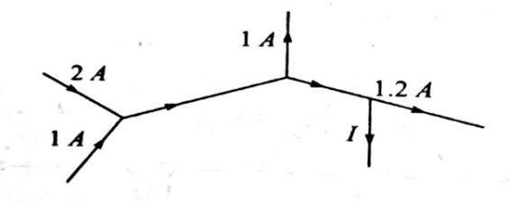

1. The current I in the circuit is

a) 1A b) 0.8A

c) 1.5A d) 0.5A

1. The maximum power drawn out of the cell from a source is given by

a)  b)  c) d) 

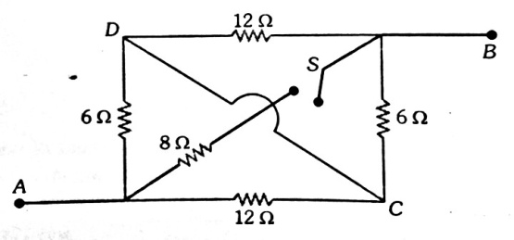

1. The equivalent resistance between points A and B with

switch S open and closed are respectively

a) 4, 8 b) 8, 4

c)6,9 d) 9,6

1. **Assertion:**In meter bridge experiment, a high resistance is always connected in series with a galvanometer.

**Reason:** As resistance increases current through the circuit increases.

a) Assertion is true, reason is false

b) Assertion is false, reason is true

c) Assertion is true, reason is true and reason is the correct explanation for assertion.

d)Assertion is true, reason is true and reason is not the correct explanation for assertion

1. 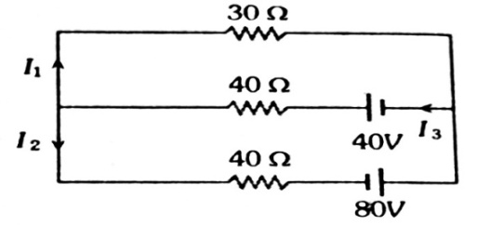In the given circuit the current I1 is

a) 0.4A b) -0.4A

c) 0.8A d) -0.8A

1. The resistivity and conductivity of a conductor change with temperature. As the temperature increases , the ratio of resistivity to conductivity

a) Increases b) decreases c) remains constant d) none of these

1. There are n similar conductors each of resistance R. The resultant resistance comes out to be  when connected in parallel. If they are connected in series, the resistance comes out to be

a) b) c) d)

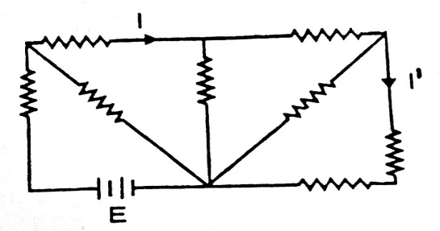

1. Consider the circuit below. All resistors are identical.

The ratio is

a) 8 b) 6

c) 5 d) 4

1. 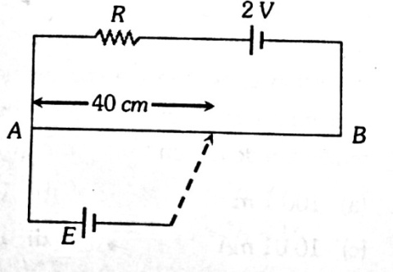AB is a potentiometer wire of length 100 cm and its resistance is

10. It is connected in series with a resistance R=40 and

a battery of emf 2V and negligible internal resistance. If a source

of unknown emf E is balanced by 40 cm length of the potentiometer

wire, the value of E is

a) 0.8V b) 1.6V

c) 0.08V d) 0.16V

1. Emf is most closely related to

a) Mechanical force b) potential difference

c)electric field d) magnetic field

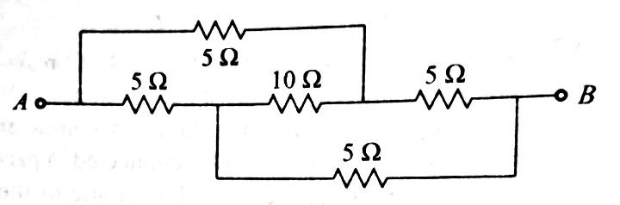

1. The effective resistance between A and B is

a) 5 b) 2.5

c) 10 d) 20

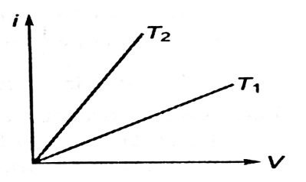

1. The current i and voltage V for a given metallic wire at two different

temperatures T1 and T2 are shown in the figure. It is concluded that

a) T1>T2 b) T1< T2

c) T1=T2 d) T1=2T2

1. When a current I is set up in a wire of radius r, the drift speed is Vd. If the same current passes through a wire of radius 2r, the drift speed will be

a) Vd/4 b) Vd/2 c) 2 Vd d) 4Vd

1. A filament bulb 500W,100V is to be used in a 230V main supply, when a resistance R is connected in series it works perfectly and bulb consumes 500W, the value of R is

a) 26  b) 13  c) 230  d) 46 

1. A copper wire of cross section area 2mm2 carries a current of 1A and its conductivity is

6.25 x 107 S/m. The electric field in the copper wire is

a) 8 x 10-3V/m b) 0.8x 10-3V/m c)56x 10-3V/m d) 78x 10-3V/m

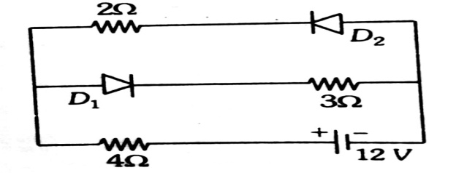

1. The circuit has two ideal diodes and resistors, then

the current flowing in the circuit

a) 2A b) 1.33A

* 1. c) 1.71A d) 2.31A

1. A p.d V is applied across a conductor of length *l*, drift velocity is Vd. The drift velocity when V is doubled and *l* is halved is

a) 4 Vd. b) 6 Vd. c) 8 Vd. d) 7 Vd.

1. In a potentiometer experiment two primary cells are connected in series to support each other and then to oppose each other. The balance points are obtained at 5m and 1m respectively. The ratio of emf of the two cells are

a) 4:1 b) 2:1 c) 5:3 d) 6:4

1. 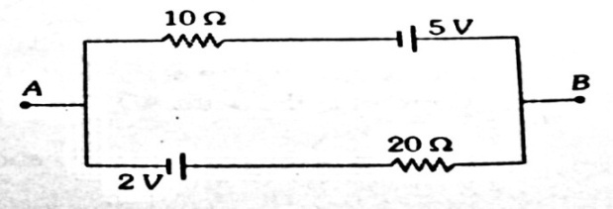The current in the given circuit is

a) 0.1A b) 0.2A

c) 0.3A d) 0.4A

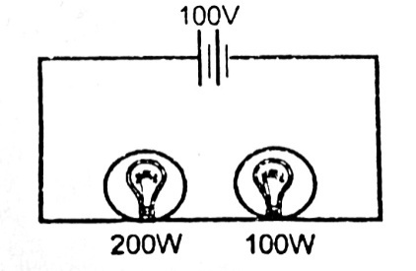

1. Two bulbs one of 200W and other of 100W are connected in

serieswith a 100V battery which has no internal resistance. Then,

a)current passing through 200W bulb is more than through100W bulb

b)current passing through 200W less is more than through100W bulb

c)power dissipation in the 200W bulb is more than that in the100W bulb

d)power dissipation in the 100W bulb is more than that in the200W bulb

1. Masses of three wires are in the ratio 1:3:5. Their lengths are in the ratio 5:3:1. If they are connected in series with a battery then the ratio of heats produced in them will be

a) 5:9:5 b) 25:9:6 c) 125:15:1 d) 25:15:9

1. When a Daniel cell is connected in the secondary circuit of the potentiometer, the balancing length is found to be 540cm. If the balancing length becomes 500 cm when the cell is short circuited with 1, the internal resistance of the cell is

a) 0.08 b) 0.04 c) 1 d) 1.08

1. When a car suddenly starts, the illuminance of head lights decreases. This is because, the

a) emf of the battery decreases b) internal resistance of the battery increases

c) current drawn from the battery decreases d) potential drop inside the battery increases.

1. Six resistors, each of resistance R, are connected to form a hexagon. The effective esistance between any two adjacent corners is

a)  b) 6R c) R d)

1. A thick wire is stretched so that its length becomes two times, assuming that there is no change in its density, what is the ratio of change in resistance of the wire to the initial resistance of the wire

a) 2:1 b) 4:1 c) 3:1 d)1:4

1. The current through a bulb is increased by 1%. Assuming that the resistance of the filament remains unchanged , the power of the bulb will be

a) increase by 1% b) decrease by 1% c)increase by 2% d) decrease by 2%

1. Copper and silicon is cooled from 300K to 60K, the specific resistance

a)decreases in copper but increases in silicon b) increases in both

c)increases in copper but decreases in silicon d) decreases in both

1. A material ‘B’ has twice the specific resistance of ‘A’. A circular wire made of ‘B’ has twice the diameter of a wire made of ‘A’. Then for the two wires to have the same resistance, the ratio  of their respective lengths must be

a) 0.5 b)0.25 c) 2 d) 1

1. Specific resistance of wire depends on

a) length b) Cross section area c) Mass d) None of these

1. 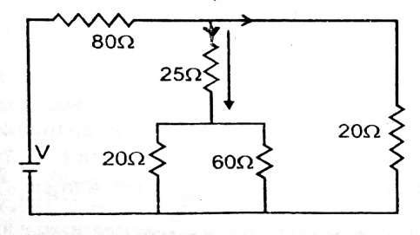A current of 0.1A flows through a 25 resistor represented by

the circuit diagram. The current in the 80 resistor is

a) 0.1A b) 0.2A

c) 0.3A d) 0.4A

1. An ammeter and a voltmeter are joined in series to a cell. Their readings are *A* and *V*respectively. If a resistance is now joined in parallel with the voltmeter, then

a) *A* will decrease*, V* will increase b)*A* will increase*, V* will decrease

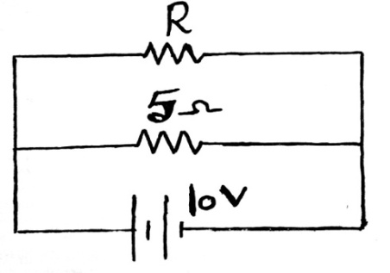c) both*A* and *V* will increase d) both *A* and *V* will decrease

1. The power dissipated in the circuit shown in the figure is 30 Watt.

The value of R is

a) 20 b) 15

c) 10 d) 30

1. The length of the conductor is halved , its conductivity will be

a)halved b) Unchanged c) Doubled d) None of these

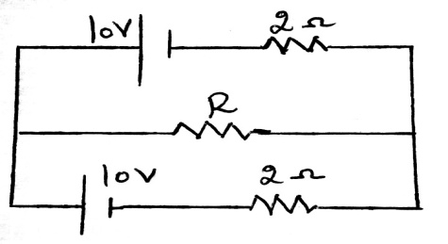

1. Maximum power developed across resistance R in the circuit is

a) 25W b) 50W

c) 75W d) 100W

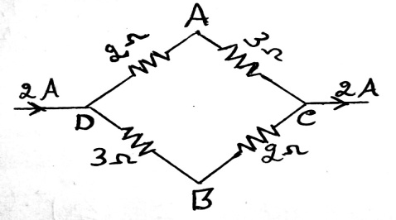

1. A current of 2A flows in a system of conductors shown.

The p.d VA-VB will be

a) 1V b) -1V

c) 2V d) -2V

1. 6 and 12 resistors are connected in parallel. This combination is connected in series with a

10 V battery and 6 resistor. What is the potential difference between the terminals of the 12 resistor?

a) 4V b) 16V c) 2V d) 8V

1. A wire of resistance 4 is stretched to twice its original length. The resistance of stretched wire would be:

a) 16 b) 2 c) 4 d) 8

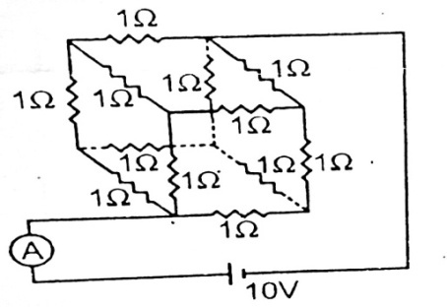

1. A battery of 10V and negligible internal resistance is connected

across the diagonally opposite corner of a cubical network

consisting of 12 resistors each of resistance 1. The total current I

in the circuit external to the network is

a) 0.83A b) 4A

c) 1A d) 12A

1. Two wires of the same material and equal length are joined in parallel combination. If one of them has half the thickness of the other and the thinner wire has a resistance of 8Ω, the resistance of the combination is equal to

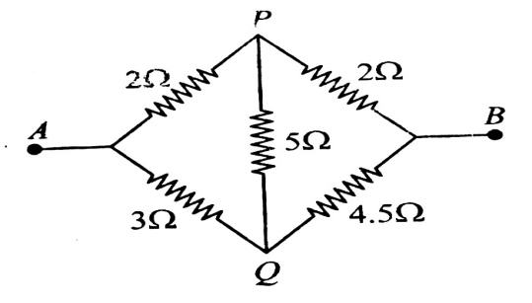a) 5/8 b) 8/5 c) 3/8 d) 8/3

1. The equivalent resistance of the network is

a) 2.6 b) 3.5

c) 6 d) 6.5

1. 4 cells each of emf 2V and internal resistance of 1 are connected in parallel to a load resistor of 2. Then the current through the load resistor is

a) 2A b) 1.5A c) 1A d) 0.888A

**MOVING CHARGES AND MAGNETISM & MAGNETISM AND MATTER**

**UNIT NO. : P - 13**

1. A cathode ray beam is bent in a circle of radius 2cm by a magnetic induction 4.5 10-3 weber/m2. The velocity of electron is

a) 3.43 107 m/s b) 5.37 107 m/s c) 1.23 107 m/s d) 1.58 107 m/s

1. A proton, deuteron and an $α$– particle enter a magnetic field perpendicular to field with same velocity. What is the ratio of the radii of circular paths?

a) 1 : 2 : 2 b) 2 : 1 : 1 c) 1 : 1 : 2 d) 1 : 2 : 1

1. The current sensitivity of moving coil galvanometer depends on

a) the number of turns in the coil b) moment of inertia of the coil

c) current sent through galvanometer d) eddy current in Al frame

1. In cyclotron the resonance condition is

a) The frequency of revolution of charged particle is equal to the frequency of A.C. voltage sources

b)The frequency of revolution of charged particle is equal to the frequency of applied magnetic field

c)The frequency of revolution of charged particle is equal to the frequency of rotation of earth

d) The frequency of revolution of charged particle, frequency of A.C. source and frequency of magnetic field are equal

1. A moving coil galvanometer has a resistance of 900 $Ω$. In order to send only 10% of the main current through this galvanometer, the resistance of the required shunt is

a)0.9  b) 100 c) 405 d) 90

1. A portion of a conductive wire is bent in the form of a semicircle of radius r as shown below in Fig. At the centre of semicircle, the magnetic induction will be

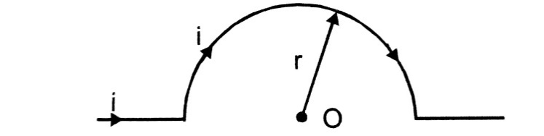a)Zero b) infinite

c) $\frac{μ_{0}}{4 π}$. $\frac{π i}{r}$ gauss d) $\frac{μ_{0}}{4 π}$. $\frac{π i}{r}$ tesla

1. A helium nucleus makes a full rotation in circle of radius 0.8 meter in 2 second. The value of the magnetic field induction B in tesla at the centre of circle will be

a)2 10-190 b) 10-19 /0 c) 10-190 d) 2 10-200

1. The distance between two magnetic poles is doubled and the pole strength of each is halved. How will the force between them change?

a) Halved b) Unchanged c)Double d) Becomes (1/16) times

1. A straight wire carrying current I is turned into a circular loop. If the magnitude of magnetic moment associated with it in M.K.S unit is m, the length of wire will be

a) 4 $π$ Im b) $\sqrt{\frac{4πm}{I}}$ c) $\sqrt{\frac{4πI}{m}}$ d) $\frac{mπ}{4I}$

1. A magnetic needle is lying in equilibrium in a uniform magnetic field B. To rotate it through 600, we need to spend energy W. How much torque needs to be applied to keep it in that position?

a) $\frac{\sqrt{3 } W}{2}$ b) $\frac{1}{2}$ W c) $\sqrt{3}$ W d) W

1. Relation between vertical component ZE and horizontal component HE at a place where dip angle is 600 is

a) ZE = HE b) ZE = HE c) HE = ZE d) HE = ZE

1. The magnetic susceptibility of a material of a rod is 499. Permeability of vacuum is 410-7 H/m. Absolute permeability of the material of rod in H/m is

a) 10-4 b)10-4 c)10-4 d)10-4

1. 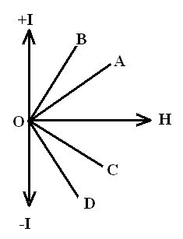The variation of the intensity of magnetization with respect to the magnetizing field in a diamagnetic substance is described by the graph

a) OC b) OD

c) OA d) OB.

1. A long solenoid carrying a current produces a magnetic field B along its axis. If the current is double and the number of turns per cm is halved, the new value of the magnetic field is

a) 4 B b) B/2 c) B d) 2 B

1. A current of 3 A is flowing in a linear conductor having a length of 40cm. The conductor is placed in a magnetic field of strength 500 gauss and makes an angle of 30 $°$ with the direction of filed. It experiences a force of magnitude

a) 3 10 - 4 N b) 3 10 - 2 N c) 3 10 2 Nd) 3 10 4 N

1. A proton and an $α$– particle enter a uniform magnetic field perpendicularly with the same speed. If proton takes 25 $μ$ second to make 5 revolutions, then the time period for the $α$– particle would be

a) 50 $μ$ second b) 25 $μ$ second c) 10 $μ$ second d) 5 $μ$ second

1. A square coil of side a carries a current I. The magnetic field at the centre of the coil is

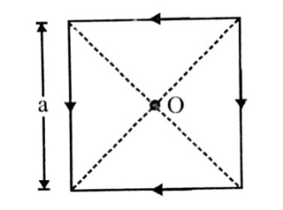

a) $\frac{μ_{0}I}{aπ}$ b) $\frac{\sqrt{2}μ_{0I}}{aπ}$

c) $\frac{μ_{0}I}{\sqrt{2}aπ}$ d) $\frac{2\sqrt{2}μ_{0}I}{aπ}$

1. Two thin, long, parallel wires , separated by a distance ‘d’ carry a current of ‘I’ A in the same direction . They will

a) repel each other with a force of 

b) attract each other with a force of 

c) repel each other with a force of 

d) attract each other with a force of 

1. The orbital speed of electron orbiting around a nucleus in a circular orbit of radius 50 pm is

2.2 x106ms-1. Then the magnetic dipole moment of an electron is

a)1.6x10-19 Am2  b) 5.3x10-21 Am2

c) 8.8x10-24 Am2 d)8.8x 10-26 Am2

1. A deuteron of kinetic energy 50ke V is describing a circular orbit of radius 0.5m,in a plane perpendicular to magnetic field. The kinetic energy of a proton that describes a circular orbit of radius 0.5m in the same plane with the same magnetic field  is

a) 200keV b) 50keV c) 100keV d) 25kev

1. 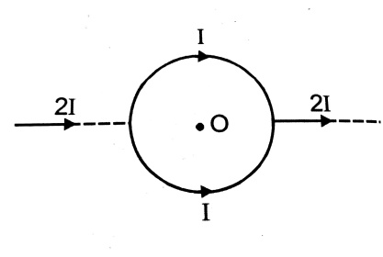An infinite straight conductor carrying current 2 I is split into a loop of radius r as shown in fig. the magnetic field at the centre of the coil is

a) b)

c)  d) zero

1. A conducting circular loop of radius r carries a constant current i. It is placed in a uniform magnetic field  such that  is perpendicular to the plane of the loop. The magnetic force acting on the loop is

a) ir B0 b)  c) zero d) 

1. 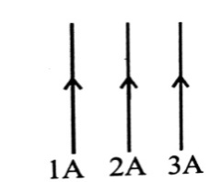Three wires are situated at the same distance. A current of 1A,2A,3A flows through these wires in the same direction. What is ratio of F1/F2 ,where F1 is force on 1 and F2 on 2 ?

a)7/8 b) 1

c) 9/8 d) None of these

1. 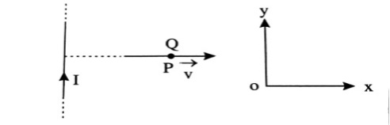A very long straight wire carries a current I. At the instant when a charge + Q at point P has velocity, as shown , the force on the charge is

a)along oy b) opposite to oy

c) along ox d) opposite to ox

1. A uniform electric field and uniform magnetic field are acting along the same direction in a certain region. If an electron is projected in the region such that its velocity is pointed along the direction of fields, then the electron

a) will turn towards right of direction of motion

b) speed will decrease

c) speed will increase

d) will turn towards left direction of motion

1. 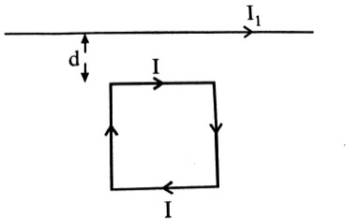A square loop, carrying a steady current I, is placed in a horizontal plane near a long straight conductor carrying a steady current I1 at a distance d from the conductor as shown in figure. The loop will experience

a) a net repulsive force away from the conductor

b) a net torque acting upward perpendicular to the horizontal plane

c) a net toque acting downward normal to the horizontal plane

d) a net attractive force towards the conductor

1. Two similar coils of radius R are lying concentrically with their planes at right angles to each other. The currents flowing in them are I and 2 I, respectively. The resultant magnetic field induction at the centre will be

a) $\frac{\sqrt{5}μ_{0}I}{2R}$ b) $\frac{3μ_{0I}}{2R}$ c) $\frac{μ_{0I}}{2R}$ d) $\frac{μ_{0I}}{R}$

1. Electron move at right angle to a magnetic field of 1.5 10-2 tesla with speed of 6 107 m/s. If the specific charge of the electron is 1.7 1011 C/kg. The radius of circular path will be

a) 3.31 cm b) 4.31 cm c) 1.31 cm d) 2.35 cm

1. A charged particle moves through a magnetic field in a direction perpendicular to it. Then the

a)velocity remains unchanged b) speed of the particle remains unchanged

c) direction of the particle remains unchanged d)acceleration remains unchanged

1. In the magnetic meridian of certain place, the horizontal component of the earth’s magnetic field is 0.26 G and dip angle is 60o. The magnetic field of earth at this location is

a) 0.26 G b)0.13 G c) 0.52 G d) None of these

1. Gauss law in magnetism signifies

a) nonexistance of magnetic poles b)nonexistance of magnetic monopole

c) nonexistance of magnetic dipole d)nonexistance of magnetic field

1. Assertion(A): When small holes are made in the body of the magnet, its magnetic moment decreases

Reason (R):for a magnet intensity of magnetization remains constant and on making holes, magnetized volume decreases, hence magnetic moment decreases

a) Both A and Rare true and R is the correct explanation of A

b) Both A and R are true and R is not correct explanation of A

c)A is true , but R is false

d) A is false, but R is true

1. If a magnet is suspended at an angle 30 $°$ to the magnetic meridian, the dip needle makes an angle of 60 $°$ with the horizontal. The true value of dip is

a) tan-1(2/3) b) tan-1(3/2) c) tan-1(3) d) tan-1(2)

1. When a bar magnet is suspended in an uniform magnetic field, then the torque acting on it will be

List – 1 List – 2

a. Maximum e. $θ$ = 45 $°$ with the field

b. half of the maximum value f. $θ$ = 60 $°$ with the field

c. $\sqrt{3}$/ 2 times the maximum g. $θ$ = 30 $°$ with the field

d. 1 / $\sqrt{2}$ times the maximum h. $θ$ = 90 $°$ with the field

a) a-h, b-g, c-f, d-e b) a-e, b-f, c-g, d-h c) a-f, b-e, c-g, d-h d) a-h, b-f, c-g, d-e

1. The neutral point in the magnetic field of a horizontally placed bar magnet is a point where magnetic field due to the bar magnet is:

a) Zero b) more than that of the earth

c) less than that of the earth d) equal to that of earth

1. A bar magnet of magnetic moment 4 Am2 is free to rotate about a vertical axis through its centre. The magnet is released from rest from east-west position. Kinetic energy of the magnet in north – south position will be (B = 25 T)

a)10-2J b) 10-4J c) 10-6J d) 0

1. A paramagnetic substance of susceptibility 3 10-4 is placed in a magnetic field of

4 10-4 Am-1 Then the intensity of magnetization in the units of Am-1 is

a) 1.33 108 b) 0.75 10-8 c) 12 10-8 d) 14 10-8

1. Needles N1, N2 and N3 are made of a ferromagnetic, a paramagnetic and a diamagnetic substance respectively. A magnet when brought close to them will

a) Attract N1 and N2 strongly but repel N3

b) Attract N1 strongly, N2 weakly and repel N3 weakly

c) Attract N1 strongly, but repel N2 and N3 weakly

d) Attract all three of them

1. Rate of change of torque $τ$ with deflection $θ$ is maximum for a magnet suspended freely in a uniform magnetic field of induction B, when

a) $θ$ = 0 $°$ b) $θ$ = 45 $°$ c) $θ$ = 60 $°$ d) $θ$ = 90 $°$

1. The coercivity of a small magnet where the ferromagnet gets demagnetized is 3 103 Am-1. The current required to be passed in a solenoid of length 10 cm and number of turns 100, so that magnet gets demagnetized when inside the solenoid, is

a) 6A b) 30 mA c) 60 mA d)3A

1. If the magnetic dipole moment of an atom of diamagnetic material, paramagnetic material and ferromagnetic material are denoted by d,pand f respectively, then

a)d = 0 and p 0 b)d0 and p = 0

c)p = 0 and f 0 d)d  0 and f 0

1. 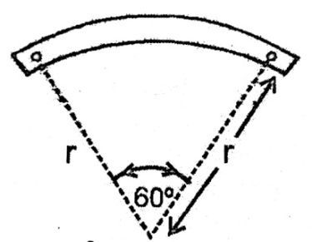A bar magnet of length ‘l’and magnetic dipole moment ‘M’ is bent in the form of an arc as shown in figure. The new magnetic dipole moment will be

a) $\frac{3}{π}$ M b) $\frac{2}{π}$ M

c) $\frac{M}{2}$ M d) M

1. A bar magnet having a magnetic moment of 2 104 JT-1 is free to rotate in a horizontal plane. A horizontal magnetic field B=6×10-4T exist in the space. The work done in taking the magnet slowly from a direction parallel to the field to a direction 600 from the field is

a)12J b) 6J c) 2J d) 0.6J

1. A dip needle lies initially in the magnetic meridian when it shows an angle of dip  at a place. The dip circle is rotated through an angle x in the horizontal plane and then it shows an angle of dip . Then $\frac{\tan{}}{\tan{`}}$ is

$a)\frac{1}{\cos{x}}$ b) $\frac{1}{\sin{x}}$ c) $\frac{1}{\tan{x}}$ d) $\cos{x}$

1. The length of a magnet is large compared to its width and breadth. The time period of its oscillation in a vibration magnetometer is 2s .The magnet is cut along its length into three equal parts and three parts are then placed on each other with their like poles together. The time period of this combination will be

a) 2s b) 2/3 s c) $2\sqrt{3 }$ s d) $\frac{2}{\sqrt{3}}$ s

1. Time period of a freely suspended magnet does not depend upon

a) Length of the magnet

b) Pole strength of the magnet

c) Horizontal component of earth’s magnetic field

d) Length of the suspension thread

1. Time periods of vibration of two bar magnets in sum and difference positions are 4 second and

6 second respectively. The ratio of their magnetic moments $\frac{M_{1}}{M_{2}}$ is

a) 6 : 4 b) 30 : 16 c) 2.6 : 1 d) 1.5 :1

1. A coil of one turn is made of a wire of certain length and then from the same length a coil of two turns is made. If the same current is passed in both the cases, then the ratio of the magnetic induction at their centers will be

a) 2:1 b) 1:4 c) 4:1 d) 1:2

1. A cell is connected between two points of a uniformly thick circular conductor and I1 and I2 are the currents flowing in two parts of the circular conductor of radius a. The magnetic field at the centre of the loop will be

a)zero b) (I1 – I2) c) (I1 + I2) d) (I1 + I2)

1. A proton carrying 1 Me V kinetic energy is moving in a circular path of radius R in uniform magnetic field. What should be the energy of a $α$- particle to describe a circle of same radius in the same field ?

a) 2MeV b) 1 MeV c) 0.5 MeV d) 4MeV

1. An electron beam is shot into a region containing electric field of 10NC-1 and magnetic field of 2T.If the electron beam passes undeviated, then velocity of electron beam in ms-1 is

a) 5 b) 0.2 c) 20 d) zero

1. An electron moving with a velocity of 106ms-1 enters a magnitic field first at an angle 900 and then at 450 to the field.The forces acting on the electron in two cases are in the ratio

a) b)  c)  d)

1. A current of 1A is passing in the sides of equilateral triangle of each side .The magnetic field at the centroid

a) 2.1T b)  c) 3.2T d) 5.01T

1. What is the relation between voltage sensitivity and current sensitivity of MCG. Where G is galvanometer resistance

a)  =G b)  c) =G d) none

1. The time period of a freely suspended magnet is 4 s. If it is broken in length into two equal parts and one part is suspended in the same way, then its time period will be

a) 4 s b)2 s c) 0.5 s d) 0.25 s

1. A magnetic dipole is under the effect of two magnetic fields inclined at 75 $°$ to each other. One of the fields has a magnitude of 1.5 10-2 T. The magnets come to stable position at an angle of 30 $°$ with the direction of above field. The magnitude of other field is

a) 10-2 T b) 10-2 T c)1.5 10-2 T d)1.510-2 T

1. Two identical short bar magnets, each having magnetic moment of 10 Am2, are arranged such that their axial lines are perpendicular to each other and their centers be along the same straight line in a horizontal plane. If the distance between their centers is 0.2 m, the resultant magnetic induction at a point midway between them is

X10-7 T b) X10-7 T c)X10-3 T d) X10-3 T

1. The angle of dip at a place is $δ$. If the dip is measured in a plane making an angle $θ$ with the magnetic meridian, the apparent angle of dip $δ_{1}$ will be

a) tan-1 ( tan) b) tan-1 ( tan )

c) tan-1 ( tan ) d) 0

1. Two identical magnetic dipoles of magnetic moments 1.0 A-m2 each, placed at a separation of 2m with their axis perpendicular to each other. The resultant magnetic field at a point midway between the dipoles is

a)5 10-7 T b) 10-7 T c)10-7 T d) None of these

1. A bar magnet of length 6 cm has a magnetic moment of 4 JT-1. Find the strength of magnetic field at a distance of 200 cm from the centre of the magnet along its equatorial line.

a) 4 10-8 tesla b) 3.5 10-8 tesla c) 5 10-8 tesla d) 3 10-8 tesla

**EMI and AC**

**UNIT NO : P – 14**

1. A magnetic field of 2x10-2T acts at right angles to a coil of area 100cm2with 50 turns.The average e.m.f induced in the coil is 0.1V, when it is removed from the field in time t. The value of t is

(a) 0.1sec (b) 0.01sec (c) 1sec (d) 20sec

1. An average induced e.m.f of 1V appears in a coil when the current in it is changed from 10A in one direction to 10A in opposite direction in 0.5sec. Self inductance of the coil is

(a) 25mH (b) 50mH (c) 75mH (d) 100mH

1. The magnetic flux linked with a coil , in weber , is given by the equation . Then the magnitude of induced emf at t=2sec will be

(A) 2V (b) 4V (c) 8V (d) 16V

1. Magnetic flux in a circuit containing a coil of resistance 2changes from 2.0Wb to 10Wb in 0.2sec. The charge passed through the coil in this time is

(a) 0.8C (b) 1.0C (c) 5.0C (d) 4.0C

1. Two coils of self inductances 2mH and 8mH are placed so close together that the effective flux in one coil is completely linked with the other. The mutual inductance between these coils is

(a) 10mH (b) 6mH (c) 4mH (d) 16mH

1. A long solenoid has 500 turns. When a current of 2A is passed through it, the resulting magnetic flux linked with each the turn of the solenoid is 4x10-3Wb. The self inductance of the solenoid is

(a) 2.5H (b) 2.0H (c) 1.0H (d) 4.0H

1. The wing span of an aero-plane is 20m.It is flying in field where vertical component of magnetic field of earth is 5x10-5T, with velocity 360k/h. The potential difference produced between the blades will be

(a) 0.10V (b) 0.15V (c) 0.20V (d) 0.30V

1. A rectangular , a square, a circular and an elliptical loop , all in the(x-y) plane are moving out of a uniform magnetic field with a constant velocity, . The magnetic field is directed along the negative z-axis direction. The induced emf, during the passage of these loops, out of the field region , will not remain constant for

(a) the rectangular, circular and elliptical loops (b) the circular and the elliptical loops

(c) only the elliptical loop (d) any of the four loops

1. A conducting circular loop is placed in a uniform magnetic field , B= 0.025T with its plane perpendicular to the loop. The radius of the loop is made to shrink at the constant rate of 1mms-1. The induced emf when the radius is 2cm is

(a) 2 (b)  (c)  (d) 2

1. In a circular coil , when no. of turns is doubled and resistance becomes th of initial value, then inductance becomes

(a) 4 times (b) 2 times (c) 8 times (d) No change

1. In the given circuit the reading of voltmeter V1and V2 are 300V each. The reading of the voltmeter V3 and ammeter A are respectively

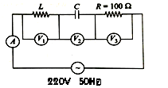

(a) 150V, 2.2A (b) 220V, 2.2A (c) 220V ,2A (d) 100V , 2A

1. What is the value of inductance L for which the current is a maximum in series LCR circuit with C=10F and =1000s-1 ?

(a) 100mH (b) 1mH

(c) can not be calaculated unless R is known (d) 10mH

1. A transformer is used to light a 100W and 110V lamp from a 220V mains. If the main current is 0.5A, the efficiency of the transformer is approximately;

(a) 30% (b) 50% (c) 90% (d) 10%

1. An AC voltage is applied to a resistance R and an inductor L in series. If R and inductive reactance are both equal to 3 , the phase difference between the applied voltage and current in the circuit is

(a)  (b)  (c) zero (d) 

1. In an ac circuit an alternating voltage e=200sin100t volt is connected to a capacitor of capacity 1F. The rms value of the current in the circuit is

(a) 100mA (b) 200mA (c) 20mA (d) 10mA

1. A coil has resistance 30and inductive reactance 20 at 50 Hz frequency. If an AC source of 200V, 100Hz, is connected across the coil, the current in the coil will be

(a) 4.0A (b) 8.0A (c) A (d) 2A

1. In an electrical circuit R, L, C and an AC voltage source are all connected in series. When L is removed from the circuit , the phase difference between the voltage and the current in the circuit is . If instead , C is removed from the circuit, the phase difference is again . The power factor of the circuit is

(a) 1/2 (b)  (c) 1 (d) 

1. A resistance R draws power P when connected to an AC source. If an inductance is now placed in series with the resistance, such that the impedance of the circuit becomes Z, the power drawn will be

(a) P (b)  (c) P (d) P

1. A series R-C circuit is connected to an alternating voltage source. Consider two situations.

(a) When capacitor is air filled.

(b) When capacitor is mica filled.

Current through resistor is I and voltage across capacitor is V then

(a)Va=Vb (b) Va<Vb (c) Va>Vb (d) ia=ib

1. An alternating voltage E=200sin(100t) is connected to 1microfarad capacitor through an AC ammter. The reading of the ammeter shall be

(a) 10mA (b) 20mA (c) 40mA (d) 80mA

1. The impedance of a circuit consists of 3 ohm resistance and 4 ohm reactance. The power factor of the circuit is

(a) 0.4 (b) 0.6 (c) 0.8 (d) 1.0

1. In the circuit shown below , the AC source has voltage V=20cos volts with =2000 rad/sec. the amplitude of the current will be nearest to

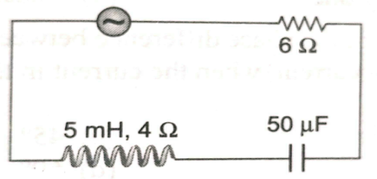

(a) 2A (b) 3.3A (c) A (d) A

1. A 20 volts AC is applied to a circuit consisting of a resistance and a coil with negligible resistance. If the voltage across the resistance is 12V, the voltage across the coil is

(a) 16 volt (b) 10 volt (c) 8 volt (d) 6 volt

1. Current in the circuit is wattles, if

(a) Inductance in the circuit is zero (b) resistance in the circuit is zero

(c) Current is alternating (d) Resistance and inductance both are are zero

1. A series resonant L-C-R circuit has a quality factor 0.4 and a band width of 1.3kHz. If R=2k, C=0.1F then the value of inductance is:

(a) 0.1H(b)0.64H (c) 2H(d) 10H

1. The co-efficient of self inductance of a solenoid is 0.18mH. If a core of soft iron of relative permeability 900 is inserted, then the coefficient of self inductance will become nearly

(a) 5.4mH (b) 162mH (c) 0.006mH (d) 0.0002mH

1. A wire of length of 1m is moving at a speed of 2m/s perpendicular to its length and a homogeneous magnetic field of 0.5T. The ends of the wire are joined to a circuit of resistance 6. The rate at which work is being done to keep the wire moving at constant speed is

(a) W (b) W (c) W (d) 1W

1. A lamp consumes only 50% of peak power in an ac circuit. What is the phase difference between the applied voltage and the circuit current

(a)  (b)  (c) (d) 

1. The phase difference between the flux linkage and the induced e.m.f. in a rotating coil in a uniform magnetic field

(a)  (b)  (c) (d) 

1. A short circuited coil is placed in a time-varying magnetic field. Electrical power is dissipated due to the current induced in the coil . If the number of turns were to be quadrupled and wire radius halved , the electrical power dissipated would be

(a) Halved (b) The same (c) Doubled (d) Quadrupled

1. A copper disc of radius 0.1m rotates about its centre with the 10 revolution per second in a uniform magnetic field of 0.1T. The emf induced across the radius of the disc is

(a)  V (b) V (c) 10mV (d) 20mV

1. The armature of dc motor has 20 resistance. It draws current of 1.5A when run by 220V dc supply. The value of back emf induced in it will be

(a) 150V (b)170V (c) 180V (d) 190V

1. In an AC circuit, the current is given by i=5sinand the AC potential is V=200sin(100t) volt. Then the power consumption is

(a) 20W (b) 40W (c) 1000W (d) 0W

1. In a circuit , the value of the alternating current is measured by hot wire ammeter as 10A. its peak value will be

(a) 10A (b) 20A (c) 14.14A (d) 7.07A

1. The rms value of an AC of 50Hz is 10A. The time taken by the alternating current in reaching from the zero to maximum value and the peak value of the current will be

(a) 2x10-2sec and 14.14A (b) 1x10-2sec and 7.07A

(c) 5x10-3sec and 7.07A (d) 5x10-3sec and 14.14A

1. A wire loop is rotated in a magnetic field. The frequency of change of direction of the induced emf is

(a) Once per revolution (b) Twice per revolution

(c) four times per revolution (d) six times per revolution

1. 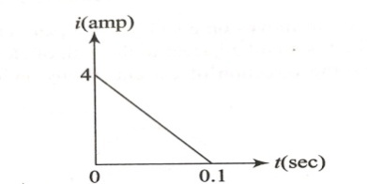In a coil of resistance 10, The induced current developed by changing magnetic flux through it, is shown in figure as function of time. The magnitude of change in flux through the coil in weber is

(a) 8 (b) 2 (c) 6 (d) 4

1. A long solenoid has 1000 turns when a current of 4A flows through it , the magnetic flux linked with each turn of the solenoid is 4x103 Wb. The self inductance of the solenoid is

(a) 1H (b) 4H (c) 3H (d) 2H

1. Pure inductance of 3.0H is connected as shown below The equivalent inductance of the circuit is

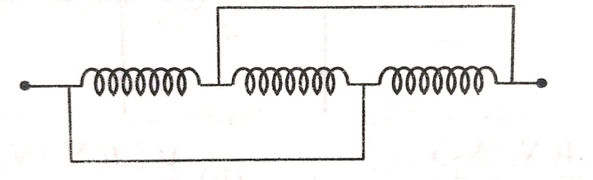

(a) 1H (b) 2H (c) 3H (d) 9H

1. In the figure magnetic energy stored in the coil is

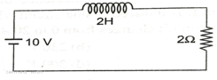

(a) zero (b) infinite (c) 25J (d) none of the above

1. A Solenoid has 200 turns wound over length of 0.30m.The area of its cross-section is 1.2x10-3m2. Around its central section a coil of 300 turns is wound. If an initial current of 2A in the solenoid is reversed in 0.25second, then the emf induced in the coil is

(a) 6x10-4V (b) 4.8x10-3V (c) 6x10-2V (d) 48mV

1. The mutual inductance between primary and secondary circuit is 0.5H. The resistances of the primary and the secondary circuit are 20 and 5 respectively. To generate a current of 0.4A in the secondary , current in the primary must be changed at the rate of

(1) 4.0A/s (b) 16A/s (c) 1.6A/s (d) 8.0A/s

1. In a circuit, L, C and R are connected in series with an alternating voltage source of frequency f . The current leads the voltage by 450 . The value of C is  
   (a)  (b)  (c)  (d) 
2. A conducting rod PQ of length L = 1.0m is moving with a uniform speed v=2m/s in a uniform magnetic field B=4T directed in to the paper. A capacitor of capacity C= 10F is connected as shown in the figure. Then

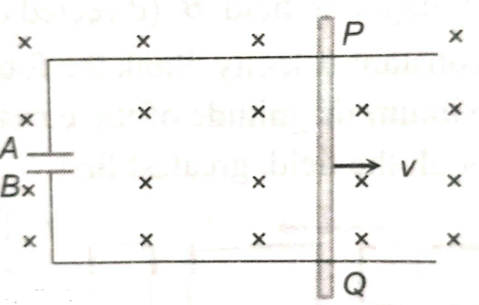

(a) qA=+80C and qB=-80C

(b) qA=-80C and qB=+80C

(c) qA=0 =qB

(d) charge stored in the capacitor increases exponentially with time

1. A straight wire of length L is bent in to a semicircle. It is moved in a uniform magnetic field with speed v with diameter perpendicular to the field. The induced emf between the ends of the wire is

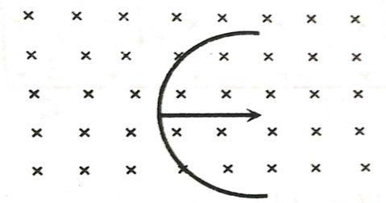

(a) Blv (b) 2Blv (c) 2Blv (d) 

1. 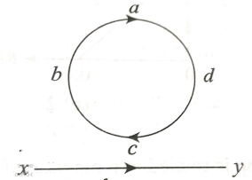An electron moves on a straight line path XY as shown. The abcd is a coil adjacent to the path of an electron. What will be the direction of current, if any , induced in the coil?

(a) No current induced (b) abcd (c) adcb

(d) the current will reverse its direction as the electron goes past to the coil

1. A coil of 40H inductance is connected in series with a resistance of 8 ohm and the combination is joined to the terminals of a 2V battery. The time constant of the circuit is

(a) 5s (b) 1/5s (c) 40s (d) 20s

1. A coil of inductive reactance 31has a resistance of 8. It is placed in series with a condenser of capacitive reactance 25. The combination is connected to an ac source of 110V. The power factor of the circuit is

(a) 0.56 (b) 0.64 (c) 0.80 (d) 0.33

1. A transistor-oscillator using a resonant circuit with an inductor L( of negligible resistance) and capacitor C in series produce oscillation of frequency f. If L is doubled and C is changed to 4C, the frequency will be

(a) f/4 (b) 8f (c) f/2 (d) f/2

1. The primary and secondary coils of transformer have 50 and 15400 turns respectively. If the magnetic flux linked with the primary coil is given by , where is in weber, t is time in second and is a constant, the output voltage across the secondary coil is

(a) 90V (b) 120V (c) 220V (d) 30V

1. A coil having n turns and resistance R is connected with a galvanometer of resistance 4R. This combination is moved in time t seconds from a magnetic field W1 weber to W2 weber. The induced current in the circuit is

(a)  (b)  (c) (d) 

1. A conducting ring of radius 1m is placed in an uniform magnetic field B of 0.01T oscillating with frequency 100Hz with its plane at right angles to B. What will be the induced electric field?

(a) volt/m (b) 2volt/m (c) 10volt/m (d) 62volt/m

1. Two circular , similar , coaxial loops carry equal currents in the same direction. If the loops are brought nearer , What will happen?

(a) Current will increase in each loop

(b) Current will decrease in each loop

(c) Current will remain same in each loop

(d) Current will increase in one and decrease in the other

1. Same current is flowing in two alternating circuits. The first circuit contains only inductance and other contains only a capacitor. If the frequency of the e.m.f. of AC is increased, the effect on the value of the current will be

(a) Increase in the first circuit and decreases in the other

(b) Increases in both the circuit

(c) decreases in the both the circuit

(d) decreases in the first circuit and increases in the other

1. L, C and R represent physical quantities inductance capacitance and resistance respectively. The combination representing dimension of frequency is

(a) LC (b)  (c)  (d)

1. A virtual current of 4A and 50Hz flows in an AC circuit containing a coil. The power consumed in the coil is240W. If the virtual voltage across the coil is 100V its inductance will be

(a) H (b) H (c) H (d)H

1. For a series RLC circuit R=XL=2XC. The phase difference between V and I will be

(a)  (b)  (c) (d) 

1. An r.m.s. voltage of 110V is applied across a series circuit having a resistance 11 ohm, and impedence 22 ohm. The power consumed is

(a) 275W (b) 366W (c) 550W (d) 1100W

1. In a step-up transformer , the turns ratio is 1:10. A resistance of 200 ohmconnected across secondary is drawing a current of 0.5A. What is the primary voltage

(a) 50V (b) 10V (c) 25V (d) 20V

1. **Assertion:** In a series LCR circuit , at resonance condition power consumed by circuit is maximum

**Reason:**At resonance condition effective resistance of circuit is maximum

(a) Both assertion and reason are true and reason is the correct explanation of assertion.

(b) Both assertion and reason are true and reason is not the correct explanation of assertion.

(c) Assertion is true but reason is false.

(d) Assertion and reason both are false.

**RAY OPTICS**

**UNIT NO : P - 15**

1. A man is 180 cm tall and his eyes are 10 cm below the top of his head. In order to see his entire height right from toe to head, he uses a plane mirror kept at a distance of 1m from him. The minimum length of the plane mirror required is

a) 180cm b) 90cm c) 85cm d) 170cm

1. The focal length of a concave mirror is f and the distance from the object to the principle focus is $x$. The ratio of the size of the image to the size of the object is

a) $\frac{f+x}{f}$ b) $\frac{f}{x}$ c) $\sqrt{\frac{f}{x}}$ d) $\frac{f^{2}}{x^{2}}$

1. All of the following statements are correct except

a) The magnification produced by a convex mirror is always less than one

b) A virtual, erect, same-sized image can be obtained using a plane mirror

c) A virtual, erect, magnified image can be formed using a concave mirror

d) A real, inverted, same-sized image can be formed using a convex mirror

1. 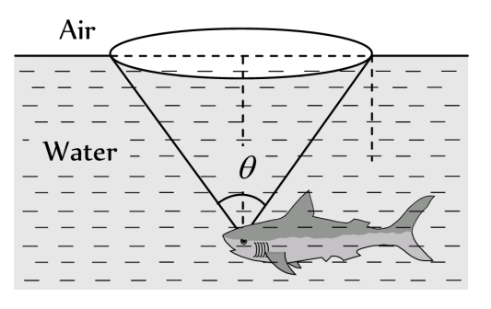A fish is a little away below the surface of a lake. If the critical angle is 49°, then the fish could see things above the water surface within an angular range of $θ$ where

a) $θ={49}^{o}$

b) $θ={90}^{o}$

c) $θ$ = ${98}^{o}$

d) $θ={24}^{o}$

1. A ray of light propagates from glass (refractive index = 3/2) to water (refractive index = 4/3). The value of the critical angle

a) $\sin^{-1}{\frac{1}{2}}$ b) $\sin^{-1}{\frac{\sqrt{8}}{9}}$ c) $\sin^{-1}{\frac{8}{9}}$ d) $\sin^{-1}{\frac{5}{7}}$

1. A ray of light is incident at 50° on the middle of one of the two mirrors arranged at an angle of 60° between them. The ray then touches the second mirror, get reflected back to the first mirror, making an angle of incidence of

a) 50° b) 60° c) 70° d) 80°

1. The angle of a prism is 60° and its refractive index is $\sqrt{2}$. The angle of minimum deviation suffered by a ray of light in passing through it

a) above ${20}^{o}$ b) ${30}^{o}$ c) ${60}^{o}$ d) ${45}^{o}$

1. A telescope has an objective lens of focal length 200cm and an eyepiece with focal length 2 cm. If this telescope is used to see a 50 m tall building at a distance of 2 km. What is the height of the image of the building formed by the objective lens?  
   a) 5cm b) 10cm c) 1cm d) 2cm
2. A ray of light travelling in a transparent medium falls on a surface separating the medium from air at an angle of incidence of 45°. The ray undergoes total internal reflection. If $n$ is the refractive index of the medium with respect to air, select the possible value(s) of $n$ from the following

a) 1.3 b) 1.4 c) 1.5 d) 1.6

1. 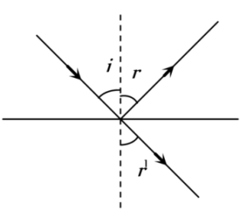A ray of light is incident at an angle $i$ from denser to rarer medium. The reflected and the refracted rays are mutually perpendicular. The angle of reflection and the angle of refraction are respectively $r$ and $r’$, then the critical angle will be

a) $\sin^{-1}({\sin{r)}}$ b) $\sin^{-1}{(tan{r’}})$

c) $\sin^{-1}({\tan{i}})$ d) $\tan^{-1}({\sin{i}})$

1. A combination of two thin lenses with focal lengths $f_{1}$ and $f_{2}$ respectively forms an image of distant object at distance 60 cm when lenses are in contact. The position of this image shifts by 30cm towards the combination when two lenses are separated by 10cm. The corresponding values of $f_{1}$ and $f_{2}$ are

a) 30cm, -60 cm b) 20 cm, -30cm c) 15cm, -20 cm d) 12cm, -15cm

1. 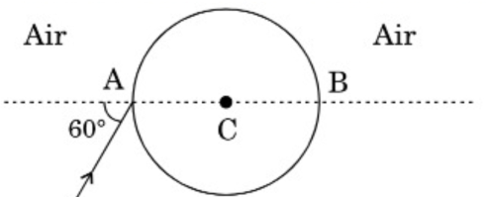A ray of light falls on transparent sphere with centre C as shown in the figure. The ray emerges from sphere parallel to line AB. The refractive index of sphere is  
   a) $μ=\sqrt{2}$ b) $μ=\sqrt{\frac{3}{2}}$

c) $μ=\sqrt{3}$ d) $μ=\sqrt{\frac{5}{2}}$

1. The ratio of thickness of plates of two transparent mediums A and B is 6:4. If light takes equal time in passing through them, then refractive index of B with respect to A will be

a) 1.4 b) 1.5 c) 1.75 d) 1.33

1. In the formation of a rainbow light from the sun on water droplets undergoes

a) Dispersion only b) Only total internal reflection

c) Dispersion and total internal reflection d) none of these

1. A parallel beam of monochromatic light is incident at one surface of an equilateral prism. Angle of incidence is 55° and angle of emergence is 46°. The angle of minimum deviation will be

a) Less than 41° b) Equal to 41° c) More than 41° d) None of these

1. A transparent cube of 15 cm edge contains a small air bubble. Its apparent depth when viewed through one face is 6 cm and when viewed through the opposite face is 4cm. Then the refractive index of the material of the cube is

a) 2 b) 2.5 c) 1.6 d) 1.5

1. A plano-convex lens of refractive index 1.5 and radius of curvature 30 cm is silvered at the curved surface. Now this lens has been used to form the image of an object. At what distance from this lens an object be placed in order to have a real image of the size of the object

a) 20 cm b) 30 cm c) 60 cm d) 80cm

1. 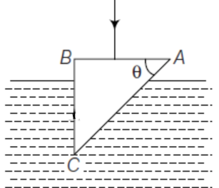A glass prism of refractive index 1.5 is immersed in water (n= 4/3) refer figure. A light beam incident normally on the face AB is totally reflected to reach the face BC if

a) $\sin{θ≤}\frac{2}{3}$ b)

c) d) $\cos{θ≤}\frac{8}{9}$

1. A convex lens of focal length f is placed somewhere in between an object and a screen. The distance between the object and the screen is *x*. If the numerical value of the magnification produced by the lens is $m$, then the focal length of the lens is

a) $\frac{mx}{{(m+1)}^{2}}$ b) $\frac{mx}{{(m-1)}^{2}}$ c) $\frac{{(m+1)}^{2}}{m}x$ d) $\frac{{(m-1)}^{2}}{m}x$

1. 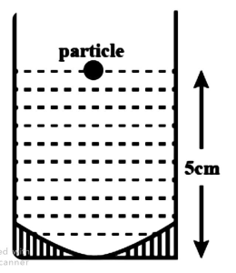A concave mirror has radius of curvature of 40 cm. It is at the bottom of a glass that has water filled up to 5 cm. If a small particle is floating on the surface of water its image as seen, from directly above the glass, is at a distance ‘d’ from the surface of water. The value of ‘d’ is close to (R.I of water = 1.33)

a) 13.4 cm b) 11.7 cm

c) 6.7 cm d) 8.8 cm

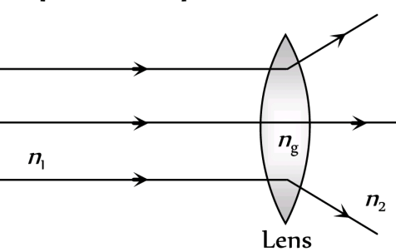

1. The ray diagram could be correct

a) If $n_{1}=n_{2}=n_{g}$

b) If $n_{1}=n_{2}$ and $n_{1}<n_{g}$

c) If $n_{1}=n_{2}$ and $n_{1}>n_{g}$

d) Under no circumstances

1. A convex lens of focal length 0.15m is made of a material of refractive index 3/2. When it is placed in a liquid, its focal length is increased by 0.225m. The refractive index of the liquid is

a) $\frac{7}{4}$ b) $\frac{5}{4}$ c) $\frac{9}{4}$ d) $\frac{3}{2}$

1. A point object is placed at a distance of 10cm and its real image is formed at a distance of 20cm from a concave mirror. If the object is moved by 0.1 cm towards the mirror, the image will shift by about

a) 0.4cm away from the mirror b) 0.4cm towards the mirror

c) 0.8cm away from the mirror d) 0.8cm towards the mirror

1. A point object is placed at a distance of 20 cm from a thin plano convex lens of focal length 15cm. The plane surface of the lens is now silvered. The image created by the system is at

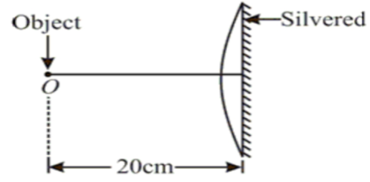a) 60cm on the left of the system

b) 60cm to the right of the system

c) 12cm to the left of the system

d) 12cm to the right of the system

1. A concave lens of glass, refractive index 1.5, has both surfaces of same radius of curvature R. On immersion in a medium of refractive index 1.75, it will behave as a

a) convergent lens of focal length 3.5 R b) convergent lens of focal length 3R

c) divergent lens of focal length 3.5 R d) divergent lens of focal length 3R

1. A vessel of depth $x$ is half filled with oil of refractive index 1 and other half is filled with water of refractive index 2. The apparent depth of the vessel when viewed from above is

a) $\frac{x(μ_{1}+μ_{2})}{{2μ}_{1}μ_{2}}$ b) $\frac{xμ_{1}μ_{2}}{{2(μ}_{1}+μ_{1})}$ c) $\frac{xμ_{1}μ_{2}}{x(μ_{1}+μ_{2})}$ d) $\frac{2x(μ_{1}+μ_{2})}{μ_{1}μ_{2}}$

1. A fish looking up through the water sees the outside world contained in a circular horizon. If the refractive index of water is 4/3 and the fish is 12cm below the surface, the radius of this circle in cm is

a) 36 $\sqrt{5}$ b) 4 $\sqrt{5}$ c) 36 $\sqrt{7}$ d) 36/ $\sqrt{7}$

1. A glass slab of thickness 3 cm and refractive index 3/2 is placed on ink mark on a piece of paper. For a person looking at the mark at a distance 5cm above it, the distance of mark will appear to be

a) 3cm b) 4cm c) 4.5cm d) 5cm

1. A plano-convex lens fits exactly into a plano-concave lens. Their plane surfaces are parallel to each other. If the lens are made of different materials of refractive indices $μ_{1}$ and $μ_{2}$ and R is the radius of curvature of the curved surface of the lenses, then the focal length of combination is

a) $\frac{2R}{\left(μ_{2}-μ_{1}\right)}$ b) $\frac{R}{2\left(μ_{1}+μ_{2}\right)}$ c) $\frac{R}{2\left(μ_{1}-μ_{2}\right)}$ d) $\frac{R}{\left(μ_{1}-μ_{2}\right)}$

1. The image of an electric bulb fixed in a wall is to be obtained on the wall opposite to it at a distance of 3m. The maximum possible focal length of the convex lens is

a) 3.25 m b) 1.55 m. c) 0.75m d) 0.28m

1. A point object is placed at a distance of 12cm on the axis of a convex lens of focal length 10cm. On the other side of the lens, a convex mirror is placed at a distance of 10 cm from the lens such that the image formed by the combination coincides with the object itself. What is the focal length of convex mirror?

a) 25cm b) 50cm c) 10cm d) 20cm

1. A prism of certain angle deviates the red and blue rays by 8o and 12o respectively. Another prism of the same angle deviate the red and blue rays by 10o and 14o respectively. The prisms are small angled and made of different materials. The dispersive powers of the materials of the prisms are in the ratio

a) 5:6 b) 9:11 c) 6:5 d) 11:9

1. A double convex lens has focal length 25 cm. The radius of curvature of one of the surfaces is double of the other. Find the radii, if the refractive index of the material of the lens is 1.5

a) 100cm, 50cm b) 25cm, 50cm c) 18.75cm, 37.5cm d) 50cm, 100cm

1. The light ray is incident at angle of 60o on a prism of angle 45o. When the light ray falls on the other surface at 90o, the refractive index of the material of the prism $μ$ and the angle of deviation $δ$ are given by

a) $μ=\sqrt{2}$, $δ={30}^{o}$ b) $μ= 1.5$, $δ={15}^{o}$ c) $μ=\sqrt{\frac{3}{2}}$, $δ={15}^{o}$ d) $μ=\sqrt{\frac{3}{2}}$, $δ={30}^{o}$

1. 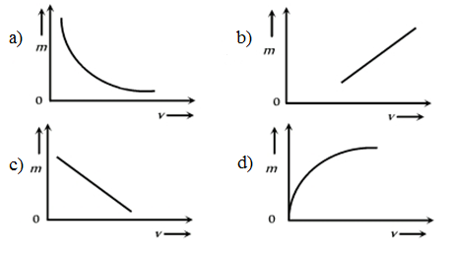The graph between lateral magnification (m) produced by a lens and the distance of the image (v) is given by
2. A lens of focal power 0.5 D is

a) a convex lens of focal length 0.5 m b) a concave lens of focal length 0.5 m

c) a convex lens of focal length 2 m d) a concave lens of focal length 2 m

1. 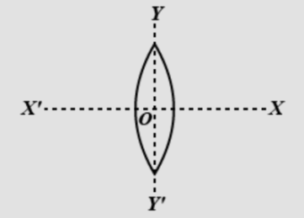An equiconvex lens is cut into two halves along (i) XOX $'$ and (ii)YOY $'$ as shown. Let f, f $'$ and f $''$ be the focal lengths of complete lens, of each half in case(i) and of each half in case(ii) respectively. Choose the correct statement from the following

a) f $'$ = 2f and f $''$ = f b) f $'$ = f and f $''$ = f

c) f $'$ = 2f and f $''$ = 2f d) f $'$ =f and f $''$ = 2f

1. Two objects A and B when placed in turns in front of a concave mirror, give images of equal size. The focal length of the concave mirror is 7.5cm and the size of object A is three times the size of the object B. The distance of B from the mirror, if A is placed 30cm from the mirror, is

a) 18cm b) 15cm c) 20cm d) 25cm

1. A compound microscope has an eyepiece of focal length 10cm and an objective of focal length 4cm. Calculate the magnification, if an object is kept at a distance of 5cm from the objective, so that the final image is formed at the least distance of distinct vision 20 cm.

a) 12 b) 11 c) 10 d) 13

1. A watch shows time as 3: 25 when seen through the mirror, time appeared will be

a) 8: 35 b) 9: 35 c) 7: 35 d) 8: 25

1. Two similar thin equi–convex lenses, of focal length ‘ $f$’ each are kept co – axially in contact with each other such that the focal length of the combination $F_{1}$. When the space between the two lenses is filled with glycerine (which has same refractive index as that of glass, $μ=1.5$) then the equivalent focal length is $F_{2}$. The ratio of $F_{1}:F_{2}$ will be [**NEET – 2019]**

a) $2:1$ b) $1:2$ c) $2:3$ d) $3:4$

1. Pick the wrong answer in the context with rainbow **[NEET – 2019]**

a) When the light rays undergo two internal reflections in a water drop a secondary rainbow is formed.

b) The order of colours is reverse in the secondary rainbow.

c) An observer can see a rainbow when his front is towards the sun.

d) Rainbow is a combined effect of dispersion refraction and reflection of sun light.

1. In total internal reflection when the angle of incidence is equal to the critical angle for the pair of media in contact. What will be the angle of refraction? **[NEET – 2019]**

a) $180°$ b) $0°$ c) equal to angle of incidence d) $90°$

1. An equi-convex lens has power p. It is cut into two symmetrical halves by a plane containing the principal axis. The power of one part will be **[NEET –Odisha – 2019]**

a) 0 b) $\frac{p}{2}$ c) $\frac{p}{4}$ d) p

1. A linear object of height 10 cm is kept in front of a concave mirror of radius of curvature 15 cm, at a distance of 10 cm. The image formed is **[KCET – 2017]**

a) magnified and erect b) magnified and inverted

c) diminished and erect d) diminished and inverted

1. An astronomical refracting telescope will have large angular magnification and high angular resolution, when it has an objective lens of **[NEET – 2018]**

a) large focal length and large diameter b) large focal length and small diameter

c) small focal length and large diameter d) small focal length and small diameter

1. The refractive index of the material of a prism is $\sqrt{2}$ and the angle of the prism is $30°$. One of the two refracting surfaces of the prism is made a mirror inwards by silver coating. A beam of monochromatic light entering the prism from the other face will retrace its path (after reflection from the silvered surface) if its angle of incidence on the prism is **[NEET – 2018]**

a) $30°$ b) $45°$ c) $60°$ d) zero

1. During scattering of light, the amount of scattering is inversely proportional to _______of wavelength of light **[KCET – 2017]**

a) cube b) square c) fourth power d) half

1. An object is placed at a distance of 40 cm from a concave mirror of focal length 15 cm. If the object is displaced through a distance of 20 cm towards the mirror, the displacement of the image will be **[NEET – 2018]**

a) 30 cm towards the mirror b) 36 cm away from the mirror

c) 30 cm away from the mirror d) 36 cm towards the mirror

1. A thin prism having refracting angle $10°$ is made of glass of refractive index 1.42. This prism is combined with another thin prism of glass of refractive index 1.7. This combination produces dispersion without deviation. The refracting angle of second prism should be **[NEET – 2017]**

a) 4o b) 6o c) 8o d) 10o

1. A beam of light from a source L is incident normally on a plane mirror fixed at a certain distance x from the source. The beam is reflected back as a spot on a scale placed just above the source L. When the mirror is rotated through a small angle $θ$, the spot of the light is found to move through a distance y on the scale. The angle $θ$ is given by [**NEET - 2017]**

a) $\frac{y}{x}$ b) $\frac{x}{2y}$ c) $\frac{x}{y}$ d) $\frac{y}{2x}$

1. Two identical glass $\left(μ_{g}=\frac{3}{2}\right)$ equi convex lenses of focal length $f$ each are kept in contact. The space between the two lenses is filled with water $\left(μ_{w}=\frac{4}{3}\right)$. The focal length of the combination is **[NEET – II 2016]**

a) $\frac{f}{3}$ b) $f$ c) $\frac{4f}{3}$ d) $\frac{3f}{4}$

1. An air bubble in a glass slab with refractive index 1.5 (near normal incidence) is 5 cm deep when viewed from one surface and 3 cm deep when viewed from the opposite face. The thickness (in cm) of the slab is **[NEET – II 2016]**

a) 8 b) 10 c) 12 d) 16

1. A person can see clearly objects only when they lie between 50 cm and 400 cm from his eyes. In order to increase the maximum distance of distinct vision to infinity, the type and power of the correcting lens, the person has to use, will be **[NEET – II 2016]**

a) convex, $+2.25$ diopter b) concave, $-0.25$ diopter

c) concave, $-0.2$ diopter d) convex, $+0.15$ diopter

1. Match the corresponding entries of column I with column II. Where $m$ is the magnification produced by the mirror

**Column I ` Column II**

A) $m=-2$ p) convex mirror

B) $m=-\frac{1}{2}$ q) concave mirror

C) $m=2$ r) real image

D) $m=\frac{1}{2}$ s) virtual image **[NEET – I 2016]**

$a)A→p and s ;B→q and r; C→q and s ;D→q and r$

b) $A→r and s ;B→q and s; C→q and r ;D→p and s$

c) $A→q and r ;B→q and r; C→q and s ;D→p and s$

d) $A→p and r ;B→p and s; C→p and q ;D→r and s$

1. The angle of incidence for a ray of light at a refracting surface of a prism is $45°$. The angle of prism is $60°$. If the ray suffers minimum deviation through the prism, the angle of minimum deviation and refractive index of the material of the prism respectively are **[NEET – I 2016]**

a) $45° ; \sqrt{2}$ b) $30° ; \frac{1}{\sqrt{2}}$ c) $45° ; \frac{1}{\sqrt{2}}$ d) $30° ; \sqrt{2}$

1. In an astronomical telescope in normal adjustment a straight black line of length L is drawn on inside part of objective lens. The eye – piece forms a real image of this line. The length of this image is I. The magnification of the telescope is **[NEET – I 2015]**

a) $\frac{L+I}{L-I}$ b) $\frac{L}{I}$ c) $\frac{L}{I}+1$ d) $\frac{L}{I}-1$

1. A certain prism is found to produce a minimum deviation of $38°$. It produces a deviation of $44°$ when the angle of incidence is either $42°$ or $62°$. What is the angle of incidence when it is undergoing minimum deviation? **[KCET - 2019]**

a) $49°$ b) $30°$ c) $60°$ d) $40°$

1. A candle placed 25 cm from a lens forms an image on a screen placed 75 cm on the other side of the lens. The focal length and type of the lens should be **[KCET – 2018]**

a) 18.75 cm and convex lens b) $-18.75$ cm and concave lens

c) 20.25 cm and convex lens d) $-20.25$ cm and concave lens

1. According to Cartesian sign convention in ray optics **[KCET – 2017]**

a) all distances are taken positive

b) all distances are taken negative

c) all distances in the direction of incident ray are taken positive

d) all distances in the direction of incident ray are taken negative

**WAVE OPTICS**

**UNIT NO: P-16**

1. The principle of superposition is basic to the phenomenon of

a)Total internal reflection b) interference c)Reflection d) Polarization

1. Spherical wave fronts emanating from a point source, strike a plane reflecting surface. What will happen to these wave fronts immediately after reflection

a) They will remain spherical with the same curvature, both in magnitude and sign

b) They will become plane wave fronts

c) They will remain spherical with the same curvature but sign of curvature reversed.

d) They will remain spherical but with different curvature both in magnitude and sign

1. Two slits in Young’s experiment have widths in the ratio $1:25$. The ratio of intensity at the maximum and minimum in the interference pattern, $\frac{I_{max}}{I_{min}}$ is

a) $\frac{121}{49}$ b) $\frac{49}{121}$ c) $\frac{4}{9}$ d) $\frac{9}{4}$

1. Monochromatic green light of wavelength $5×{10}^{-7} m$ illuminates a pair of slits 1mm apart. The separation of bright lines on the interference pattern formed on a screen 2m away is

a) $0.25 mm$ b) $0.1 mm$ c) $1.0 mm$ d) $0.01 mm$

1. A thin mica sheet of thickness 2 x 10-6 m. and refractive index 1.5 is introduced in the path of the first wave. The wavelength of wave used is 5000 . The central bright maximum will shift

a) 2 fringes upward b) 2 fringes downward

c) 10 fringes upward d) none of these

1. A mixture of light consisting of wavelength 590 nm and an unknown wavelength, illuminates young’s double slit and give rise to two overlapping interference pattern on the screen. The central maximum of both lights coincide. Further, it is observed that the third bright fringe of known light coincides with the 4th bright fringe of the unknown light. From this data the wavelength of the unknown light is

a) $393.4 nm$ b) $885.0 nm$ c) $442.5 nm$ d) $776.8 nm$

1. In a double slit experiment the two slits are 1mm apart and the screen is placed 1m away. A monochromatic light wavelength 500nm is used. What will be the width of each slit for obtaining ten maxima of double slit within the central maxima of single slit pattern

$a)0.1 mm$ b) $0.5 mm$ c) $0.02 mm$ d) $0.2 mm$

1. The young’s experiment is performed with the lights of blue and green colour.If the distance of the 4th fringe from the centre is x, then

a) $x \left(Blue\right)=x(Green)$ b) $x \left(Blue\right)>x(Green)$

c) $x \left(Blue\right)<x(Green)$ d) $\frac{x\left(Blue\right)}{x\left(Green\right)}=\frac{5460}{4360}$

1. In young’s double slit experiment with slit separation d, a monochromatic light of wavelength $λ$ is used. The angular separation of the fringes is

a) $\frac{d}{λ}$ b) $\frac{λ}{d}$ c) $\frac{2λ}{d}$ d) $\frac{λ}{2d}$

1. In young’s double slit experiment fringes of width $β$ are produced on a screen kept at a distance of 1 m from the slit. When the screen is moved away by $5×{10}^{-2}m$ fringe width changes by $3×{10}^{-5}m$. The separation between the slits is $1×{10}^{-3}m$. The wavelength of the light used is (in nm)

a) $500$ b) $600$ c) $700$ d) $400$

1. If the two slits in young’s double slit experiment are of unequal width then

a) The bright fringes will have unequal spacing

b) The bright fringes will have unequal brightness

c) The fringes do not appear

d) The dark fringes are not perfectly dark

1. In young’s double slit experiment the intensity of light coming from the first slit is double the intensity from the second slit. The ratio of the maximum intensity to the minimum intensity on the interference fringe pattern observed is

a) $34$ b) $40$ c) $25$ d) $38$

1. A heavenly body is receding from earth such that the fractional changes in $λ$ is 1, then its velocity is

$a)c$ b) $\frac{3c}{5}$ c) $\frac{c}{5}$ d) $\frac{2c}{5}$

1. A spectral line $λ=5000$ in the light coming from a distant star is observed as a $5200$.What will be recession velocity of the star

a) $1.15×{10}^{7} cm/s$ b) $1.15×{10}^{7} m/s$ c) $1.15×{10}^{7} km/s$ d) $1.15 km/s$

1. If the separation between slits in young’s double slit experiment is reduced to ${\frac{1}{3}}^{rd},$ the fringe width becomes n times. The value of n is

a) 3 b) $\frac{1}{3}$ c) 9 d) $\frac{1}{9}$

1. In a young’s double slit experiment the slit separation is 1 mm and the screen is 1 m from the slit. For a monochromatic light of wavelength 500 nm the distance of 3rd minima from the central maxima is

a) $0.50 mm$ b) $1.25 mm$ c) $1.50 mm$ d) $1.75 mm$

1. The two slits are 1mm apart from each other and illuminated with a light of wavelength $5×{10}^{-7}m$. If the distance of the screen is 1 m from the slits then the distance between third dark fringe and fifth bright fringe is

a) 1.5 nm b) 0.75 mm c) 1.25 mm d) 0.625 mm

1. A parallel beam of fast moving electrons is incident normally on a narrow slit. A screen is placed at a large distance from the slit. If the speed of the electrons is increased, which of the following statement is correct

a) Diffraction pattern is not observed on the screen in the case of electrons

b) The angular width of the central maxima of the diffraction pattern will increase.

c) The angular width of the central maxima will decrease

d) The angular width of the central maxima will remain the same.

1. A slit of width a is illuminated by white light. For red light the first minima is obtained at $θ=30°$. Then the value of a will be

a) $3250$ b) $6.5×{10}^{-4} mm$ c) $1.24 microns$ d) $2.6×{10}^{-4} cm$

1. Red light is generally used to observe diffraction pattern from single slit. If blue light is used instead of red light then diffraction pattern

a) will be more clear b) will contract c) will expanded d) will not be visualized

1. For what distance is ray optics a good approximation when the aperture is 4 mm wide and the wavelength is 500 nm

a) $32m$ b) $64m$ c) $16m$ d) $8m$

1. At the first minimum adjacent to the central maximum of a single slit diffraction pattern the phase difference between the Huygen’s wavelet from the edge of the slit and the wavelet from the midpoint of the slit is

a) $\frac{π}{2}$ radian b) $π$ radian c) $\frac{π}{8}$ radian d) $\frac{π}{4}$ radian

1. A beam of light of wavelength 600 nm from a distant source falls on a single slit 1 mm wide and the resulting diffraction pattern is observed on a screen 2 m away. The distance between the first dark fringes on either side of the central bright fringe is

a) $1.2mm$ b) $1.2 cm$ c) $2.4 cm$ d) $2.4 mm$

1. In a single slit diffraction experiment the width of the slit is reduced by half. Which of the following needs to be done if the width of the central maxima has to remain the same

a)Reduce the distance between the slit and screen by half

b)Reduce the distance between the slit and the screen to ${\left(\frac{1}{4}\right)}^{th}$ the original separation

c)Double the distance between the slit and the screen

d) No need to do anything as the width of the central maxima does not depend on the slit width

1. A parallel beam of monochromatic light of wavelength $5000$ is incident normally on a single narrow slit of width 0.001 mm. The light is focused by a convex lens on a screen placed on the focal plane. The first minimum will be formed for the angle of diffraction equal to

a) $0°$ b) $15°$ c) $30°$ d) $60°$

1. The width of the diffraction band varies

a) Inversely as the wavelength

b) Directly as the width of the slit

c) Directly as the distance between the slit and the screen

d)Inversely as the size of the source from which the slit is illuminated

1. A single slit of width a is illuminated by violet light of wavelength 400nm and the width of the diffraction pattern is measured as y. When half of the slit width is covered and illuminated by yellow light of wavelength 600 nm the width of the diffraction pattern is

a) The pattern vanishes and the width is zero b) $\frac{y}{3}$

c) $3y$ d) none of these

1. Through which character we can distinguish the light waves from sound waves

a) interference b)Refraction c) polarization d) Reflection

1. A polaroid is placed at $45°$ to an incoming light of intensity $I_{0}$. Now the intensity of light passing through Polaroid after polarization would be

a) $I_{0}$ b) $\frac{I_{0}}{2}$ c) $\frac{I_{0}}{4}$ d) $zero$

1. A beam of natural light falls on a system of 5 polaroids, which are arranged in succession such that the pass axis of each Polaroid is turned through $60°$ with respect to the preceding one. The fraction of the incident light intensity that passes through the system is

a) $\frac{1}{32}$ b) $\frac{1}{256}$ c) $\frac{1}{128}$ d) $\frac{1}{512}$

1. The Brewster angle for the glass – air interface is $54.74°$. If a ray of light going from air to glass strikes at an angle of incidence $45°$ then the angle of refraction is [ tan 54.740 = ].

a) b) c) d)

1. Light is incident on a glass surface at polarizing angle of $57.5°$. Then the angle between the incident ray and the refracted ray is

a) $57.5°$ b) $115°$ c) $65°$ d) $205°$

1. Two beams A and B of plane polarized light with mutually perpendicular planes of polarization are seen through a Polaroid. From the position when the beam A has maximum intensity (and beam B has zero intensity) a rotation of Polaroid through $30°$ makes the two beams appear equally bright. If the initial intensities of the two beams are $I_{A} and I_{B}$ respectively, then $\frac{I_{A}}{I_{B}}$ equals to

$a)3$ b) $\frac{3}{2}$ c) $1$ d) $\frac{1}{3}$

1. Polarizing angle for water is $54°4'$. If light is incident at this angle on the surface of water and reflected the angle of refraction is

a) $53°4'$ b) $126°56'$ c) $36°56'$ d) $30°4'$

1. When the angle of incidence on a material is $60°$ the reflected light is completely polarized. The velocity of the refracted ray inside the material is

a) $3×{10}^{8}$ b) $\left(\frac{3}{\sqrt{2}}\right)×{10}^{8}$ c) $\sqrt{3}×{10}^{8}$ d) $0.5×{10}^{8}$

1. In a Young's double slit experiment the slit separation is 0.5m from the slits. For a monochromatic wavelength of 500nm, the distance of third maxima and second minima on the either side is

[ screen is at a distance 1 m from the slits]

a) 2.75mm b) 2.5mm c) 22.5mm d) none of these

1. For what distance the ray optics is good approximation when the aperture is 5mm and the wavelength of light is 500nm

a) $24 m$ b) $50 m$ c) $18 m$ d) $30 m$

1. Light of wavelength 600nm is incident normally on a slit of width 0.2mm. The angular width of central maximum in diffraction patterns is

a)6 $×{10}^{-3}$ rad b) 4 $×{10}^{-3}$ rad c) 2.4 $×{10}^{-3}$ rad d) 4.5 $×{10}^{-3}$ rad

1. In Young's double slit experiment the source is white light. One slit is covered with red filter and other with blue filter. There shall be

a) alternate red and blue fringes b) alternate dark and pink fringes

c) alternate dark and yellow fringes d) no interference

1. In a system of two crossed polarisers, it is found that intensity of light from the second polariser is half from that of first polariser. The angle between their pass axis is

a) $45°$ b) $60°$ c) $30°$ d) $0°$

1. Angular width of the central maxima in the Fraunhofer diffraction for $λ=6000$ Å is $θ_{0}$. When the same slit is illuminated by another monochromatic light, the angular width decreases by 30%. The wavelength of this light is

a) 420 Å b) 1800 Å c) 4200 Å d) 6000 Å

1. In Young’s double slit experiment the separation d between the slit is 2mm, the wavelength $λ$ of the light used is 5896Å and distance D between the screen and slit is 100cm. It is found that angular width of the fringes is 0.20o. To increase the fringe angular width 0.21o(with same $λ$ and D) the separation between the slits needs to be changed to

a) 2.1mm b) 1.9mm c) 1.8mm d) 1.7mm

1. Two polaroids P1 and P2 are placed with their axis perpendicular to each other. Unpolarised light Io is incident on P1. A third polaroid P3 is kept in between P1 and P2 such that its axis makes an angle 45o with that of P1. The intensity of transmitted light through P2 is

a) b) c) d) $\frac{I_{0}}{2}$

1. Young’s double slit experiment is first performed in air and then in a medium other than air. It is found that 8th bright fringe in the medium lies where 5th dark fringe lies in air. The refractive index of the medium is nearly

a) $1.59$ b) $1.69$ c) $1.78$ d) $1.25$

1. The ratio of resolving powers of an optical microscope for two wavelengths $λ_{1}=4000Å$ and $λ_{2}=6000Å$ is

a) 9:4 b) 3:2 c) 16:81 d) 8:27

1. A linear aperture whose width is 0.02cm is placed immediately in front of a lens of focal length 60cm. The aperture is illuminated normally by a parallel beam of wavelength 5 $×{10}^{-5}$ cm. The distance of the first dark band of the diffraction pattern from the centre of the screen is

a) 0.10cm b) 0.25cm c) 0.20cm d) 0.15cm

1. The interference pattern is obtained with two coherent light sources of intensity ratio *n.* In the interference pattern, the ratio $\frac{I_{max}-I_{min}}{I_{max}+I_{min}}$ will be

a) $\frac{\sqrt{n}}{n+1}$ b) $\frac{2\sqrt{n}}{n+1}$ c) $\frac{\sqrt{n}}{{\left(n+1\right)}^{2}}$ d) $\frac{2\sqrt{n}}{{\left(n+1\right)}^{2}}$

1. The intensity at the maximum in a Young’s double slit experiment is $I_{0 }$. Distance between two slits is $d=5λ$, where $λ$ is the wavelength of light used in the experiment. What will be the intensity in front of one of the slits on the screen placed at a distance $D=10d$?

a) $\frac{3}{4}I_{0 }$ b) $\frac{I_{0}}{2}$ c) $I_{0 }$ d) $\frac{I_{0 }}{4}$

1. In a diffraction pattern due to a single slit of width $a$, the first minimum is observed at an angle ${30}^{0}$ when light of wavelength 5000 $Å$ is incident on a slit. The first secondary maximum is observed at an angle of

a) $\sin^{-1}\left(\frac{1}{2}\right)$ b) $\sin^{-1}\left(\frac{3}{4}\right)$ c) $\sin^{-1}\left(\frac{1}{4}\right)$ d) $\sin^{-1}\left(\frac{2}{3}\right)$

1. Two slits in Young’s experiment have width in the ratio 1:9. The ratio of intensity at the maxima and minima in the interference pattern, $\frac{I_{max}}{I_{min}}$ is

a) $\frac{49}{121}$ b) $\frac{4}{9}$ c) 4 d) $\frac{121}{49}$

1. A beam of polarized light makes an angle of 600 with the axis of the Polaroid sheet. How much is the intensity of light transmitted through the sheet?

a) 100 % b) 50 % c) 25% d) 0%

1. In a Young’s double slit experiment, the intensity of light at a point on the screen where the path difference $λ$ is K, ( $λ$ being the wavelength of light used). The intensity at a point where the path difference is $\frac{λ}{4}$ will be

a) $K$ b) $\frac{K}{4}$ c) $\frac{K}{2}$ d)zero

1. Calculate the resolving power of microscope with semi vertical angle of light falling on the objective equal to 300( given wave length of light is 600 nm)

a) 1.67 x 106 b) 2.67 x 106 c) 3 x 106 d) 1.2 x106

1. In a Young’s double slit experiment, using monochromatic light of wavelength $λ$, the intensity of light at a point on the screen where the path difference is $λ$ is K units. The intensity at a point where the path difference is $\frac{λ}{3}$ will be

a) $\frac{K}{4}$ b) $2K$ c) $K$ d)4K

1. A plane wave front of wavelength $λ$ is incident on a single slit of width a. The angular width of a principal maximum is

a) $\frac{λ}{a}$ b) $\frac{2λ}{a}$ c) $\frac{a}{λ}$ d) $\frac{a}{2λ}$

1. In a Fraunhofer diffraction at a single slit, if yellow light illuminating the slit is replaced by blue light , then diffraction bands

a) Remains unchanged b) becomes wider c) disappear d) becomes narrower

1. In a Young's double slit experiment two wavelengths $λ_{1}=$ 780nm and $λ_{2}=$ 540nm are used to obtain interference fringes. If nth bright band due to $λ_{1}$ coincides with (n+1)th bright band due to $λ_{2}$. Then value of n is

a) $4$ b) $3$ c) $2$ d) $6$

1. In Young's double slit experiment, slits are separated by 2mm and the screen is placed at a distance of 1.2m from the slits. Light consisting of two wavelengths 6500Å and 5200 Å are used to obtain interference fringes. Then separation between the fourth bright fringe of two different patterns produced by the two wavelengths is

a) 0.312mm b) 0.123m c) 0.21mm d) 0.412mm

1. In Young's double slit experiment if yellow light is replaced by Blue light, the interference fringes become

a) wider b) brighter c) narrower d) darker

1. According to Huygens’ principle, during refraction of light from air to a denser medium

a) wavelength and speed decrease b) wavelength and speed increases

c) wavelength increases but speed decreases d) wavelength decreases but speed increases

**ATOMS AND NUCLEI**

**UNIT NO: P-17**

1. What is the energy of an emitted photon when the hydrogen atom changes from an energy state of n=5 to n=4?

a) 13.06eV b) 0.54eV c) 1.36eV d) 0.31eV

1. In Bohr’s atomic model, it is assumed that the force between electron and proton varies inversely as r4, energy of the system will be proportional to

a) n2 b) n4 c) n6 d) n8

1. The ionisation energy of hydrogen is 13.6eV.If the atom is excited by a monochromatic beam of 12.1eV, the number of spectral lines emitted will be

a) 1 b) 2 c)3 d) 4

1. In an atom two electrons move round the nucleus in circular orbits of radii R and 4R.The ratio of the time taken by them to complete one revolution is

a)1:4 b) 4:1 c) 1:8 d) 8:1

1. The energy required to remove an electron in a hydrogen atom from n=10 state is

a)13.6eV b) 1.36eV c) 0.136eV d) 0.0136eV

1. The frequency of the first line of Balmer series in hydrogen atom is υ. The frequency of the line emitted by singly ionised helium atom will be

a) 2υ b) 4υ c)  d) 0.25υ

1. Doubly ionised helium atom and hydrogen ion are accelerated from rest through the same potential difference. The ratio of the final velocities of helium and hydrogen ion is

a)1:2 b) 2 c)1:  d)

1. The radius of hydrogen in its ground state is 0.53A0 .After collision with electron its radius is found to be .In this state principal quantum number n of the hydrogen atom is
   1. 2 b) 3 c) 4 d) 16
2. A nuclear reactor delivers a power of 10W, Find fuel consumed by the reactor per hour, if its efficiency is 20%.(Given, c=3x108ms-1 )

a) 2x10-6g/h b) 9x10-12g/h c) 8x10-9g/h d) 2x10-9g/h

1. The ratio of magnetic dipole moment of an electron of charge e and mass m in Bohr’s orbit in hydrogen to its angular momentum is

a) e : m b) e : 2m c)m:e d) 2m:e

1. The specific charge of proton is  .The specific charge of an alpha particle will be

a)  b)  c)  d) 

1. Hydrogen, deuterium, singly ionised helium and doubly ionised lithium have one electron around the nucleus. For a given transition say n=2 to n=1,the approximate expected relation between wavelengths is

a)λH=λD=2λhe=3λL b) λH=λD=4λhe=9λL) c) λH=λD=0.5λhe=0.25λL  d) none

1. ASSERTION: If the accelerating potential in an x-ray machine is decreased, the minimum value of the wavelength of emitted x-ray gets increased

REASON: The minimum value of the wavelength of emitted x-ray is inversely proportional to the accelerating potential

a)Both assertion and reason are true and the reason is the correct explanation of assertion

b)Both assertion and reason are true and the reason is not the correct explanation of assertion

c)Assertion is true, reason is false

d) Assertion is false, reason is true

1. The velocity of an electron in the first orbit of hydrogen atom is v.The velocity of an electron in the second orbit of He+ is

a)2v b) v c) 0.5v d) 0.25v

1. If 1g hydrogen is converted into 0.993g of helium in a thermonuclear reaction, the energy released in the reaction is

a) 63 × 107J b) 63 × 1010J c) 63 × 1014J d) 63 × 1020J

1. The wavelength of the energy emitted when electron comes from fourth orbit to second orbit in hydrogen is 20,397cm.The wavelength of energy for the same transition in He+ is

a) 81,988cm b) 40,994cm c) 20,497cm d)5,099cm

1. The ionisation energy of the electron in the hydrogen atom in its ground state is 13.6eV.The atoms are excited to higher energy levels to emit radiations of 6 wavelengths. Maximum wavelength of emitted radiation corresponds to the transition between

a) n=3 to n=1 states b) n=2 to n=1 states c) n=4 to n=3 states d) n=3 to n=2 states

1. The wavelength of the first line of Lyman series for hydrogen atom is equal to that of the second line of Balmer series for hydrogen like ion. The atomic number Z of hydrogen like ion is

a)3 b) 4 c) 1 d) 2

1. 200MeV energy is released in a fission of single nucleus of U-235.How many fissions must occur per second to produce a power of 1kW

a) 3.125x1013 b) 3.125x1012 c) 3.125x1014 d) 3.125x1016

1. In Rutherford’s scattering experiment what will be the correct angle for α scattering for b=0 is

a) 0 b) 1800 c) 900 d) 2700

1. The ground state energy of hydrogen is -13.6eV.What is the potential energy of the electron in this state?

a)0eV b)-27.2eV c)1eV d)2eV

1. During mean life of a radioactive element, the fraction that undecayed is

a) e b)  c)  d) 

1. Second excitation potential of an atom is E. What will be the ionisation potential?

a) E b) 9E/8 c) 4E/3 d) E/3

1. The area of the electron orbit for the ground state of hydrogen atom is A. Then what will be the area of electron orbit corresponding to the first excited state?

a) 4A b) 8A c) 16A d) 32A

1. The difference in frequencies of series limit of Lyman series and Balmer series is equal to the frequency of the first line of the

a) Lyman series b)Balmer seriesc) Paschen series d)Brackett series

1. Which one of the following is not a mode of radioactive decay?

a)Electron emission b) Alpha decay c) Proton emission d) Gamma emission

1. The half life period of radium is 1600 years. The fraction of a sample of radium that would remain after 6400 years is

a)1/4 b) 1/2 c) 1/8 d) 1/16

1. After 2 hours (1/16)th of the initial amount of a certain radio isotope remains undecayed. The half-life of the isotope is:

a) 60 minute b) 45 minute c) 30 minute d) 15minute

1. Radioactive element has a half life of 10 days. How much element will be left after a period of 40 days, if the original amount of element is 2gram?

a) 0.125g b)1.25g c) 0.0125g d) 12.5g

1. Beta rays emitted by a radioactive material are

a) Electromagnetic radiation b) The electrons orbiting around the nucleus

c) Charged particles emitted by nucleus d) Neutral particles

1. In the given reaction  radioactive radiations are emitted in the

Sequence

a) , ,  b) , ,  c) , ,  d) , , 

1. During a nuclear reaction protons are destroyed producing an energy of 3724MeV.T he number of

Protons destroyed is

a)4 b)3 c)2 d) 1

1. Three particles and oneparticle decaying takes place in series from an isotope . Finally the isotope obtained will be

a)  b)  c)  d) 

1. Two nuclei have their mass numbers in the ratio of 1:3. The ratio of their nuclear densities would be

a)1:2 b) 1:1 c)1:3 d) 3:1

1. Half life of a substance is 20 minutes. What is the time between 33% and 67% decay?

a) 40minute b) 20minute c) 30minute d) 25minute

1. N atoms of a radioactive element emit n alpha particles per second. The half life of the element is

a)s b) s c)  s d) s

1. What is the respective number of  and  particles emitted in the following radioactive decay



a) 6 and 8 b) 8 and 8 c) 6 and 6 d) 8 and 6

1. Half life of radioactive element depends upon

a) Amount of element presents b) Temperature

c) Pressure d) Nature of element

1. A radioactive nucleus emits a beta particle. The parent and daughter nuclei are

a) Isotones b) Isotopes c) Isobars d) Isomers

1. If the matter in proton is completely converted in to energy, it will be about:

a) 9310MeV b) 100.78MeV c) 931MeV d) 10078MeV

1. The nuclear radius of a nucleus with nucleon number 16 is 3x10-15m. Then, the nuclear radius of a

Nucleus with nucleon number 128 is

a) 3x10-15m b) 1.5x10-15m c) 6x10-15m d) 4.5x10-15m

1. If Avogadro number is 6x1023 , then the number of protons, neutrons and electrons in 14g of are respectively

a) 36x1023, 48x1023, 36x1023 b) 36x1023, 36x1023, 36x1023

c) 48x1023, 36x1023, 48x1023 d) 48x1023, 48x1023, 36x1023

1. 99% of the radioactive substance decay within:

a)6 to 7 half lives b) 8 to 9 half lives c) 7 to 8 half lives d) 9to 10 half lives

1. A heavy nucleus at rest breaks into two fragments which fly off with velocities 8:1.The ratio of radii of the fragments is

a) 1:2 b) 1:4 c) 4:1 d) 2:1

1. Match column1 and column 2

**COLUMN 1 COLUMN 2**

1) Binding energy per nucleon for 56Fe P) 5.5MeV

2) energy of alpha particle in Geiger Marsden experiment Q) 200MeV

3) Energy of photon of visible light R) 8.75MeV

4) Energy released in fission of uranium nucleus S) 2MeV

a)1-P,2-Q3-R,4-S b)1-Q,2-R.3-S,4-P c)1-R,2-P,3-S,4-Q d)1-R,2-P,3-Q,4-S

1. An x-ray tube has a shorter wavelength end at 0.45A0 . The voltage of tube is

a)450000V b) 9600 V c) 27500 V d) 60600V

1. If the difference between (n+1)th Bohr radius and nth Bohr radius is equal to the (n-1)th Bohr radius then find the value of ‘n’

a)4 b) 3 c) 2 d) 1

1. The product of angular speed and tangential speed of electron in nth orbit of hydrogen atom is

a) Directly proportional to n2 b) Directly proportional to n3

c) Muersely proportional to n4 d) Independent of ‘n’

1. Out of the following which one is not a possible energy for a photon to be emitted by hydrogen atom according to Bohr’s atomic model

a)13.6 eV b) 0.65 eV c) 1.9 eV d) 11.1 eV

1. How many elementary particles are emitted when  transforms to?

a) One b) Two c) Three d) Four

1. The half life of a radioactive nucleus is 50 days. The time interval (t2-t1) between the time t2 when 2/3 of it has decayed and the time t1 when  of it had decayed as

a) 30 days b) 50 days c) 60 days d) 15 days

1. Fusion reaction takes place at high temperature because

a) Molecules break up at high temperature

b) Nuclei break up at high temperature

c) Atoms get ionised at high temperature

d) Kinetic energy is high enough to overcome the coulomb repulsion between nuclei

1. The decay constant of a radio isotope is λ . If A1 and A2 are its activities at times t1 and t2 respectively, the number of nuclei which have decayed during the time(t1-t2)

a) A1t1-A2t2 b) A1-A2 c) (A1-A2)/ λ d) λ(A1-A2)

1. The half life of I131 is 8 days. Given a sample of I131 at time t=0, we can assert that

a) No nucleus will decay before t=4 days b) No nucleus will decay before t=8 days

c) All nuclei will decay before t=16 days d) A given nucleus may decay at t=0

1. Pauli suggested the emission of neutrino during β+ decay to explain

a) Continuous energy distribution of positrons b)Conservation of linear momentum

c) Conservation of mass-energy d) All of these

1. Half life of a radioactive isotope X is 20years.It decays to another element Y which is stable. The two elements X and Y were found to be in the ratio 1:7 in the sample of given rock. The age of the rock is estimated to be,

a) 80 years b) 100 years c) 40 years d) 60 years

1. The half life of tritium is 12.5 years. What mass of tritium of initial mass 64mg will remain undecayed after 50 years?

a)32mg b)8mg c)16mg d)4mg

1. The half life of a radioactive substance is 30 minutes. The time taken between 40% decay and 85% decay of the same radioactive substance is

a)15 minutes b) 30 minutes c) 45 minutes d) 60 minutes

1. A radioactive decay can form an isotope of the original nucleus with the emission of particles

a) one alpha and four beta b) one alpha and two beta

c) one alpha and one beta d) four alpha and one beta

1. Alpha particle consists of

a) 2 neutrons and 2 protons b) 2 neutrons, 2 electrons and 2 protons

c) 2 electrons and 2 protons d)2 protons

**SEMICONDUCTOR ELECTRONICS, ELECTROMAGNETIC WAVES, DUAL NATURE OF MATTER AND RADIATION**

**UNIT NO. : P – 18**

1. In a n-type semiconductor, which of the following statement is true

a) holes are majority carriers and trivalent atoms are dopants

b) electrons are majority carriers and trivalent atoms are dopants

c) electrons are minority carriers and pentavalent atoms are dopants

d) holes are minority carriers and pentavalent atoms are dopants

1. A Germanium specimen is doped with Aluminium. The concentration of acceptor atoms is ~1021 /m3. Given that the intrinsic concentration of electron hole pairs is ~1019 /m3. The concentration of electrons in the specimen is

a) 1017 /m3 b) 1015 /m3 c) 104 /m3 d) 102 /m3

1. A semiconductor X is made by doping a germanium crystal with arsenic (Z=33). A second semiconductor Y is made by doping germanium with indium (Z=49).

The two are joined end to end and connected to a battery

as shown. Which of the following statements is correct

1. X is P-type, Y is N-type and the junction is forward biased
2. X is N-type, Y is P-type and the junction is forward biased
3. X is P-type, Y is N-type and the junction is reverse biased
4. X is N-type, Y is P-type and the junction is reverse biased
5. Two PN junctions can be connected in series by three different methods as shown in the figure. If the potential difference in the junctions is the same, then the correct connections will be
6. In the circuit (1) and (2)
7. In the circuit (2) and (3)
8. In the circuit (1) and (3)
9. Only in the circuit (1)
10. The current through an ideal p-n junction

diode shown in the figure is

1. 20mA b) 10mA
2. 0mA d) 50mA
3. In the given figure, which of the diodes are forward biased

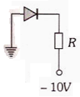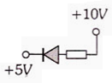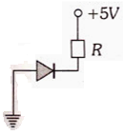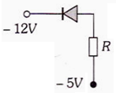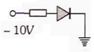

1) 2) 3) 4) 5)

1. 1, 2, 3 b) 2, 4, 5 c) 1, 3, 4 d) 2, 3, 4
2. A reverse biased diode is

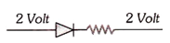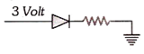

a) b)

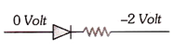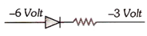

c) d)

1. A diode having potential difference of 0.5V across its junction is connected in series with a resistance of 20Ω across the source. If 0.1A passes through the resistance, then the voltage of the source is

a) 1.5V b) 2V c) 2.5V d) 5V

1. Which circuit will not show current in ammeter?

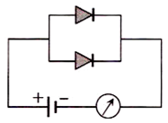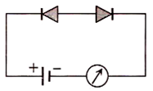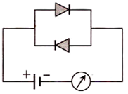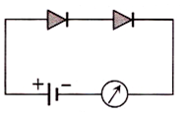a) b) c) d)

1. The I-V characteristic of a p-n junction diode is as shown. The approximate dynamic resistance of the p-n junction when a forward bias of 2V is applied is
2. 1Ω
3. 0.25Ω
4. 0.5Ω
5. 5Ω
6. In the given circuit, the current through the battery is
7. 1.5A
8. 1A
9. 0.5A
10. 2A
11. 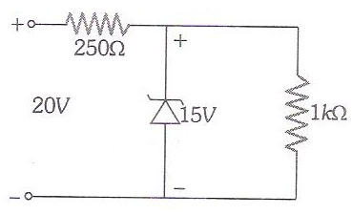A zener diode having breakdown voltage equal to 15V is used in a voltage regulator circuit as shown in the figure. The current through the diode is
12. 20mA
13. 5mA
14. 10mA
15. 15mA
16. The forbidden energy gap in Ge is 0.72eV. Given hc = 12400eV A0.

The maximum wavelength of radiation that will generate electron hole pair is

1. 172220A0 b) 172.2A0 c) 17222A0 d) 1722A0
2. Semiconductor devices whose characteristics given below in order (a), (b), (c), (d) are

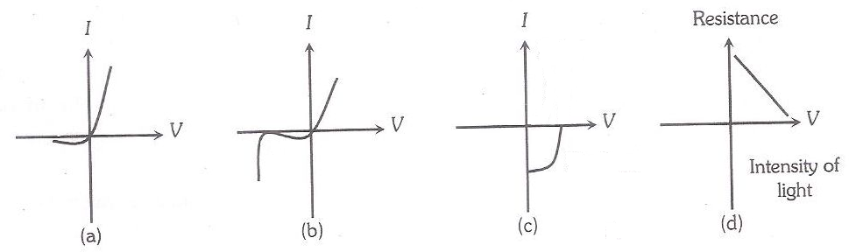

a) zener diode, simple diode, light dependent resistance, solar cell

b) solar cell, light dependent resistance, zener diode, simple diode

c) zener diode, solar cell, simple diode, light dependent resistance

d) simple diode, zener diode, solar cell, light dependent resistance

1. If in a p-n junction diode, a square input signal of 10V is applied as shown

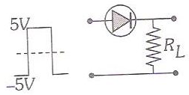

Then the output signal across RL will be

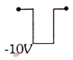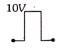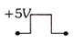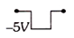

a) b) c) d)

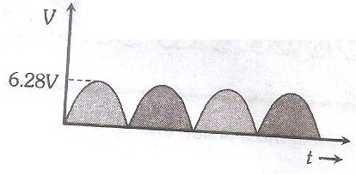

1. For the given electric voltage signal,

the dc value is

1. 6.28V
2. 3.14V
3. 4V
4. 0V
5. An n-p-n transistor can be considered to be equivalent to two diodes connected. Among the following figures, the correct representation of it is

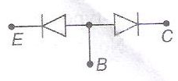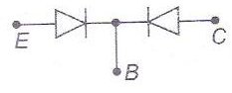

a) b)

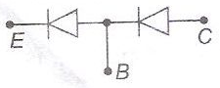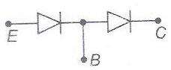

c) d)

1. When npn transistor is used as an amplifier

a) Electrons move from base to collector b) Holes move from emitter to base

c) Electrons move from collector to base d) Holes move from base to emitter

1. A npn transistor conducts when

a) both collector and emitter are positive with respect to the base

b) collector is positive and emitter is negative with respect to the base

c) both collector and emitter are negative with respect to the base

d) none of these

1. In an npn transistor, the collector current is 24mA. If 80% of electrons reach collector, then its base current in mA is

a) 36 b) 26 c) 16 d) 6

1. For a common base configuration of pnp transistor, . Then the maximum current gain in the common emitter configuration will be

a) 12 b) 6 c) 24 d) 5

1. For a transistor, the parameter β = 99. The value of the parameter α is

a) 0.99 b) 0.9 c) 0.09 d) 9.9

1. A npn transistor having ac current gain of 50 is to be used to make an amplifier of power gain of 300. The voltage gain of the amplifier is

a) 8 b) 6 c) 4 d) 3

1. The circuit diagram shows a logic combination with the states of outputs X, Y and Z given for the inputs P, Q, R and S all at state 1. When input P and R change to state 0 with inputs Q and S still at 1, then the states of outputs X, Y and Z change to

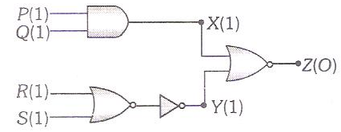

1. 1,0,0
2. 1,1,1
3. 0,1,0
4. 0,0,1
5. The circuit is equivalent to

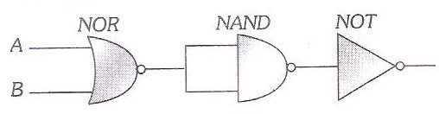

a) NOR gate b) OR gate c) AND gate d) NAND gate

1. In the circuit given, A, B and C are inputs and Y is the output.

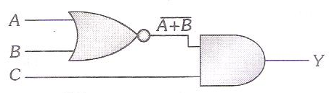The output of Y is

1. High for all the low inputs
2. High when A=1, B=1, C=0
3. Low when A=0, B=0, C=1
4. Low for all low inputs
5. Given figure shows the wave forms for two inputs A and B and that for output Y of a logic circuit. The logic circuit is

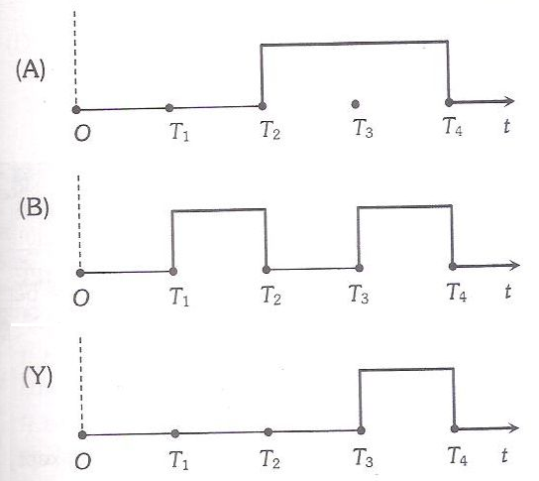

a) AND gate b) OR gate c) NAND gate d) NOT gate

1. The logic gates giving output 1 for the inputs of 1 and 0 are
2. AND and OR b) OR and NOR
3. NAND and NOR d) NAND and OR
4. The device that can act as a complete electronic circuit is

a) integrated circuit b) junction diode

c) zener diode d) junction transistor

* 1. TV waves have a wavelength range of 1-10metre. Their frequency range in MHz is

a) 30-300 b) 3-30 c) 300-3000 d) 3-3000

* 1. The speed of electromagnetic wave in vacuum depending upon the source of radiation

a) increases as we move from gamma rays to radio waves

b) decreases as we move from gamma rays to radio waves

c) is same for all of them

d) none of these

* 1. An electromagnetic wave going through vacuum is described by the equation

E = E0 sin(kx – ωt). Which of the following is independent of wavelength

a) k b) ω c) k/ω d) kω

* 1. A new system of units is evolved in which the values of μ0 and ε0 are 2 and 8 respectively. Then the speed of light in this system will be

a) 0.25 b) 0.5 c) 0.75 d) 1

* 1. The wavelength of the short radio-waves, micro-waves, ultraviolet-waves are λ1, λ2, λ3 respectively. Arrange them in decreasing order

a) λ1, λ3, λ2 b) λ1, λ2, λ3 c) λ3, λ1, λ2 d) λ2, λ1, λ3

* 1. The ratio of the amplitude of magnetic field to the amplitude of electric field for an electromagnetic wave propagating in vacuum is equal to

a) the speed of light in vacuum b) unity

c) reciprocal of speed of light in vacuum d) none of these

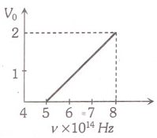

* 1. The stopping potential (V0) versus frequency (ν) plot of a

substance is shown. In the figure, the threshold wavelength is

a) 5 x 1014m

b) 6000A0

c) 5000A0

d) None of the above

* 1. The energy of the incident photon is 4eV and the work function is 2eV. Then the stopping potential is

a) 2V b) 4V c) 6V d) 8V

* 1. For the Bohr’s first orbit of circumference 2πr, the de-Broglie wavelength of revolving electron will be

a)  b) πr c) 2πr d) 

* 1. The ratio of de-Broglie wavelengths of proton and α-particle of same energy will be

a) 2 : 1 b) 1 : 2 c) 4 : 1 d) 1 : 4

* 1. If particles are moving with same velocity, then maximum de-Broglie wavelength will be for

a) neutron b) proton c) β-particle d) α-particle

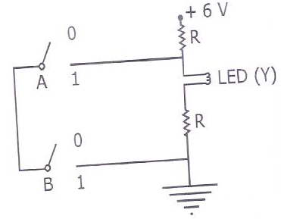

1. The correct Boolean operation represented by

the circuit diagram drawn is **[NEET 2019]**

a) NAND

b) NOR

c) AND

d) OR

1. For a p-type semiconductor, which of the following statement is true? **[NEET 2019]**

a) holes are majority carriers and pentavalent atoms are dopants

b) electrons are majority carriers and pentavalent atoms are dopants

c) electrons are majority carriers and trivalent atoms are dopants

d) holes are majority carriers and trivalent atoms are dopants

1. 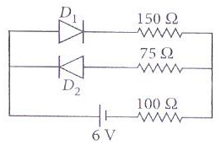The circuit shown below contains two ideal diodes, each with a forward resistance of 50Ω. If the battery voltage is 6V, then the current through the

100Ω resistance is **[JEE 2019]**

a) 0.02A

b) 0.08A

c) 1.02A

d) 1.08A

1. For the circuit shown below, the current through the zener diode is **[JEE 2019]**

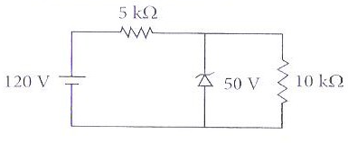

a) zero

b) 5mA

c) 9mA

d) 14mA

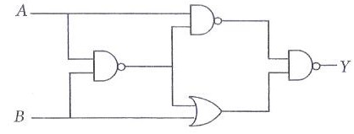

1. The output of the given logic circuit is **[JEE 2019]**

a) 

b) 

c) 

d) 

1. The reading of the ammeter for a silicon diode in the given circuit is **[JEE 2018]**

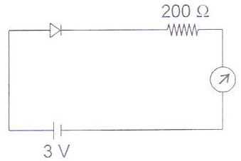a) 0.5mA

b) 7.5mA

c) 11.5mA

d) 15.5mA

1. In a p-n junction diode, change in temperature due to heating **[NEET 2018]**

a) affects the overall V-I characteristics of the p-n junction

b) affects only the reverse resistance

c) does not affect the resistance of the p-n junction

d) affects only the forward resistance

1. 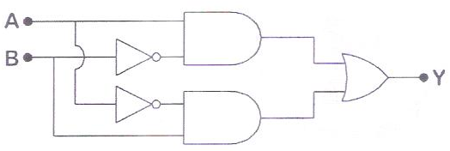In the combination of the following gates, the output Y can be written in terms of inputs A and B as **[NEET 2018]**

a) 

b) 

c) + A . B

d) + 

1. Which one of the following represents forward bias diode? **[NEET 2017]**

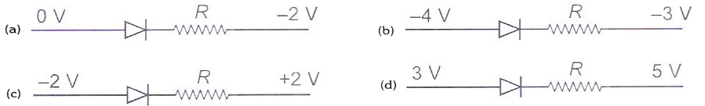

1. The circuit is equivalent to **[NEET 2017]**

a) NOR gate

b) OR gate

c) AND gate

d) NAND gate

1. 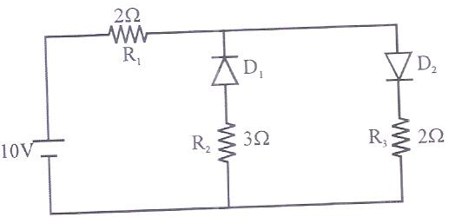The given circuit has two ideal diodes connected as shown in the figure below. The current flowing through the resistance R1 will be **[NEET 2016]**

a) 0.5A

b) 2.5A

c) 4.5A

d) 6.5A

1. 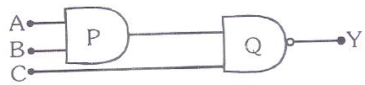The output Y in the following circuit when all the three inputs A, B, C are first 0 and then 1 is **[NEET 2016]**
2. 1, 0 b) 1, 1
3. 0, 1 d) 0, 0
4. The energy associated with electric field is UE and with magnetic field is UB for an electromagnetic wave in free space. Then **[JEE 2019]**

a)  b)  c)  d) 

1. If the magnetic field of a plane electromagnetic wave is given by

, then the maximum electric field associated with it is (The speed of light = 3x108m/s) **[JEE 2019]**

a) 4.5 x 104N/C b) 4 x 104N/C c) 6 x 104N/C d) 3 x 104N/C

1. An EM wave is propagating in a medium with a velocity  The instantaneous oscillating electric field of this em wave is along +y axis. Then the direction of oscillating magnetic field of the EM wave will be along  **[NEET 2018]**

a) –x direction b) –z direction c) –y direction d) +z direction

1. Out of the following options, which one can be used to produce a propagating electromagnetic wave? **[NEET 2016]**

a) a stationary charge b) a chargeless particle

c) an accelerating charge d) a charge moving at constant velocity

1. A particle moving with kinetic energy E has de-Broglie wavelength λ. If energy ΔE is added to its energy, then the wavelength becomes. The value of ΔE is **[JEE 2020]**

a) 2E b) E c) 3E d) 4E

1. An electron of mass m and a photon have the same energy E in the range of a few eV. The ratio of the de-Broglie wavelength associated with the electron and the wavelength of the photon is

(c = speed of light in vacuum) **[JEE 2020]**

a) b) c) d)

1. An electron is accelerated through a potential difference of 10,000V.

Its de-Broglie wavelength nearly is (me = 9 x 10-31kg) **[NEET 2019]**

a) 12.2 x 10-14m b) 12.2nm c) 12.2 x 10-13m d) 12.2 x 10-12m

1. When the light of frequency 2ν0 (where ν0 is threshold frequency), is incident on a metal plate, the maximum velocity of electrons emitted is v1. When the frequency of the incident radiation is increased to 5ν0 , the maximum velocity of electrons emitted from the same plate is v2. The ratio of v1 to v2 is **[NEET 2018]**

a) 2 : 1 b) 1 : 2 c) 4 : 1 d) 1 : 4